Lego Serious Play in Psychology: Exploring its use in qualitative interviews
Lego Serious Play (LSP) developed in corporate settings to encourage collaboration, problem-solving, and drive creativity. It has since been applied in other contexts because of its accessibility and ability to facilitate reflection and the sharing of ideas. As a research method, LSP is one of a range of creative approaches but is relatively under-researched. We suggest that the constructive ‘build, share, listen’ process of LSP has considerable potential as a tool with individual participants to promote reflection and elicit talk in phenomenological research. We draw on our experiences using LSP in an in-depth interview study to explore the meaning of happiness to five young adults in Hong Kong who had moved back to the parental home. We explain our approach in detail and discuss the potential benefits of applying LSP to enhance individual interviews, including as a participant-led approach, which reduces anxiety, enables ‘flow,’ self-expression and reflection, access to tacit knowledge, use of metaphor and symbolism. We also discuss some limitations of our approach and identify considerations for future researchers, including the time burden, aspects which were more researcher- than participant-led, potential improvements to enhance data generation, and ethical reflections on the cathartic nature of the LSP-supported interviews.

Keywords: Lego Serious Play; qualitative; interviews; creative approaches; methodology.

1. Introduction
LSP is an open source-methodology, originally developed in 2001 by Lego Group executives, Robert Rasmussen and Per Kristiansen, as a way to problem-solve, unlock innovative thought and encourage collaboration within their organisation (Kristiansen and Rasmussen, 2014). Typically used in workshop settings, participants are invited to follow a simple three-step process of ‘build, share and listen,’ whereby each builds a model and explains its meaning while the rest of the group listens. One of LSP’s benefits is the creation of a non-judgemental, participatory and democratic environment. Listeners are encouraged not to interrupt or question others’ models, preventing domination of the discussion by more confident or experienced group members and giving a voice to everyone in the room (Kristiansen and Rasmussen, 2014). It also appears to increase engagement: Kristiansen and Rasmussen (2014) also noted that people were ‘leaning in’ (p. 17) more than usual, rather than disconnecting.

Recognizing the value of this creative and accessible communication process, researchers, psychologists and educators have explored LSP’s potential benefits in varied contexts, including psychotherapy (e.g., Lindsay, Hounsell and Cassiani, 2017), learning and development (e.g., Pedregosa-Fauste et al., 2024) and research (e.g., Rainford, 2020). This paper focuses on the use of and potential for LSP in qualitative research interviews in psychology. Coemans and Hannes (2017) noted a lack of methodological reflection in the research field on creative methods, such as LSP, and argue for greater discussion about the process, implications and experience of using these approaches. Compared with some other creative approaches, such as photography and drawing, the use of LSP as an elicitation tool within individual research interviews is relatively under-reported, though it is considered to have potential in this context (Kriszan and Nienaber, 2024). We draw on theory and literature in the creative methods field, research applying LSP in both group contexts and individual interviews, and experiences from our own LSP-based interview study to discuss practical and ethical considerations, potential benefits and limitations of this approach.

2. Theoretical and Methodological Context
LSP as a research approach falls under the umbrella of creative methods, a term which encapsulates a broad set of tools designed to move qualitative research beyond the traditional word and text-based approaches it has relied on. Interviews and focus groups are the most commonly used qualitative research methods across psychology and the social sciences (Pottinger et al., 2022), but the exclusive focus on words has been criticised by some who value other means of uncovering meaning, such as ethnographic observation (Crang and Cook, 2007), practice and performativity (Vannini, 2015). Some view the retrospective nature of interviews as problematic (Hitchings, 2012) because of the “tidy, rehearsed” accounts they tend to elicit (Burrell, 2014, p.137), although Burrell notes that the immediate geographical, social and temporal context of the interview can also generate “in-the-moment” ideas and concerns (p. 137).

Hitchings and Latham (2020) suggest that interviews offer great potential but have a “taken-for-granted quality” (p. 395) and argue for more critical reflection within the qualitative research community. This discussion could be informed by the small but growing number of researchers who have, over the past two decades, reported interview findings which were enriched by creative, participatory, sensory and embodied activities during or to elicit talk (Hitchings and Latham, 2020). Creative techniques used within interviews include drawing and sketching (Bagnoli, 2009; Buse et al., 2020), art, photography and collage (Barron, 2021a; Mannay, 2020; Mooney, Bhui and Co-Pact Project Team, 2023; Tarr, Gonzalez-Polledo and Cornish, 2018), sandboxing (Mannay, 2020), walking (Warren, 2017), metaphors and objects (Brown, 2019; Holmes and Hall, 2020; Nind and Vinha, 2016; Owen, 2021).

Creative approaches are generally set within a constructivist-interpretivist framework. Piaget’s constructivist theory (1950) assumes that individual understandings of the world are constructed from within, with experience interpreted through internalised ideas and thought processes. From a research perspective, this suggests that in order to learn about a human experience one must inquire about it through the individual’s construction of it. Broussine (2011) suggests that assumptions underpinning creative approaches include a recognition of the complex nature of human experience, a belief in creative arts as a meaningful way to express and learn about this, and a valuing of collaborative approaches to inquiry.

Constructivism asserts that social phenomena are continually shaped between individuals, and interpretivism acknowledges the role of the researcher in creating knowledge (Creswell and Creswell, 2022). This perspective recognises that the objective detachment of the researcher from the research is not possible. Instead, the researcher should reflexively consider their position and acknowledge what they bring to the research process and outcomes (Braun and Clarke, 2021; Finlay, 2002). As Charmaz (2006) points out, “constructivists acknowledge that their interpretation of the studied phenomenon is itself a construction” (p. 187). The application of creative approaches often provides multi-faceted knowledge about a topic (Coemans and Hannes, 2017) and, because of the greater complexity of resulting data, analysis can be more difficult (Wang and Burris, 1997). The meaning of words may be more widely recognised and clearly understood, whereas the interpretation of creative outputs is subjective, with features which might be universally recognised as well as elements with a more private, personal meaning (Mooney, Bhui and Co-Pact Project Team, 2023). It is important that the participant is enabled to communicate the meaning their creative outputs hold for them. Not only does this avoid the researcher inadvertently super-imposing their own meaning (Broussine, 2011), it also allows the participant control over what is communicated and what is kept private. These arguments speak to concerns about participant voice, which are not unique to creative methods, but common among participatory action and feminist scholars (e.g. Easterby-Smith, Thorpe and Lowe, 2004; Eichler, 1988; Olesen, 1998, cited in Broussine, 2011), that researchers avoid replicating existing social hierarchies and power relations, in which the socially dominant voice is prioritised and the marginalised voice, silenced. Broussine (2011) highlights the importance of reflexivity here too, that researchers reflect carefully on power dynamics within their research. Mannay (2016) observes that creative approaches can be participatory but, where the researcher decides on the creative task, unequal power relations remain because of researcher-led limitations on what the participant can create.

Where creative methods accompany interviews focused on the creative output, this encourages participant engagement, enhances critical reflection, reconstruction and sense-making about the phenomenon, and often elicits deeper, richer and more emotional accounts (Mitchel, 2011; Ward and Shortt, 2020; Wicks and Rippin, 2010). The act of creating offers extra time and space for reflection, and a shared focus between researcher and participant, making the interview a more collaborative process, in line with a broader push for more participatory (Kara, 2015). Creative outputs thereby act as an elicitation tool, enabling the participant to remember, reflect, and come to new understandings (Mooney, Bhui and Co-Pact Team, 2023), and moving them on from the pre-rehearsed narratives which arguably limit traditional interviews (Hitchings, 2012). The created artefact circumvents the more linear, organised thinking associated with speech, and can facilitate new ways of thinking about everyday phenomena (Gauntlett, 2007), resulting in the potential for deeper thought on and insights into phenomena than through interview questions alone (Kara, 2015; Rainford, 2020).

Gauntlett and Holzwarth (2006) argue that it can be difficult to provide accurate responses to complex questions in the moment, as expected in interviews, and that the reflection time offered by creative approaches generates more considered – and perhaps, therefore – more accurate responses. Conversely, others argue that the requirement to create could, in fact, pose barriers to reflection if there is a lack of creative confidence (Kearney and Hyle, 2004). Buckingham (2009) also cautions against assuming greater truth or accuracy via creative methods. He argues that the success of a creative approach depends on the quality of the researcher-participant interaction, and the adequacy and relevance of the visual material, making researcher reflexivity about the creative medium and research process vital when interpreting outcomes.

3. Lego Serious Play: A Literature Review

As a creative methods approach, LSP is less well researched than other approaches. Ward and Shortt (2020) noted a potential hierarchy in the creative methods field, with photography-based methods the most widely known and researched, and suggested greater attention be paid to other methods.

In keeping with its use to encourage collaboration in organisations, LSP has been used in focus group research where the aim was to arrive at shared conceptualisations. In this context, researchers have reported the benefits of LSP in reducing hierarchies, encouraging participant engagement, facilitating the wider sharing of ideas and personal stories, resulting in ideas, conceptualisations and visions which better represented the whole group (Ajibade and Hayes, 2020; McCusker, 2019). Wheeler, Passmore and Gold (2020, p.149) recounted one participant’s comment about LSP in organisational research: ‘there’s an ease and a restfulness about that, that really unlocks a lot of anxiety around what you might want to say or express. So, that’s welcome and I think unusual in one's working life where you’re always second guessing, you’re always trying to anticipate the implications of everything you say or do.’

Some of the key points of discussion emerging from studies employing LSP as a research method are enhanced reflection and self-expression, the use of metaphor, the potential for fun and ‘flow’, and the issue of creative confidence. Researchers who have interviewed participants about using LSP as a reflective practice tool report positive findings about the constructive process and self-reflection it facilitated. For example, Quinn, Trinh and Passmore (2022) both helped create new awareness and insights within participants and produced rich and nuanced data for the researcher, as they observed in real-time how participants thought about, expressed, reflected on and reconsidered their knowledge. Cavaliero (2017)’s participants valued how the creative, tactile process facilitated new perspectives on themselves, their experiences and concerns and illuminated changes in these things over time. Gauntlett (2007) describes how storytelling combined with construction enabled participants to find words for ideas which were otherwise difficult to express. The physical act of creation and the bodily engagement with the environment in LSP fosters a different type of cognitive process, making the Lego ‘a tool for thinking’ (Gauntlett, 2007). Where LSP has been used within a multi-modal approach, combining LSP workshops with individual interviews, researchers have commented that the activity enhanced participants’ engagement in the research and facilitated in-depth reflection, resulting in richer data than verbal methods alone (Vusio, Thompson and Birchwood, 2022; Wengel, 2020). LSP is also supports self-expression in vulnerable participants, and where there are language differences or social inequalities (Kriszan and Nienaber, 2024; Solta, 2023; Wengel, 2020) through its ability to address inherent power structures, overcome hesitancy in self-expression and facilitate open communication.

Because of their obvious physical limitations, Lego blocks can be used to convey complex, detailed ideas, and encourage self-expression through metaphor and symbolism (Wengel, 2020). In their study exploring young people’s experience of mental health services in the UK, Vusio, Thompson and Birchwood (2022, p. 7) noted that LSP ‘led to a range of metaphors that were narratively explained by young people in their own words, which allowed us to better understand young people’s realities and their experiences.’ Cavaliero (2017) reported that metaphors helped participants and, therefore, researchers to access tacit knowledge. Their twelve participants mentioned finding that new, unexpected or subconscious thoughts surfaced while they were unpacking a metaphorical model. In the act of reflecting on and explaining their Lego block models to the researcher, and the metaphors and symbols they contained, participants were experiencing new insights in real-time. This offered researchers a glimpse into how those connections were being made, resulting in richer, deeper, more nuanced data than might have been possible through interviews alone.

In comparison to many other creative approaches, the scope and requirement for creative skill in LSP are less. This brings advantages and disadvantages. Lego blocks offer a finite range of stylised bricks which limits builders in terms of what they can draw on in representing their ideas, which naturally restricts what they and the researchers can achieve (Rainford, 2020). This may be seen as a disadvantage, yet looser or more open-ended tasks which offer greater potential for creativity and skill can arouse anxiety in participants about their creative abilities (e.g. Brown, 2019). Fear of being unable to draw, for example, is a barrier rather than a facilitator to participation and reflective depth (Ward and Shortt, 2020). Compared with the finite number and type of bricks of Lego, drawing offers participants relatively unbounded creative potential, in which they create something of significance from nothing (Banks, 2001: Literat, 2013). A lack of artistic confidence has led in some cases to participants finding the creative task uncomfortable (Rainford, 2020) or even refusing to participate as instructed (Broussine, 2011), though in the latter case, what they opted to produce gave an opportunity for insightful discussion. In LSP, the participant cannot construct an exact model or perfect representation of their idea, so creative confidence becomes less of a concern, though the occasional example of anxiety is reported. For example, Wheeler, Passmore and Gold (2020, pp. 146-147) cite one participant who found the LSP task ‘quite stressful because I’m not a particularly creative person … this thing that I’ve made with my hands doesn’t really explain ... I’m more of a word person.’ Combining the creative task with an interview could overcome this particular limitation and address this participant’s anxieties about being able to express themselves fully. However, although LSP may elicit fewer creativity concerns than other creative tools, it still relies on openness to different modes of self-expression, play and ‘thinking symbolically,’ so the potential for participant discomfort remains (Peabody and Noyes, 2017; Pedregosa-Fauste et al., 2024). In many ways, LSP shares similarities with ‘sandboxing’ in which participants construct representative scenes in a sandbox from a range of objects offered by the researcher (Mannay, 2020), though, arguably, Lego blocks offer greater scope for construction and creativity.

Researchers have noted the potential for fun and ‘flow’ with LSP. Rainford (2020)’s post-research survey found that his LSP participants reported greatly enjoying the task. Cavaliero (2017) described how LSP resulted in a flow-like sensation for the participants: ‘because I was focused on building the Lego the ideas flowed more freely’ (Cavaliero, 2017, p.138). ‘Flow’ is ‘the holistic sensation present when we act with total involvement’ (Csíkszentmihályi, 1975, p.43). Quinn (2022, p. 111) described how flow reduced ‘internal chatter,’ helped participants to slow down and relax, and facilitated more insights. Flow is arguably beneficial to qualitative researchers because it generates a positive emotional state (Csíkszentmihályi, 1988) and reduces performance anxiety (Kirschner, Paas and Kirschner, 2008). Increased immersion in the task reduces participants’ self-consciousness and inhibition, allowing them to access deep thoughts and emotions with less obstruction from stress and anxiety (Wheeler, Passmore and Gold, 2020).

The vast majority of research relating to LSP has grouped participants together for the construction and, often, for the model narration / discussion / interview aspects, both where its application in a particular context, such as teaching or reflective practice, was being researched, and where it was combined with verbal methods in a multi-method research study. Therefore, most of the LSP research considered above was conducted with groups, and Kriszan and Nienaber (2024) comment on the particular suitability of LSP in group-based contexts, because of its facilitation of communication and social interaction, However, Kriszan and Nienaber (2024) recommend further exploration of LSP’s applications in qualitative research, and comment that LSP also has potential in individual qualitative interview studies, where it is barely considered to date.

Individual interviews permit greater and more in-depth exploration of the individual’s perspective, and thus a more complex understanding of their unique lived experience. Combined with LSP, the interview participant is invited to construct a model and explain its meaning to the researcher. Rainford (2020) conducted a rare study in which LSP was compared with drawing as an elicitation tool in individual interviews. Rainford described what LSP offered for the researcher-participant relationship, rapport and interview process. Constructing models took the focus away from direct questioning, changing the relationship from one in information is drawn from the participant to one in which the conversation between researcher and participant was constructed in the interview setting as the artefacts were constructed. The visibility of the model helped illuminate, made concrete and facilitated discussion about the builder’s thoughts, feelings, beliefs, values and meanings that were under exploration, expanding and enriching what verbal communication alone could reveal. Rainford (2020) found that the LSP process enabled participants to consider their initial assumptions and question them through working and reworking their models until they were satisfied. Through this construction process an interrogation of their decision-making process was made possible, giving light to deeper findings and discussion. There was scope for more freedom in the task Rainford (2020) offered to his participants, however, where the main focus was on ranking different professions on a ‘Ladder of Aspiration.’ It could be argued that this structured approach constrained the participants' narrative because freestyle construction was not an option. This sense of being limited was reflected in the remarks of one participant: ‘I don’t really believe that professions can be ranked in this way and hoped not to come across as thinking this was the case’ (Rainford, 2020, p.118). Rainford (2020) opted for this structured approach to pre-empt creative anxieties but it is possible to do this without losing creative freedom, as we set out below.
4. Methodological Description and Analysis
4.1 Focus of Study
In our study, LSP was used to facilitate individual interviews with a previously neglected research demographic in Hong Kong: adults between the age 30-40, who had moved back home.

Hong Kong has historically ranked low in the World Happiness Report (77 / 146 countries in 2021), leading to media attention on and suggestion to address residents’ unhappiness (Leung, 2018). The housing crisis created by its unaffordability is considered a contributor (Bloomberg, 2021; Chu and Yuen, 2015). Three quarters of those aged 18-35 live with their parents despite an unemployment rate of 3% (City U Urban Research, 2015). This trend is not confined to Hong Kong and has been noted in the West (Fry, Passel, and Cohn, 2020). However, the trend has been responded to with concern and action in the West (Weiner, 2021), whereas however the idea of adult children living with parents may be more accepted due the relatively collectivist norms of Hong Kong (Hofstede-insights.com, 2021).
The study aimed to explore participant perceptions about the impact of returning to and living in the family home on their happiness.

4.2 Research Design and Approach
In keeping with our exploratory research aim, we adopted a qualitative, inductive and phenomenological design. Phenomenology conceptualises experience as unique to the person, and as embodied and situated in the world (Smith, Flowers and Larkin, 2012). Phenomenological research therefore aims to explore in detail the individual lived experience of a phenomenon, and understand how they make sense of it. (Smith, Flowers and Larkin, 2012; Neubauer, Witkop and Varpio, 2019). It also recognises the co-construction of research findings between researcher and participant (Smith, Flowers and Larkin, 2012). These ideas are entirely in keeping with the constructivist principles and assumptions of creative methods research.
In-depth individual semi-structured interviews took place, facilitated by LSP, and we conducted an inductive thematic analysis (Braun and Clarke, 2021). LSP seemed an appropriate tool to facilitate participants’ reflection and self-expression on this topic. In addition to offering plenty of scope for metaphor, Lego grounds and bricks also seemed particularly well-suited to the place-related phenomenon under study.

4.3 Ethical Approval and Recruitment

University ethical approval was granted (ER44849327) and British Psychological Society ethical principles were applied (BPS, 2021).
A purposive sample of five participants – three women and two men - who met the age and residency criteria were recruited via online fora (3 women; 2 men). Samples in phenomenological research are often below 10, and samples of between 3 and 6 have been recommended for postgraduate student projects such as this (Smith, Flowers and Larkin, 2012). All gave informed consent and individual identities are protected by means of pseudonyms.

4. 4 Data Generation
4.4.1 Interview schedule
Interviews were conducted in English by the lead researcher, SR, audio-recorded, transcribed and pseudonymised for analysis. Interviews were semi-structured in their approach, and a short but broad set of questions was developed to guide data collection (see Figure 1), with some identified as key questions. Questions were designed to open up the narrative and were deliberately not theoretically informed, in keeping with the inductive approach in the project. To enable a fluid and expansive discussion, openness to participant narrative and direction was maintained, with questions being omitted, added or edited in real-time, in response to comments, emotions or cues from the participant. For example, one participant became visibly upset when asked Q7, commenting, 'I get really emotional when I talk about family so I'd rather exclude it,' and in response, SR moved onto the next question. Questions were occasionally added to encourage participants to clarify or expand on their answers.
FIGURE 1 HERE
Figure 1 identifies Questions 2 and 6, ‘construct your happy place’ and ‘construct your home’, as ‘key questions’ in the interview schedule. Key questions introduced a new focus, whereas other questions explored aspects of happiness in relation to that topic. In discussion, follow-up questions were asked to further explore or clarify ideas shared during the previous build activity. Pragmatically, models took time to construct and explain, so the decision was made to opt for fewer key build questions, rather than more key questions with fewer models, which may have resulted in more surface-level data and could have disrupted participants’ ongoing reflection on and elaboration of their existing models. Thus, our approach prioritised depth over breadth.

4.4.2 Orientation to the LSP process
Mindful of the possibility of creative anxieties, SR provided an orientation to the LSP process at the start of each interview to demonstrate both that perfect representations and complete models were not necessary for self-expression, and how metaphor and symbolism could be used when building. As demonstrated step-by-step in Figure 2, SR asked herself the first question, ‘tell me about yourself’ and chose several colourful Lego blocks as the base to symbolise an extroverted personality, adding multiple sticks reaching out from the base to symbolise that she ‘likes to connect and collaborate with others’, and a green leaf on top to act as a metaphor for ideas and creativity. SR explained her model to the participant part-by-part. Following the demonstration, participants were provided with a board and asked Q1 - to introduce themselves - by mirroring the steps they had just witnessed.

FIGURE 2 HERE
4.4.3 Model Building
For key questions 2 and 6, SR invited participants to build between 10 and 20 models to represent their thoughts, ideas and feelings relating to that question. Our aim with this number and range was to offer scope for individual differences but ample opportunity to build enough models to fully express their ideas. Asking for fewer models might have resulted in participants presenting only the ideas which were most accessible or seemed most importance, holding back those they considered less essential, a self-filtering process which might limit research insights. In addition, we believed that offering more models would increase the chance of free rein, flow and spontaneity in expression, and thereby participants’ unfiltered thoughts. The theoretical benefits of this approach were observed in practice: For example, both Tracy and Heidi’s first models on the board related to simple hedonistic pleasures such as ‘eating chocolate’ and ‘watching tv’. A few models in, they opened up further and talked about topics like ‘being on stage giving them a sense of control’ and ‘nature bringing them a sense of peace,’ suggestive of greater reflectivity, comfort in self-expression and depth of ideas as they progressed.
4.4.5 Data Collection
Interviews were audio-recorded and transcribed using secure online transcription software. Non-verbal nuances present in the recordings that could be lost during transcription were noted, for example, sighing or pitch change, tears or animated speech. Notes were also taken of any interactions between the participant and the Lego, for example, if models were moved around or added in real-time in response to a reflection.
Each Lego model was photographed and labeled using post-it notes to remind SR which models corresponded to the relevant parts of the interview transcript. For example, when Oliver pointed at his model on wheels and said ‘This represents my tiny home,’ SR labeled the model ‘tiny home.’
Data for analysis included interview audio-recordings, transcribed interview transcripts, notes and annotated images of participants’ Lego models. Data relating to specific models were organised alongside one another to facilitate the analysis processs and an extract from the spreadsheet is presented in Figure 3, below.
FIGURE 3 HERE
4.4.6 Data Analysis
Initial analysis was conducted by SR, and themes were discussed and refined with PF. Themes were based on a thorough analysis of all data, including the transcripts, models and notes described above. We applied inductive thematic analysis, a qualitative research approach developed by Braun and Clarke (2006) to identify, consider and compare patterns in the resulting data, and generate themes. Semantic and latent content were considered.

Sematic data included participants’ descriptive terms and own language, for example, in Charles’ reflections on his Lego model of a beach, he explicitly mentioned notions of privacy and seclusion as important to his happiness. During discussion of this expressed wish, Charles then began to reflect on the importance of friends, and added people to his Lego board in response. Our semantic codes reflected Charles’s own ideas of privacy, seclusion and company.

Consideration of latent ideas involved moving beyond participants’ own words, offering an interpretation of ‘meanings that lie beneath the semantic surface of the data’ (Braun and Clarke, 2006, p. 61). The Lego models lent themselves to latent analysis because metaphors have two meanings, the literal, direct ones and a symbolic meaning that communicates something beyond the literal. Returning to Charles’s beach model, the text and models revealed complexity in his ideas about happiness. Initially he built a relatively empty beach with a few trees, and spoke of constructing a wall to keep people out. The notion of a wall conveyed a strong message – literal and metaphorical - about his desire to be alone and protected from the outside world. In explaining this metaphor to SR and further reflecting on his initial ideas, Charles remarked on the value to his happiness of friends and that, in fact, he would not want to be by himself. This justaposition of ideas and images, and the addition of new elements to his original model suggested that Charles saw value in both seclusion and company. Observing his thinking process in which both reflected a strong response, suggested that both being alone and with others met his conflicting needs, perhaps at different times. This inference resulted in our latent code, termed ‘balance,’ as demonstrated in Figure 4, below.
FIGURE 4
Resulting themes were named, ‘Development and Growth,’ ‘Doing things for Myself,’ and ‘Connectedness,’ a full account of which is beyond the scope of this methodological article.
4.4.7 Reflexivity
As interviewer and main analyst, SR was mindful of the possible influence that her personal identity and experience on the research process and considered whether her values and beliefs might be guiding her towards certain themes and conclusions. SR was conscious of the cultural and demographic differences between herself and interviewees: SR is a Caucasian British female, similar in age to her participants. She lives and works in Hong Kong but holds strong individualistic values, whereas most participants were ethnically Chinese, likely influenced by the combined collective and individualistic values present in Hong Kong. Despite the inductive approach, SR was aware that her own beliefs and values could orient her towards particular semantic content and influence latent interpretations. For example, she believed that moving back in with parents at age 30-40 would impact independence, so codes such as ‘freedom,’ ‘escape’ and ‘privacy’ would likely lead her towards an autonomy-related theme. Cognisant of this, SR referred back to the semantic codes and Lego models to ensure that final codes and themes did not stray too far from participants’ expressed meanings.
PF is a middle-aged UK-based Caucasian female, an academic, psychologist and psychotherapist. She has a particular interest in how people experience, think about, make sense of and live within their individual, interpersonal and social contexts, how they cope with any setbacks and challenges these present, and how they work in their environment to develop, progress and thrive. PF was less directly involved in data collection and initial analysis; however as project supervisor and co-analyst her personal experiences and professional interests will have influenced her perspective on the data and contributed to how final themes were conceptualised and named.

5. Discussion

Based on our experiences in this study, we reflect here on the strengths and limitations of LSP in individual interviews, and of the decisions we made in applying the LSP approach.

5.1 Methodological strengths
When the research aim is to gain in-depth understanding of individual lived experiences and perceptions, individual interviews are the approach of choice. In our experience, LSP strengthened the in-depth interview process by introducing flow, facilitating deep engagement, and involving the body as well as the brain. This offered different ways of thinking, the opportunity to create, reflect on and recreate models in real time, and access to immediate, new and unexpected ideas elicited by the creative and reflective process. In comparison with the group context of much previous LSP research, the focus on one participant alone, as they create, reflect on, and discuss their models, affords greater depth of insights into the individual experience, which is particularly helpful in phenomenological research.

Here we consider a number of key features, which were supported by LSP, and helped generate rich individual data for analysis. These features included a participant-led narrative within a collaborative relationship, anxiety reduction, flow, self-reflection, accessing tacit and implicit knowledge, and use of metaphor. We include data extracts where relevant to illustrate points. While not all of the features are unique to LSP, we attempt to demonstrate what is particular to this approach.

5.1.1 A participant-led narrative in a collaborative relationship
One of the methodological strengths of a qualitative interview is its potential to produce a participant-driven narrative. When combined with creative approaches such as LSP, this potential is enhanced as participants can use the creation time to consider and prepare their responses and take control of their ‘stories’ from the onset of the interview. This is particularly valuable when exploring phenomena that are highly personal yet have an existing public narrative. In relation to our study, literature and media identify housing as a detractor in the happiness of Hong Kong citizens, most participants did not directly link housing / home and happiness, suggesting that there was not an immediate association between the two concepts for them. Charlie’s happy place was situated on a secluded beach which represented ‘minimalism’ and reflected the importance of nature. His models represented sociability and friends, sporting ability and job stability, suggesting that ‘home’ was not front of mind when Charlie thought about happiness. Allowing participants to take the lead on building and articulating their happy place meant their stories were not constrained or dominated by pre-existing ideas we might have had, via personal experiences or literature, about the topic.

Although the build process allowed the participant the lead role in determining the flow of ideas, we also noticed that LSP introduced a different quality into the researcher-participant relationship than an interview alone. Rainford (2020) describes the LSP interview process as more of a conversation than a question-answer format. We observed that providing external models of internal ideas offered the researcher a different perspective on the participant’s internal world and ideas than via words alone, with more immediate access, and an ability to consider her own responses to the visual representation of those ideas. This offered SR a somewhat more participatory role, sometimes verbally reflecting back to the participant what she could see and exploring its meanings with them, sometimes noticing how the visual object related to what she was hearing. Thus, although the narrative was participant-led, the data generation and exploratory process was also more collaborative than might be the case in an individual interview. Compared with a focus group, however, the collaboration was not aimed at a shared perspective, however, but greater depth of understanding of the participant’s individual one.

5.1.2 Anxiety Reduction
We were aware both that sensitive topics might be touched upon and cause some anxiety for participants, and that creative methods in research can be accompanied by creative anxieties in participants.

In relation to anxieties around discussing sensitive topics, previous LSP research has reported that building Lego models actively reduced topic-related anxiety. For example, one of Wheeler, Passmore and Gold (2020)’s participants commented on the ‘ease and restfulness about that, that really unlocks a lot of anxiety about what you might want to say or express’ (p. 149). That may be partly explained by the physical activity of LSP: Wilson (2011) and Shields et al., (2020) noted that keeping their hands busy by playing with Lego blocks relieved participants’ discomfort. Research into the effects on stress of activating the ‘hand-brain connection’ show that certain manual tasks light up the brain's reward centres, triggering a positive feedback loop which releases dopamine and serotonin, and subsequently minimises feelings of anxiety (Wilson, 2011). Similarly, Sandmire and colleagues (2012) found that ‘art making’ had a significant reductive effect on anxiety before university exams. One interesting study compared the effect of ‘colouring in books’ against ‘playing with Lego blocks’ on university students, and found both had similar effects (Shields et al., 2020). From a research perspective, reduced anxiety in the participant is desirable as it reduces awkwardness and inhibition (Wheeler, Passmore and Gold, 2020), allowing for more open sharing, less filtering and, thereby, a fuller, more candid picture of the participants’ inner world.

We did not gather information in our study about anxiety, but participants freely commented on having enjoyed the LSP interview experience, with one reflecting that ‘sharing in that way felt very cathartic.’ This experience of catharsis is further considered below in Limitations.

In relation to anxieties around the creative task (Rainford, 2020; Wheeler, 2020), our participants expressed few creative concerns. This may have been helped by building models in the context of an individual interview, rather than a group setting. However, LSP differs from other creative approaches in its semi-structured design, which may also positively impact creative confidence. It offers freedom of expression in how participants use the materials provided to create their own objects and scenes without the completely blank slate of a creative task such as drawing, which could feel daunting. It also arguably offers more personal creative potential than sandboxing, given participants build their own models, albeit with limitations determined by the blocks. Like sandboxing, where scenes can be recreated and redesigned in real time (Mannay, 2020), Lego models can easily be altered to better express what the builder wanted to say, as shown above.

The orientation task offered by SR also acted to ease participants into the task with a self-introduction activity. There is the potential for this activity to be leading, so we chose a different topic for the orientation but were still able to demonstrate how to use the blocks and ground, how simple blocks could be used to create expressive metaphors, and modelled the verbal explaining process which would follow. This demonstration importantly showed the level / relative lack of ‘skill’ required, revealed something personal about the researcher, making her vulnerable in the same way she would ask participants to be, and perhaps contributed to reducing both creative anxieties and the power imbalance often present in research studies.

5.1.3 Flow
The orientation activity offered an opportunity for participants to engage and familiarise themselves with the building and communication process, release anxiety or inhibition, relax and enjoy themselves. As far as we were able to judge, it was an effective approach: Oliver commented, ‘I quite enjoy this. It’s fun. I never shared about my life in this way. The time goes quickly while you're building.’ Molly remarked that the interview felt like therapy as she was able to let her thoughts flow freely without fear of judgement. Tracy noted feeling uninhibited in her expression during the first building phase and this enabled her to reveal her true thoughts without filtering them based on what she believed others thought she should say. The notion of flow was described in an interview by Csíkszentmihályi (cited in Geirland, 1996) as a state of mind where ‘the ego falls away. Time flies. Every action, movement, and thought follows inevitably from the previous one.’ Our participants’ comments about their experience seemed to reflect this idea, in keeping with previous research (Quinn, Trinh and Passmore, 2022).

Investigating the process and benefits of flow, cognitive neuroscientist Arne Dietrich (2004) described how the prefrontal cortex becomes less engaged, whilst the basal ganglia become more engaged. The prefrontal cortex processes external information and stimuli in order to react and adapt, which activates the individual's ego as self-related information is processed. The basal ganglia, on the other hand, processes internal information or previously acquired knowledge, which reduces activation of the ego. Limiting the activity of the prefrontal cortex, according to Dietrich (2004), permits greater access to the participants' authentic experience, reduces interference from any external stimuli, doing away with feelings of self-consciousness or anxiety, allowing them to focus entirely on the task at hand and express their truest thoughts and feelings. This theory suggests that using a creative tool such as Lego may have advantages over more traditional qualitative research methods, in helping to overcome inhibitions and social desirability barriers to disclosure. In comparison to other creative approaches, the relative simplicity of the LSP task arguably generates fewer creative anxieties and inhibitions, and therefore greater potential for flow and disclosure. However, the implications of greater disclosure are not all advantageous, as discussed in the Limitations section below.

5.1.4 Self-Expression and Reflection
LSP facilitated self-expression and reflection in a variety of ways. Firstly, long periods of building time allowed participants free rein to follow their creative trains of thought, without the intrusion of questions, meaning that their ideas could evolve gradually and naturally for them, moving from most salient to more reflective, perhaps suggestive of how ideas were prioritised for or accessible to them. Secondly, seeing the constructed models individually and side-by-side, and explaining them to the researcher was another opportunity for self-reflection. Thirdly, Lego models are very easy to construct, deconstruct and reconstruct – unlike some other creative tools. This allowed participants to change models, add or remove things, and move models around the board during the building and explaining stages, if the initial models were not quite right. This offered a further opportunity to reflect on and refine their self-expression as the participant considered their revised construction. A few examples are provided here to illustrate these processes in the study.

Reflecting on constructed models revealed and permitted exploration of contradictory and contrasting ideas in a way which verbal data alone may not have done. For example, Charles’s models of ‘happy place’ and ‘home’ contrasted starkly. In contrast to the simple, secluded beach of his happy place, his ‘home’ model was cluttered. Explaining his model, he recounted security guards in his building ‘gossiping’ to his family about his movements, a living space in which ‘my parents just have everything covered’, which he experienced as ‘mentally draining,’ ‘claustrophobic,’ and ‘energy-sapping’. He later remarked that, while he did not like the aesthetics and that living at home made him feel like he ‘hadn’t progressed in life,’ he enjoyed the fact that he could ‘hang out with his parents every day,’ reflecting that ‘those moments really add up’ and contributed to his happiness. Without the models it is not clear whether this complexity of ideas would have emerged. Their visibility of models to both SR as researcher and Charles as participant offered her an opportunity to draw attention to the contrast she could see, leading to further reflection for Charles as he, apparently in real time, worked to understand and explain his ideas. In doing so he observed that, although he liked the idea of seclusion and had an introverted quality to his personality, he was also an extrovert who enjoyed the company of people, specifically his parents whom he hoped would be ‘an intricate part of his life.’ This complex self-understanding appeared to emerge in the moment through reflection, allowing him to make sense of his own initially conflicting ideas.

Oliver’s happy place models included a ‘tiny home on wheels’ and ‘a private jet.’ Oliver animatedly describing his passion for a lifestyle of self-reliance, ‘a place of my own, on my own terms,’ ‘to travel freely,’ asserting that ‘the freedom of choosing the way you live makes me happy.’ However, Oliver went on to make some additions to his ‘happy place’ in the form of figurines representing his family: ‘Family keeps me very grounded, reminds me the value of being human, they’re a huge part of my happiness. I love them. Sometimes they nag me, but being around my family makes me happy.’ Asked whether he would invite his parents to join him on his private jet or in his tiny home, he replied, ‘I’d take them if they were willing to... but they do not have a concept of breaking free.’ Oliver’s dilemma was clearly visualised through the physical models he built, one representing freedom and aloneness, the other, his love for and connectedness with others, firmly rooted in Hong Kong, and this visible representation offered a strong opportunity to explore the tensions visible in these models.

Perhaps in contrast to some other creative approaches, Lego provides an opportunity for participants to use motion to express themselves, as models can be moved around the board freely. In Oliver’s case this was particularly important, as mobility and freedom were key concepts related to his happiness.

FIGURE 5 HERE

This was evident, not only in the number of Lego wheels utilised as a literal representation of movement (see Figure 5), but also symbolically through Oliver’s tendency throughout the interview to roll his tiny home on wheels around the board while talking, even after the discussion had moved on to other topics. The physical fluidity of LSP visibly brought to life Oliver’s desire to move, and it may also have acted as a way for him to relieve some anxiety in the moment. An interview is typically a static experience of sitting and talking, whereas the ability to get up, move around, physically engage with, change and move things on the board, etc. might have reduced any discomfort inherent in the interview experience for Oliver. This potential for movement and shift – both in the models and in the body – is a feature that not all creative approaches share and seemed to be useful in our experience.

5.1.5 Accessing tacit and implicit knowledge
As mentioned, LSP can help researchers to access tacit knowledge. According to Chandler and Munday, tacit knowledge is a form of knowledge which may not be verbally expressed or even conscious but can be inferred through a person’s behaviour (Chandler and Munday, 2011). The sight of Oliver wheeling his tiny home around the board, often unconsciously when talking, revealed something beyond words of his desire and urge for movement.

Another example of how LSP can help access tacit knowledge is found in Tracy’s interview. One ‘happy place’ for Tracy was a ‘painting easel.’ She said, ‘even though I don't paint well I enjoy doing that, but with my busy lifestyle, I find it really hard to squeeze in time for it.’ Later, Tracy spoke of her regular yoga practice, and SR reflected that yoga did not appear to feature in her ‘happy place.’ In response, Tracy said, ‘I think because of the way we were taught in school, going to tutorial centres, always aiming for results or high scores…all of this has asserted a certain kind of pressure on me that I need to spend my time on achieving results.’ SR explored with Tracy which features of the happy place she had built existed in her current life and she responded that most did not as they did not produce the tangible results she felt driven by.

The theme of doing things for intrinsic pleasure versus extrinsic rewards persisted throughout Tracy’s interview. The absence or presence of items on her Lego board highlighted and allowed for attention to be drawn and paid to this important dialectic. SR was able to gain access to and understanding of how Tracy prioritised certain activities based on values internalised through her social and cultural upbringing, rather than by what makes her happy. In other words, her verbal account suggested that she lives according to ‘shoulds’ whilst her Lego models revealed a more authentic picture of how she would like to live her life. This example demonstrates how the physical Lego construction helps the researcher to access both a filtered and unfiltered account of the participants' experience allowing for comparison and self-reflection thus leading to richer and more nuanced findings.

5.1.6 Use of metaphor
The use of metaphor in LSP also helped us gain insight into participants’ inner worlds in a way that might not have been achieved if only verbal communication were used. In the context of LSP, metaphors are a way of communicating complex ideas and ‘knowing through objects’ (Lee and Amjadi, 2014, p.723). Metaphors offer a means by which a shared understanding of complex ideas or experiences can be achieved (McCusker, 2019; Schulz et al., 2015).
The Lego bricks can become a metaphor for, represent and communicate whatever the participant wants. Oliver’s wheels were a metaphor for movement, and participants can also express ideas in many ways, such as specific features of the blocks, the height of constructed models and use of connector pieces. Figure 6 shows the Lego models that Tracy built for her ‘happy place.’

FIGURE 6 HERE

Figure 6 indicates two models that portray different versions of Tracy. Version 1 is a model of ‘Tracy on stage’ teaching in front of a group of students. Tracy is represented by the spiderman superhero. Explaining her model, Tracy described how some of her actions in her other role as compliance officer were inauthentic and incongruent, in contrast with her role as teacher, in which she could better be herself and enact her personal values: ‘Saying that no is not out of my own free will. I'm doing that because I'm in that role. Whereas in a classroom setting I feel that I have more independence or power. I feel that I can speak my mind, the things that I do and the messages that I want to deliver aligns with my true core values when I’m a teacher.”
Her happy place meant authenticity and power, which Lego allowed her to express in a multidimensional way, elevating herself using a stage as a metaphor, and physically by adding blocks to raise the model of herself up. Although not explicitly mentioned by Tracy, the researcher noted the mask worn by ‘Tracy on stage’, which seemed reflective of and a metaphor for Tracy’s expressed lack of confidence about being seen and judged as her true self: "I don't feel comfortable sharing my true personality with my friends. I feel like I'm constantly judged.”
Later, Tracy added another model of herself to the board. ‘Tall Tracy’ was a figure without a mask, raised even higher on Lego blocks. This model represented a more confident version of Tracy who is more comfortable being herself, hence the maskless figurine. Tracy believed that being taller would help: "I can't be myself. But I'm quite good at pretending. My friends would say how I'm quite a people pleaser. If I was taller maybe I wouldn't be facing these kinds of teasings or comments." Tracy’s tall model expressed her desire to ‘gain the confidence of being taller.’ When prompted to elaborate on this she shared: ‘sometimes I blame myself for not speaking or standing up for myself’.
Lakoff and Johnson (1980) point out that one of the benefits of metaphorical communication lies in its ability to exemplify behaviours and simplify concepts. ‘Tall Tracy’ was a simple concept that leveraged physical attributes to express desired internal qualities. It symbolised the strength and confidence that Tracy believed she lacked. Discussion of this metaphor initiated further self-reflection and insights about Tracy’s difficulties in living according to her authentic desires. With both of these models, the physicality of the Lego blocks – and the ability they gave through model versions of herself to grow taller, mask and unmask – offered excellent ways for Tracy to create metaphors to explain her experiences and aspirations. Accompanied by the in-depth interview, the models also gave her a way of being seen and heard in the moment, and making herself understood to the researcher and thereby, perhaps, empowered in a way she rarely was but aspired to be in life.
It is hard to say whether similar ideas would have emerged without the Lego blocks; however, the blocks and resulting visual metaphors seemed important in prompting this particular discussion and the resulting insights.
Oliver placed two superhero figurines on his board, initially to represent a movie theatre. On further contemplation of and reflection on the figures, he was drawn to speak of his concerns about police brutality and injustice in Hong Kong and to share his sense that the superheroes were a metaphor for and symbolised ‘strength and his hope for a better, freer, Hong Kong’. This secondary symbolic meaning demonstrated the LSP benefits noted by Cavaliero (2017) and Quinn, Trinh and Passmore (2022), whereby Lego blocks can inspire new ideas or subconscious thoughts in real-time. Although this metaphor arose later, it was clearly important to this participant, contributing to the subtheme of ‘freedom’ and the broader ‘Doing things for myself’ theme.

5.2 Limitations and Considerations
There were a few limitations to our study and some issues for consideration and potential improvement in future projects. These included the time-consuming nature of the work and sample size implications, aspects of our design which were intended to address creative anxieties but perhaps limited data generation, untapped potential in Lego blocks which could be more actively harnessed, the language barrier, the researcher-led design, and some ethical reflections about the cathartic nature of the LSP-supported interviews.

5.2.1 Time burden and sample size
Conducting an interview using LSP is a time-consuming activity for both the researcher and participant. According to Nakamura and Csíkszentmihályi (2009), it takes 10-15 minutes of undistracted time to achieve a flow state. In group-based research the flow and construction time is limited to one or a handful of group sessions, whereas in individual interview-based LSP, that time has to be provided to each participant separately and accordingly, each of our interviews was of 1.5 – 2 hours duration. The depth and duration of LSP-based interviews worked well for this phenomenological study where the focus was on detailed insights, rather than generalisable outcomes. Indeed, we could arguably have given participants longer than 15-20 minutes to build to enhance flow and generate richer data, but this would have further extended interview duration. The potential benefits of individual LSP interviews may justify the time burden in small samples but this method may not be suitable for those projects requiring larger samples.

We opted for a small, self-selected sample, in keeping with the phenomenological approach, but this is a limitation. A larger sample would have provided more data to develop themes and a broader range of methodological experiences to consider. Therefore, caution must be taken in interpreting the findings and future work is required to expand on and give greater weight to the points reported here.

In addition, considering the burden on participants, incentives were not provided in this unfunded postgraduate student-led study. Participants were informed about the likely interview duration and lack of compensation and were willing to give their time on that basis. However, offering recompense for the considerable time and input offered by participants should be considered in funded projects, in keeping with principles of research ethics, such as respect for autonomy, individual beneficence, and fairness (NIHR, 2023; Różyńska, 2022).

5.2.2 Limiting ‘building’ questions
We decided to focus building activities on just two key questions, for the time and data depth reasons described above. Key questions were deliberately relatively straightforward, accessible and tangible. For example, in response to the ‘happy place’ key question, participants could begin with something physical like a swimming pool or a beach. Asking for models in response to the more abstract questions, such ‘how do you feel about your home?’ was possible, but we considered that this might require a higher level of creative thinking and confidence, and have greater potential to cause anxiety and, perhaps, disengagement. We opted for a more cautious approach, focusing on those questions which provided a more literal, concrete foundation to start, from which participants could move to greater abstraction and complexity as they progressed through 10-20 models. However, this created a smaller dataset than if we had chosen to offer more build opportunities. We noticed that participant confidence with the task grew, so the more complex, conceptual questions could have increasingly been accompanied by build tasks as the interview progressed. We also noted that one participant chose to build only a few models in response to the key questions, so we could have generated more data and discussion with this participant had there been more build questions. For this participant – and potentially for others in future studies - asking for 10 models was clearly too much. Greater flexibility in the suggested number of models might have been helpful.

5.2.3 Untapped potential in Lego blocks
None of these participants chose to use connection pieces to link models, a feature identified as a benefit of LSP when used in corporate settings, for example, to represent bridges between teams or link related concepts. Similar value could be offered in individual interviews if participants recognised links between their models in real-time and chose then to connect them using the connection blocks, potentially offering greater insights than simply a set of separate models. Considering this untapped potential, we could have modelled this feature in the orientation task, or introduced a question towards the end, explicitly asking participants whether, on reflection, they saw any links between their models and the ideas they expressed.

5.2.4 Language
Interviews were conducted in English, which was not the first language of some participants, although all spoke English with a high degree of fluency, which is common in Hong Kong where English is often the main language of the workplace. However, our participants may have found themselves unable to fully express their complex ideas. This is clearly limiting in an interview study based on abstract concepts, such as happiness, which may not directly translate from one language to another.

With funding, we could have opted to conduct the interviews in participants’ first language, and employed a bilingual translator to ensure participants’ ideas were represented as closely as possible to what was intended, offering them both versions to check content. In our experience, though, the visual communication aspect proved beneficial when participants tried to find the right words in English. One participant observed that, although she had to communicate using a more limited vocabulary, the blocks helped her to focus in on her thoughts more acutely, allowing her to get straight to the point and self-reflect more honestly.

5.2.5 A researcher-led task
Although we aimed to offer as much scope as possible for participant-led data, as set out above, we acknowledge that in designing the study, developing the questions, and taking a lead on when questions were asked and in what order, our study was researcher-led and the researcher was in control of the interview process. There is clearly scope for greater shift of power to participants, which could include involvement at the design or analysis stage, asking fewer, less directive questions, and leaving choices to participants about when and how many models to build.

5.2.6 Ethical issues relating to catharsis
Finally, LSP’s associations with children’s Lego play sets it apart from some other tools, including some creative approaches, making it a very accessible and non-intimidating means of self-expression (Cavaliero, 2017). This offered great benefits in helping to facilitate anxiety-reduction, relaxation, flow, new insights and even emotional catharsis, as explained above. However, these methodological benefits come with ethical responsibilities. The expectation of a light-hearted play-based activity might have given participants a sense of emotional safety, in which sudden insights, strong feelings and a flow of unfiltered thoughts could be experienced as unexpected and disarming for both participant and researcher. Indeed, one participant shed a few tears when explaining her models. Although the interviews took place in a warm, supportive environment, and participants were informed about the nature of questions and sources of support, more explicit consideration could have been given to the potential of this play activity to elicit these responses.

5.3 Conclusion
LSP is a creative approach which has been used effectively in both group and individual contexts, but rarely in a research study based purely on in-depth individual interviews aimed at exploring a specific phenomenon.

We found using LSP in qualitative, in-depth individual interviews to be a rich and rewarding approach. There are limitations to consider, including the time burden and potential emotional impact on participants, the suitability of the approach for different sample sizes, and in this case, underusing some of benefits of the Lego tool. However, these participants engaged enthusiastically with the process, facilitated by the initial researcher demonstration, and reported finding it an enjoyable experience.

Many of its benefits are shared by other creative approaches, but LSP has unique qualities which offer something a little different to researchers. It is a highly accessible and engaging tool, even more so when modelled, requiring minimal skill, which can be learned and used quickly to express complex ideas. It offers a level of generative scope which permits creativity without being overwhelming. It is very adaptive, lending itself both to literal and metaphorical ideas, and provides great potential for models to be easily constructed, changed, rebuilt, moved and connected as ideas progress, all of which can be observed in real time. We found it an excellent way of facilitating discussion and conversation, prompting in-depth and real-time insights, and believe LSP approach had a direct influence on the resulting depth and richness of data.
.

Acknowledgements
The authors acknowledge and thank our participants for their valuable contributions to the project.

Declaration of Interests
The authors declare no conflicts of interest.

References
Ajibade, B. O., and C. Hayes, C. 2020. An insight into utilising LEGO® Serious Play® to explore international student transitions into a UK higher education institution. London: Sage.
Bagnoli, A. 2009. Beyond the standard interview: The use of graphic elicitation and arts-based methods. Qualitative Research 9 (5): 547–70.
Banks, M. 2001. Visual methods in social research. London: Sage.
Barron, A. 2021. More-than-representational approaches to the life-course. Social and Cultural Geography 22 (5): 603–26.
Braun, V. and V. Clarke. 2021. Thematic Analysis. A Practical Guide. London: Sage.
Brickstorming. 2020. Brickstorming Testimonials: on our LEGO® SERIOUS PLAY® expertise. Brickstorming LEGO® Serious Play® Facilitators Canada. https://www.brickstorming.ca/testimonials/
British Psychological Society. 2021. Code of Ethics and Conduct. London: BPS.
Broussine, M. 2011. Creative Methods in Organisational Research. London: Sage.
Brown, N. 2019. Identity boxes: using materials and metaphors to elicit experiences, International Journal of Social Research Methodology 22 (5): 487-501.
Buckingham, D. 2009. ‘Creative’ visual methods in media research: possibilities, problems and proposals. Media, Culture and Society 31 (4): 633–52.
Burrell, K. 2014. Lifting the lid on cultural geography: Behind the scenes in the field. Journal of Cultural Geography 31 (2): 127–40.
Buse, C., N. Brown, S. Nettleton, D. Martin, and A. Lewis. 2020. Caring through distancing: Spatial boundaries and proximities in the cystic fibrosis clinic. Social Science and Medicine, 265: 113531.
Cavaliero, T. 2017. “Creative blocs”: action research study on the implementation of Lego as a tool for reflective practice with social care practitioners. Journal of Further and Higher Education, 41 (2): 133–42.
Chandler, D., and R. Munday. 2011. A Dictionary of Media and Communication. Oxford: Oxford University Press.
Charmaz, K. 2006. Constructing Grounded Theory: A Practical Guide through Qualitative Analysis. London: Sage.
Chu W.L., and W. K. Yuen. 2015. Misery index and Housing issues in Hong Kong. Presented at the International Conference on Banking, Real Estate and Financial Crises: Hong Kong, China and the World. Hong Kong, January 17.
City U Urban Research. 2015. CityU’s survey of Happiness Index for Hong Kong, Japan and Singapore. City University Hong Kong. www.cityu.edu.hk/media/news/2015/02/16/cityus-survey-happiness-index-hong-kong-japan-and-singapore Last Accessed 26/7/24.
Coemans, S., and K. Hannes. 2017. Researchers under the spell of the arts: Two decades of using arts-based methods in community-based inquiry with vulnerable populations. Educational Research Review 22: 34-49.
Creswell, J. W., and D. Creswell. 2022. Research Design: Qualitative, Quantitative, and Mixed Methods Approaches. 6th ed. London: Sage.
Csíkszentmihályi, M. 1975. Play and intrinsic rewards. Journal of Humanistic Psychology 15 (3): 41–63.
Crang, M., and I. Cook. 2007. Doing ethnographies. London: Sage.
Dietrich, A. 2004. The cognitive neuroscience of creativity. Psychonomic Bulletin and Review 11 (6): 1011–26.
Easterby-Smith, M., R. Thorpe, and A. Lowe, A. 2004. Management Research: An Introduction. London: Sage.
Eichler, M. 1988. Nonsexist research methods: A practical guide. Sydney: Allen and Unwin.
Finlay, L. 2002. "Outing" the researcher: The provenance, process and practice of reflexivity. Qualitative Health Research 12 (4): 531- 45.
Fry, R., J. Passel, and D. V. Cohn. 2020. A majority of young adults in the U.S. live with their parents for the first time since the Great Depression. https://www.pewresearch.org/fact-tank/2020/09/04/a-majority-of-young-adults-in-the-u-s-live-with-their-parents-for-the-first-time-since-the-great-depression/ Last Accessed 26/7/24.
Gauntlett, D. 2007. Creative Explorations: New Approaches to Identities and Audiences. Abingdon: Routledge.
Gauntlett, D., and P. Holzwarth. 2006. Creative and visual methods for exploring identities. Visual Studies 21 (1): 82-91.
Geirland, J. 1996. Go With The Flow. WIRED. September 1. https://www.wired.com/1996/09/czik/ Last Accessed 26/7/24.
Harel, I., and S. Papert. (Eds.). 1991. Constructionism. New York: Ablex Publishing.
Hitchings, R. 2012. “People can talk about their practices.” Area 44 (1): 61–7.
Hitchings, R., and A. Latham. 2020. Qualitative methods I: On current conventions in interview research. Progress in Human Geography 44 (2): 389–98.
Hofestede-insights. 2021. What About Hong Kong? www.hofstede-insights.com/country/hong-kong/ Last Accessed 26/7/24
Holmes, H., and S.M. Hall (Eds.) 2020. Mundane methods: Innovative ways to research the everyday. Manchester, UK: University Press.
Kara, H. 2015. Creative research methods in the social sciences: A practical guide. Bristol: Policy Press.
Kearney, K., and A. E. Hyle. 2004. Drawing out emotions in organizations: The use of participant-produced drawings in qualitative inquiry. Qualitative Research 4 (3): 361-83.
Kirschner, F., F. Paas, and P. Kirschner. 2008. Individual Versus Group Learning as a Function of Task Complexity: An Exploration into the Measurement of Group Cognitive Load. In Beyond Knowledge: The Legacy of Competence, ed J. Zumbach, N. Schwartz, T. Seufert, and L. Kester. Dordrecht: Springer.
Kristiansen, P., and R. Rasmussen. 2014. Building a better business using the Lego serious play method. Huddersfield: Wiley.
Kriszan, A., and B. Nienaber. 2024. Researching Playfully? Assessing the Applicability of LEGO® Serious Play® for Researching Vulnerable Groups. Societies 14, 15-25.
Lakoff, G., and M. Johnson. 1980. Metaphors We Live By. Chicago: University of Chicago Press.
Lee, C.-F., and M. Amjadi. 2014. The role of materiality: Knowing through objects in work practice. European Management Journal 32 (5), 723–34.
Leung, R., (2018). 8-ways-to-make-miserable-hong-kong-happier-place. https://www.scmp.com/news/hong-kong/politics/article/2127049/8-ways-make-miserable-hong-kong-happier-place-2018 Last Accessed 26/7/24.
Lindsay, S., K. G. Hounsell, and C. Cassiani. 2017. A scoping review of the role of LEGO® therapy for improving inclusion and social skills among children and youth with autism. Disability and Health Journal 10 (2): 173-82.
Literat, I. 2013. “A Pencil for Your Thoughts”: Participatory Drawing as a Visual Research Method with Children and Youth. International Journal of Qualitative Methods 12, 84-98.
Mannay, D. 2010. Making the familiar strange: Can visual research methods render the familiar setting more perceptible? Qualitative Research 10 (1): 91–111.
Mannay, D. 2016. Visual, narrative and creative research methods. Abingdon: Routledge.
Mannay, D. 2020. Artefacts, third objects, sandboxing and figurines in the doll's house. In The SAGE Handbook of Visual Research Methods, ed, L. Pauwels and D. Mannay, 2nd ed., 322-32. London: Sage.
McCusker, S. 2019. Everybody’s monkey is important: LEGO® Serious Play® as a methodology for enabling equality of voice within diverse groups. International Journal of Research and Method in Education 43 (2): 146–162.
Mitchel, C. 2011. Doing visual research. London: Sage.
Mooney R., K. Bhui and Co-Pact Project Team. 2023. Analysing multimodal data that have been collected using photovoice as a research method. BMJ Open, Volume 13. doi:10.1136/ bmjopen-2022-068289
Nakamura, J., and M. Csikszentmihalyi. 2009. Flow theory and research. In Oxford handbook of positive psychology, ed. S. J. Lopez and C. R. Snyder 2nd ed., 195–206. Oxford: Oxford University Press.
National Institute of Health Research. 2023. Payment guidance for researchers and professionals. NIHR
Neubauer, B., C. Witkop, and L. Varpio. 2019. How phenomenology can help us learn from the experiences of others. Perspectives on Medical Education 8 (2):90-97
Nind, M., and H. Vinha. 2016. Creative interactions with data: Using visual and metaphorical devices in repeated focus groups. Qualitative Research 16 (1): 9–26.
Olesen, V. 1994. Feminisms and Models of Qualitative Research. In Handbook of Qualitative Research, ed. N. Denzin and Y. Lincoln, 158-74. Thousand Oaks, CA: Sage.
Owen, J. 2021. Distancing material effects to reconcile loss: Sorting memories and emotion in self-storage. Emotion, Space and Society 38: 100748. https://doi.org/10.1016/j.emospa.2020.100748
Papert, S. 1980. Mindstorms—Children, Computers and Powerful Ideas. New York: Basic Books, Inc.
Piaget, J. 1948. The moral judgment of the child. Free Press.
Peabody, M., S. Noyes, and M. Anderson. 2022. Permission to Learn: Intentional Use of Art and Objectmediated Strategies to Develop Reflective Professional Skills. Journal of Occupational Therapy Education, 6 (3). https://doi.org/10.26681/jote.2022.060314
Pedrogosa-Fauste, S., L. L. Tejero-Vidal, F. García-Díaz, and L. Martínez-Rodríguez, L. 2024. Using LEGO® Serious Play for students' Critical-Reflective Reasoning development in the construction of the nursing metaparadigm. Nurse Education Today 134. https://doi.org/10.1016/j.nedt.2024.106104.
Piaget, J. 1950. The psychology of intelligence. Harcourt, Brace.
Pottinger, L., A. Barron, S. M. Hall, U. Ehgartner, and A. L. Browne. 2022. Talking methods, talking about methods: Invoking the transformative potential of social methods through animals, objects and how-to instructions. Geography and Environment 9. https://doi.org/10.1002/geo2.107
Quinn, T., S. Trinh and J. Passmore. 2022. An exploration into using LEGO® SERIOUS PLAY® (LSP) within a positive psychology framework in individual coaching: an interpretative phenomenological analysis (IPA). Coaching : An International Journal of Theory, Research and Practice 15 (1): 102–16.
Rainford, J. 2020. Confidence and the effectiveness of creative methods in qualitative interviews with adults. International Journal of Social Research Methodology 23 (1): 109–22.
Różyńska, J. 2022. The ethical anatomy of payment for research participants. Medicine Health Care and Philosophy, 25 (3): 449–464.
Sandmire, D. A., S. R. Gorham, N. E. Rankin, and D. R. Grimm. 2012. The influence of art making on anxiety: A pilot study. Art Therapy 29 (2), 68-73.
Schulz, K.-P., S. Geithner, C. Woelfel, and J. Krzywinski. 2015. Toolkit-Based Modelling and Serious Play as Means to Foster Creativity in Innovation Processes. Creativity and Innovation Management 24 (2): 323–40.
Shields, M., W. Hunnell, M. Tucker, and A. Price. 2020. Building Blocks and Coloring Away Stress: Utilizing Lego® and Coloring as Stress Reduction Strategies among University Students. Journal of Health Education Teaching 11 (1): 24-31.
Smith, J. A., P. Flowers, and M. Larkin. 2012. Interpretative Phenomenological Analysis: Theory, Method and Research. London: Sage.
Sonta, M. 2023. “Stop talking about gender:” Toward positive diversity and inclusion experience of female IT professionals in Poland. Equality, Diversity and Inclusion: An International Journal 42 (8): 1021-37.
Tarr, J., E. Gonzalez-Polledo, and F. Cornish. 2018. On liveness: Using arts workshops as a research method. Qualitative Research 18 (1): 36–52.
van der Vaart, G., B. van Hoven, and P. P. Huigen. 2018. Creative and Arts-Based Research Methods in Academic Research. Lessons from a Participatory Research Project in the Netherlands. Forum Qualitative Sozialforschung Forum: Qualitative Social Research 19 (2). https://doi.org/10.17169/fqs-19.2.2961
Vannini, P. 2015. Non-representational methodologies: Re-envisioning research. Abingdon: Routledge.
Vusio, F., A. Thompson, and M. Birchwood. 2022. A novel application of the Lego® Serious Play® methodology in mental health research: Understanding service users’ experiences of the 0‐19 mental health model in the United Kingdom. Early Intervention in Psychiatry, 16 (8): 845–53.
Wang C., and M. A. Burris. 1997. Photovoice: concept, methodology, and use for participatory needs assessment. Health Educ Behav 24: 369–87.
Ward, J., and H. Shortt. 2020. Using Arts-Based Methods of Research: A Critical Introduction to the Development of Arts-Based Research Methods. In Using Arts-based Research Methods. Palgrave Studies in Business, Arts and Humanities, ed, J. Ward and H. Shortt, 1-13. Palgrave Macmillan, Cham.
Warren, S. 2017. Pluralising the walking interview: Researching (im)mobilities with Muslim women. Social and Cultural Geography 18 (6): 786–807.
Weiner, Z. 2021. Well and Good. Living With Parents Again? A Psychologist Shares 6 Ways To Remind Yourself That You’re Still Adult. https://www.wellandgood.com/adults-living-at-home/ Feb 16. Last Accessed 26/7/24.
Wengel, Y. 2020. LEGO® Serious Play® in multi-method tourism research. Int. J. Contemp. Hosp. Manag. 23: 1605–23.
Wheeler, S., J. Passmore and R. Gold. 2020. All to play for: LEGO® SERIOUS PLAY® and its impact on team cohesion, collaboration and psychological safety in organisational settings using a coaching approach. Journal of Work-Applied Management 12 (2): 141–57.
Wicks, G., and A. Rippin. 2010. Art as experience: An inquiry into art and leadership using dolls and doll-making. Leadership 6 (3): 259–78.
Wilson, B, G. 2011. Constructivism in Practical and Historical Context In Current Trends in Instructional Design and Technology, ed. B. Reiser and J. Dempsey, 3rd ed. Upper Saddle River, NJ: Pearson Prentice Hall.
World Happiness Report. 2021. www.worldhappiness.report/ Last Accessed 26/7/24

Figure 1 - Interview Schedule
Order | Interview Questions
Q1. | Tell me about yourself
Q2. | Construct your happy place (key question)
Q3. | Why would this place make you happy?
Q4. | Do all of the elements in your happy place exist in reality?
Q5. | What does happiness mean to you?
Q6. | Construct your home (key question)
Q7. | How do you feel about your home?
Q8. | What makes you feel unhappy?
Q9. | Tell me about your happiest memory

Figure 2 – Orientation: Using LSP for self-introductions
 | Action | Example | Remarks
Step 1 | SR spreads Lego out all over the table | 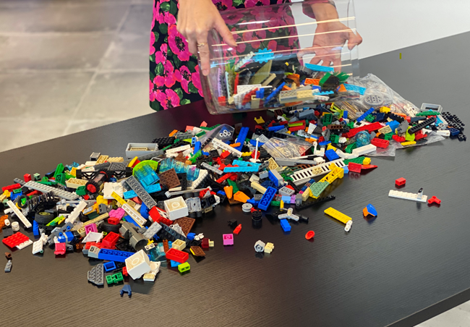 | Bricks are scattered randomly to encourage participants to pick up and play with the blocks at any time, and to signal an unstructured approach to building.
Step 2 | SR introduces herself by building a model using metaphor | 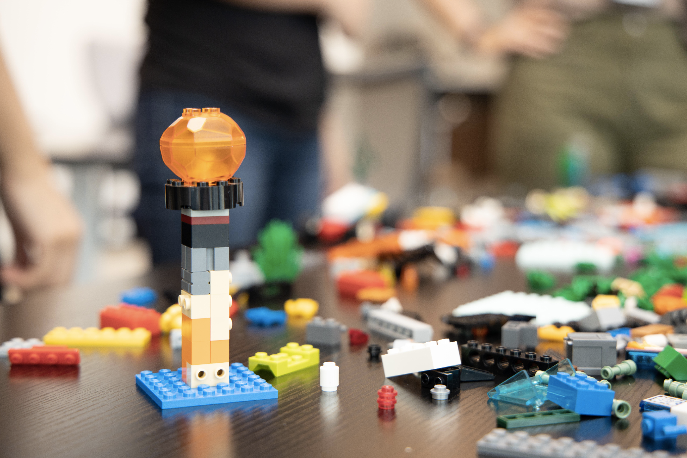 | SR demonstrates LSP for the first question to introduce participants to the process. This helps to break the ice, reduce barriers and make participants feel comfortable.
Step 3 | SR invites interviewee to build a model | 'Using the Lego Blocks in front of you, construct a model that tells me about yourself…' | Open ended question is used to invite open, participant-led responses
Step 4 | Participant introduces self | 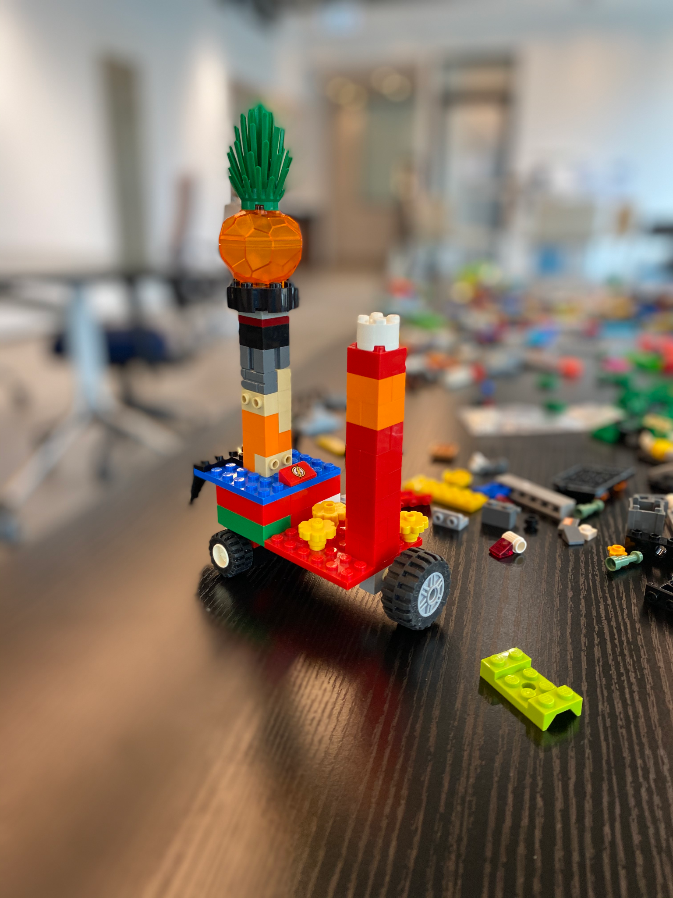 | Model explanation  Plant = ‘open to new ideas’  Wheels = ‘likes freedom to choose what they want to do’  Red Tower = ‘has a strong, ambitious side’

Figure 3: Data Sheet Extract
Lego Model | Label | Name | Written transcript | Notes
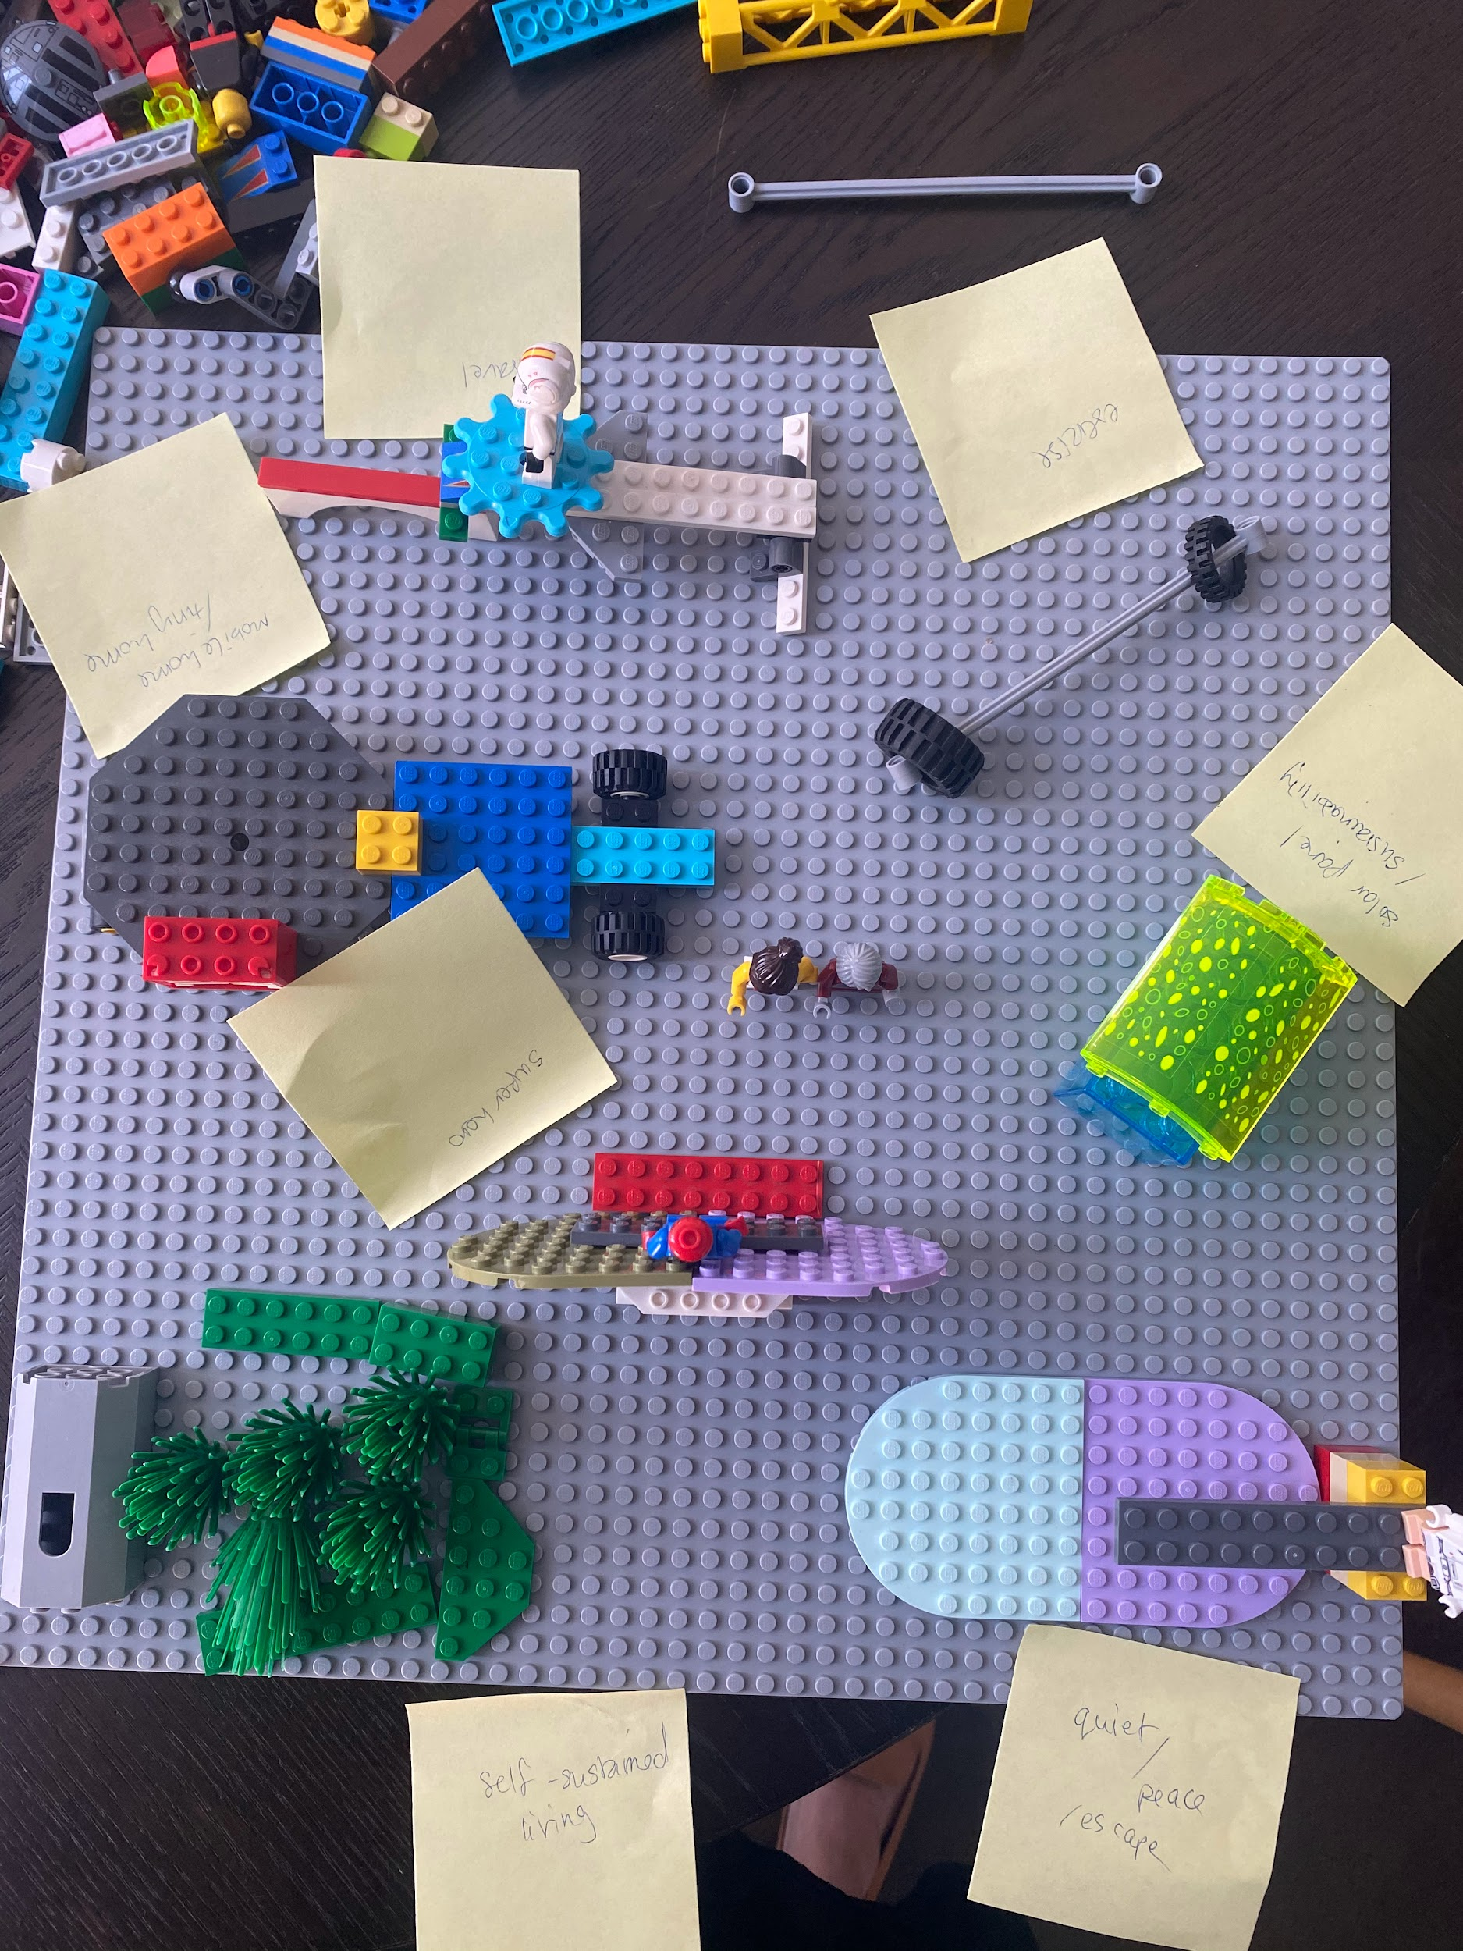 | Tiny Home | Oliver | But this symbolizes my desire of having a place of my own. So I'm so into the tiny house movement in foreign countries which I think will stop Hong Kong's different issues. But I love the fact that it gives you financial or geographical freedom to live wherever you want. So this symbolizes a place on my own. So on my own terms, the design wise, where I want to go, where I want to stay, what life I want to live. So I mean, the freedom of choosing the way you live makes me happy. Yeah, because the current situation is that I was feeling stuck. Because of the rental because of the price. Because of the geographical location. I live in my parent home.. So it's very less privacy, so to speak. So I mean, it can be really literal, but like, a trailer home would be my ideal life, of future living. So this is one thing.  Tiny house concept - I watch a lot.  It’s so fascinating, it embodies the possibilities you have in your life. You can choose to pay your mortgage for 30 years or you just build your own home and take it anywhere with you. The sense of freedom is the main part that got me so obsessed with the concept of mobile home. | Very animated when talking about tiny home movement

Figure 4: Data Coding Example
Label | Name | Transcript extracts | Semantic Codes | Latent Codes | Notes

Beach | Charles | It’s a secluded beach. I think privacy and being secluded from people. Should’ve built a wall…  Interviewer: So you say secluded. Is it just you on this beach?  I meditate quite often. For the purposes of my meditation, being by myself is quite helpful. But when you ask if that is my happiest place, no I’d probably want some friends there too. I don’t want to be hanging out there for the full day by myself. | Beach  Privacy  Seclusion  Friends  Wall  Meditation  People | Balance seems important to him as he values alone time and introspection but he also feels happy when he’s with his friends. | Charles talks about seclusion and being alone first, building a sparse beach with relatively little on it. The mention of the wall sends a strong message about wanting to keep people out.  However, Charles adds Lego people to the board after some reflection prompted by my question. This suggests that on reflection he values company.

Figure 5 – Motion and Oliver’s self-expression
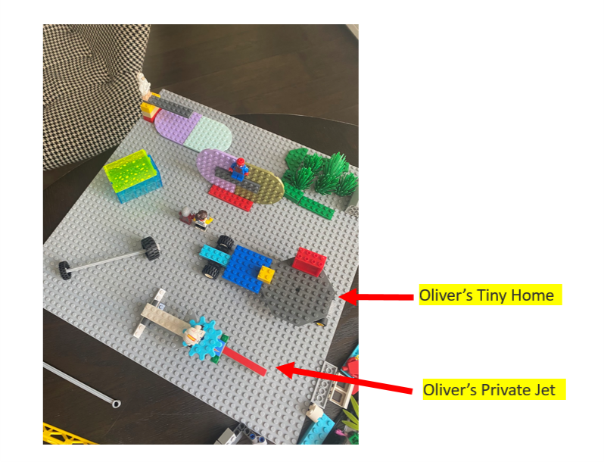

Figure 6 – Tracy’s use of block height as metaphor

