The Jury in Japan 1928 – 1943 and its legacy.



[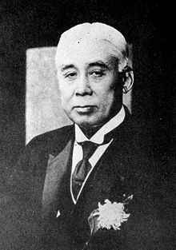](https://en.wikipedia.org/wiki/File:Takashi_Hara_posing.jpg)

[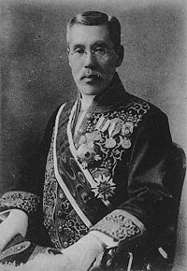](https://en.wikipedia.org/wiki/File:Hiranuma_Kiichiro.jpg)

[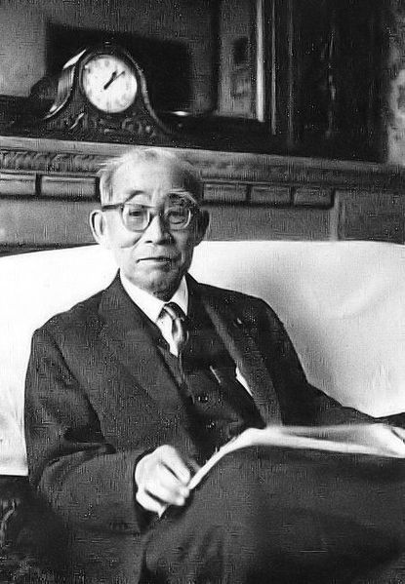](https://upload.wikimedia.org/wikipedia/commons/f/f9/Ichiro_Kiyose.jpg)

Illustrations, top to bottom:

Photograph of Yokohama Jury Courtroom.

Sketch of a Jury Courtroom in Tokyo.

Hara, Takashi, Prime Minister of Japan, 1918-21.

Hiranuma, Kiichiro, prominent right wing politician, Prime Minister of Japan 1939, dropped robust opposition to jury system in 1918 and became a supporter of it. Minister of Justice, September 1923 – January, 1924.

Kiyose, Ichiro, leading member of the bar and a supporter and drafter of the Jury Bill.

Below: The Jury Handbook 1931, published by the Japan Jury Association.

Members of TOKKO.

Professor Minobe before the Diet in 1935, defending his interpretative theory of the Meiji Constitution.



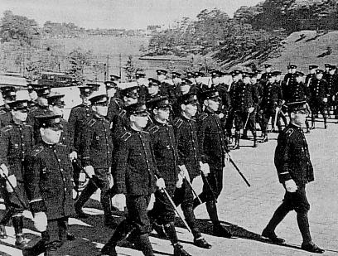[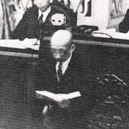](https://en.wikipedia.org/wiki/File:Tatsukichi_Minobe_at_the_Chaimber.jpg)

Chronology.

**1840s – 1850s: A Chinese translation of “Brief account of the United States of America”, by Elijah Coleman Bridgman, written in 1838, reached Japan.**

1853: Arrival of Admiral Perry and his “black ships” from the United States.

1868: Meiji Restoration.

**1873: Iwakura Embassy (1871-1873) observed a jury trial in Paris in 1873. Cautionary comments of Kunitake Kume about difficulties of adopting juries in Japan – “square block of wood into a round hole”.**

**1873 : Makimura incident. Ministry of Justice discussed possibility of a Western style jury to try that case, but rejected by Great Council of State but who introduced the bureaucratic jury ( the *sanza* system)– government officials appointed by Council to decide guilt. Judge to sentence. Verdict of guilty.**

**1875 : Hirosawa assassination case. Bureaucratic jury used, but modified rules to include assessing quality of pretrial investigations and commenting on actions of court. Defendants found not guilty. New suspect arrested in 1877, not tried by a bureaucratic judge but by twelve judges under new rules. Verdict of not guilty returned.**

**1878: Gustave Boissionade’s proposal to introduce jury trial in district courts , courts of appeal and High Court in draft Code of Criminal Instruction of 1878. Three judges and ten jurors selected by lot from list of those eligible. Prosecution and defendant given right to challenge individual jurors. Jurors required to hear case and answer questions set by judges. Plan approved by the *Genrooin* , a lower legislative body, but rejected by Great Council of State, because it did not guarantee only persons who were sufficiently educated and financially stable would serve as jurors – important as jury could not be influenced by the judge- and also not all European countries used juries they were not vital to Japan’s modernization.**

**1880: Code of Criminal Instruction and Penal Code introduced.**

**1890: Meiji Constitution came into effect. Jury trial not included. Boissonade’s advice to include it was rejected and vetoed by Prince Ito.**

**1900: Document, written by Siroo Isobe and Taizoo Miyoshi ,describing juries abroad , submitted to the Councillors of the Japan Federation of Bar Associations (“JFBA”)who adopted their proposal that a jury system be established in Japan.**

**1909: JFBA General Meeting approved idea of setting up juries and JFBA members who were members of the House of Representatives began to build political support.**

**1910: Friends of the Constitutional Government Party put a proposal before the House of Representatives to adopt a jury system, which it said would enhance judicial independence and strengthen the impartiality of justice.**

1912: Death of Emperor Meiji : a real turning point in modern Japanese history. By his end of his reign, Japan witnessed a new phase in politics: political parties became more coherent and focused on issues rather than simply clubs for parliamentarians. Popular opinion had turned against the militarization of the state and towards genuine parliamentary democracy.

Beginning of reign of Emperor Taisho, and of “Taisho democracy”.

1918 : Commencement of Takashi Hara’s Cabinet, based on party government.

**1920 : Drafting of a Jury Bill commenced.**

**1923: After several revisions the Bill was finally passed by the House of Peers.**

Economic collapse, following wartime bubble and natural catastrophe with Great Kanto earthquake.

By end of Taisho period (1926) economy was in depression .

Zaibatsu conglomerates beginning to take over the economy as private banks failed and were cultivating ever-closer connections with political parties and military. Wealth being concentrated in fewer hands . Urban population struggling to maintain their way of life and rural unrest.

1925: Peace Preservation Act, penalizing those wishing to alter the Constitution or deny private property.

1926: Death of Emperor Taisho and start of reign of Emperor Showa.

**1928: Following a period of preparation the Jury Act 1923 was put into force. The first jury trial took place, that of Mr Kameji Fujioka for attempted murder of his mistress, on October 23rd, 1928 in Oita Prefecture.**

**1929: Jury Act amended to exclude trial by jury for cases involving violation of the Peace Preservation Act 1925.**

**The number of cases of cases tried by jury was as follows:**

**1928 - 31; 1929 -143; 1930 - 66; 1931 - 60; 1932 - 55; 1933 - 36; 1934 - 26;**

**1935 - 18 ; 1936 - 19; 1937 - 15; 1938 - 4 ; 1939 - 4 ; 1940 - 4 ; 1941 - 1 ; 1942 – 2.**

1929: Collapse of New York Stock Market in 1929. Yen taken of the gold standard and slumped by 50% against the dollar. Unemployment rose to over 20 percent. Depression which followed persisted until the mid-1930s ; wrecked the country’s foreign markets and prevented villagers augmenting rice income with that of silk, then a principal export. Society became increasingly polarised and riven with class conflict.

1930: Murder of Prime Minister Hamaguchi Osachi by an ultra nationalist group in 1930.

1931:Two coups d’ etat were foiled.

1932 : Imperial Kwantung Army attacked the Manchurian railway in 1932, blamed it on local Chinese forces and used as a pretext to occupy Manchuria. Prime Minister Inukai assassinated when refused to condone the military’s actions. Puppet state of Manchukuo formed . Fifteen Years’ War between China and Japan opened.

Army announced it would no longer accept cabinet party government which was replaced by “national unity” cabinets. Effectively, the remains of fledgling democracy in Japan were removed by 1932. Much of decision making carried out by discussion between military factions, leaders of which had direct access to the Emperor.

1936: “February 26th incident”, a serious and bloody insurrection led by the “Imperial Way” army faction intent on introducing direct rule by the Emperor - a Showa Restoration. Following its crushing, the more cautious “Control faction”, which had less sweeping plans for internal reform but shared many of the Imperial Way’s foreign policy objectives, held sway in government.

1937: Marco Polo Bridge incident. Exchange of fire with Chinese soldiers at the Marco Polo Bridge, near Beijing, was swiftly followed by Japanese invasion of China.

Foreign policy and domestic politics geared more and more towards preparation for total war, and a five-year plan to co-ordinate main industries was introduced.

1938: National mobilisation. Military spending consumed 75 percent of the national budget.

1940 : Tripartite Pact signed with Germany and Italy in 1940 followed by Japanese occupation of French Indo China. America embargoed oil until Japan retreated from China. All political parties consolidated into one – the Imperial Rule Assistance Association – and all trade unions into the Patriotic Industrial Service Federation.

1941: Japanese attack on Pearl Harbor , then Malay Peninsula and Singapore, the Philippines and Dutch East Indies.

1942: The Great East Asia Ministry was established to administer the “co-prosperity sphere”.

**1943: Jury Act suspended.**

1945: Surrender of the Empire of Japan, 15th August.

**Initially the Government Section of the Supreme Commander of the Allied Powers (“SCAP”) did not favour re-introduction of the jury, but by end of the year jury trial for capital offences and felonies, at the defendant’s request, was added to a draft of the Constitution. However it was deleted from the 1946 draft Constitution.**

**1947: Possibility of a jury system was discussed by occupation lawyers and the Japanese government who opposed re-introduction. Compromise reached - Court Organisation Law contained Article “ the provisions of this law shall in no way prevent the establishment by other statutes of a jury system for criminal cases”.**

3rd May, Constitution of Japan came into effect.

**1952: End of Allied occupation of mainland Japan: Okinawa remained under United States until 1972. United States Civil Administration of the Ryukyu Islands (“USCAR”) established courts with jurisdiction of cases involving Americans.**

**1963: USCAR introduces grand and petit criminal juries and civil juries in 1964.**

**2001: Judicial Reform Council Final Report recommended introduction of “mixed courts”, lay people chosen randomly sitting in a panel with professional judges -“*saiban-in*” courts.**

**2004 : Saiban-in Act.**

**2009: After a five year period of preparation for the new system, *saiban-in* courts started to hear cases.**

[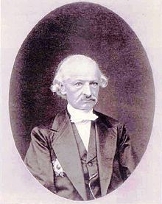](https://en.wikipedia.org/wiki/File:Boissonade.jpg)



Illustrations:

Gustave Boissonade.

A saiban-in, mixed professional and lay judge, court.