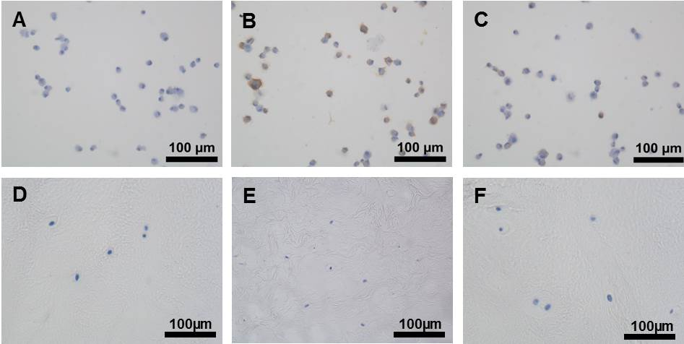Supplementary Fig 1. Immunohistochemistry of cytospun monolayer MSCs at time point zero, prior to hydrogel incorporation for aggrecan (A), Chondroitin Sulphate (B) and collagen type II (C). Immunohistochemistry IgG negative controls of NP tissue explants for aggrecan (D), chondroitin sulphate (B) and collagen type II (F). Scale bar 100µm.

