Origin of friction in running-in sliding wear of nitride coatings

Q. Luo

Materials and Engineering Research Institute, Sheffield Hallam University, Howard Street, Sheffield, S1 1WB, UK

Abstract: To investigate the origin of running-in friction in unlubricated sliding wear, a magnetron sputtered multilayer coating TiAlN/VN was tested on a ball-on-disk tribometer for a series of sliding durations from 10 to 1,000 cycles, followed by careful observation of the obtained worn surfaces using an field-emission-gun scanning electron microscope. Three steps of friction variation were found: (1) prior to wear particle generation, low initial friction coefficient was around 0.2 – 0.25 purely attributed to the asperity contact; (2) then it increased steeply to a range of 0.4 – 0.5 in the first 100 cycles following the generation, breaking and agglomeration of wear particles, and in particular the scaling-up of fish-scale-like tribofilm; (3) eventually it approached to a steady-state value around 0.5 when the friction was governed by the viscous shearing of the tribofilm. It is concluded that, under unlubricated sliding wear, the friction behaviour of transition metal nitride hard coating is dominated by the viscous shearing of tribofilm adhesively bonding to the parent nitride coating.

Key words:

Friction; Wear mechanisms; Hard coatings; High resolution SEM; Sliding wear

1. Introduction

Running-in is the starting period of sliding wear before the formation of a conformal sliding contact. For hard coatings, a running-in period is often observed in which the coefficient of friction varies from its initial value (e.g µ₀ = 0.1 – 0.2) to a relatively stable value (e.g. µ = 0.6 – 0.9). The transition of friction behaviour from the running-in period to the steady-state sliding is still not understood. In our previous research, the steady-state friction of transition metal nitride coatings has been found to be related to the formation of a tribofilm [1-3]. Meanwhile, tribofilms were found on the sliding surfaces of many other materials [4-7]. These studies, however, referred mostly to the steady-state tribological processes of the tested materials. Fundamental studies that attempt to interpret the details of running-in friction are relatively rare. For the running-in period, research has been conducted to investigate the generation of wear particles of various materials, as well as the subsequent fragmentation, adhesive agglomeration, and tribo-chemical reactions [4-13]. For example, the wear particle generation and agglomeration in the sliding wear of ceramics were observed by using an in-situ scanning electron microscopy (SEM) [4]. More recently, a method of high resolution worn surface characterization has been reported in the study of nano-scale tribofilm formation in lubricated sliding wear of zinc phosphate [11].
This paper studies the relationship between the origin of friction and the wear mechanisms occurring in the running-in sliding tests of transition metal nitride hard coatings which are highly demanded in various industrial applications, such as for machining tools. This work has been based on the latest development of field emission gun scanning electron microscope (FEG-SEM). The high spatial resolution of FEG-SEM enables imaging of extremely fine features from sub-micro to nano-scales. In the designed experiments, a multilayer coating TiAlN/VN grown by the combined cathodic arc etching and unbalanced magnetron sputter deposition was investigated for its friction kinetics through a series of running-in sliding tests using a ball-on-disk tribometer, followed by comprehensive examination of the worn surfaces using the analytical FEG-SEM instruments. The TiAlN/VN coating exhibited similar friction and wear behaviours as compared to other nitrides such as TiN, TiAlN, and TiAlCrYN, except for its lower friction coefficient and lower wear rate [1, 14 – 15]. It is expected that, the reported work would provide deeper understanding on the origin of friction of transition metal nitride coatings, and thereafter support the synthesis of novel coating materials possessing combined properties of low friction coefficient and high wear resistance.

2. Experimental

The material employed in the study was a nano-structured multilayer coating TiAlN/VN, consisting of alternating TiAlN and VN sub-layers having bi-layer thickness of 3.2 nm. The coating was deposited on the pre-hardened and polished coupon surfaces of tool steel BM2 (compositions C 0.83, Si 0.4, Mn 0.4, W6.4, Mo 5.0, Cr 4.1, V 1.9 in wt%, hardness HV 7.9 GPa) using a industrial sized four-cathode coating unit (Hauzer ABS 1000-4). Details of the deposition, structural characterization, and mechanical and tribological properties of the TiAlN/VN coatings can be found in previous publications [1, 14-17]. In brief, the deposition process included substrate surface etching with vanadium ions generated by cathodic glow discharge of the vanadium cathode, followed by reactive unbalanced magnetron sputter deposition of the nitride coating at a substrate bias voltage of -75V. The cathodic ion etching can significantly improve the coating adhesion, which however emits metal droplets onto the etched substrate surface. Therefore, the TiAlN/VN coating growing on the droplets forms large columnar grains protruding on the surface, often being termed as droplet induced growth defects [18]. Meanwhile, the low substrate bias voltage applied in the sputter deposition can significantly lower the residual stress in the coating while maintaining good packing density in the columnar structure. The surface of such TiAlN/VN coatings exhibits nano-scale cellular-like topographic profile [16]. Figure 1 shows typical high-resolution SEM images of the obtained coating surface. Note that the as-deposited coating surface exhibits both nano-scale cellular-like morphology and micro-scale protruding of large grains of growth defects.

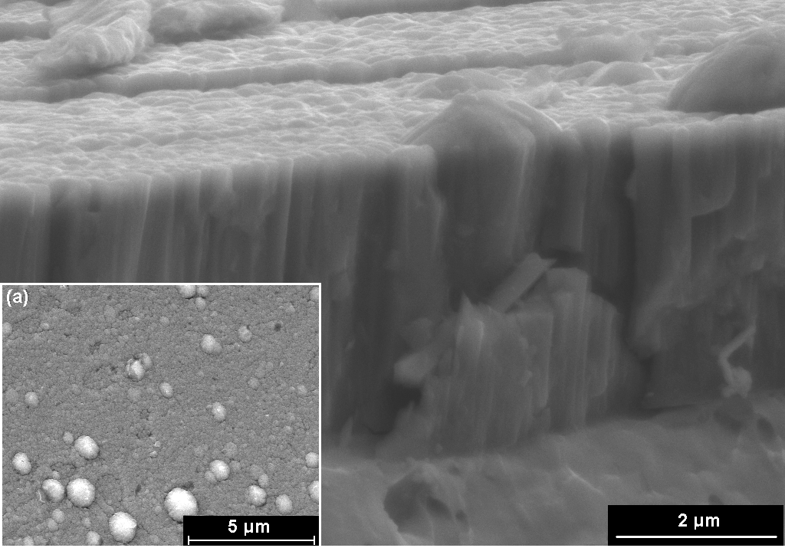
Figure 1 High resolution SEM observation of a sputtered coating at an inclined angle to show both the surface morphology and column growth. Note especially the large defect grains protruding upon the nanoscale roughness of the coating surface. The insert (a) shows overall distribution of the grow defect grains at lower magnification.

Table 1 Parameters of tribotests.
 | Sliding duration | Sliding speed | Rotation speed | Wear track radius
 | [cycles] | [m⋅s⁻¹] | [rpm] | [mm]
Counterface Ball: 6-mm dia. Alumina; data log-in frequency: 5 Hz
Test 1 | 10 | 0.10 | 127 | 7.5
Test 2 | 10 | 0.05 | 60 | 8.0
Test 3 | 20 | 0.10 | 136 | 7.0
Test 4 | 100 | 0.10 | 147 | 6.5
Test 5 | 500 | 0.10 | 159 | 6.0
Test 6 | 1,000 | 0.10 | 112 | 8.5
Counterface Ball: 6-mm dia. WC-Co; data log-in frequency: 10 Hz
Test 7 | 10 | 0.05 | 53 | 9.0
Test 8 | 20 | 0.05 | 56 | 8.5
Test 9 | 100 | 0.05 | 60 | 8.0
Test 10 | 1,000 | 0.05 | 64 | 7.5
Note: applied normal load 5N.
Unlubricated sliding tests were performed on a ball-on-disk tribometer (RT tribometer, CSM Instruments SA, Swizerland) by using the TiAlN/VN coated disk samples and two types of counterpart balls, i.e. alumina and cemented WC balls. The disk and ball samples were sized 30 mm and 6 mm in diameter respectively. The test conditions were: applied load 5 N, linear sliding speed 0.1 or 0.05 m⋅s⁻¹, room temperature 20 – 30 ⁰C and relative humidity 30 – 40 %. A series of sliding rotation cycles, from 10, 20, 100, 500 to 1,000 cycles, were planned for different wear tracks in order to examine the progressive evolution of worn surface as a function of testing duration. The tribotest parameters are provided in Table 1. Before each test, both the disk and ball samples were cleaned with acetone and dried in air. Then in the test, the tangential force applied on the ball sample, as a measurement of the coefficient of friction, was continuously acquired to the computer at a preset frequency of 5 or 10 Hz. Then the data of friction were processed using MS-Excel to study the variation of friction coefficient with increasing sliding duration.
To observe the obtained worn surfaces of the tested coating samples as well as those on the counterpart balls, two FEG-SEM instruments, Philips XL-30 and FEI Nova200, were employed. Being operated under high vacuum mode at 15 – 30 KV, the instruments can reach a high spatial resolution capability of 1.5 – 2.0 nm. In areas of interest, chemical analysis was also performed using the attached energy dispersive X-ray spectroscopy (EDX), to trace the progressive chemical changes on the worn surfaces.
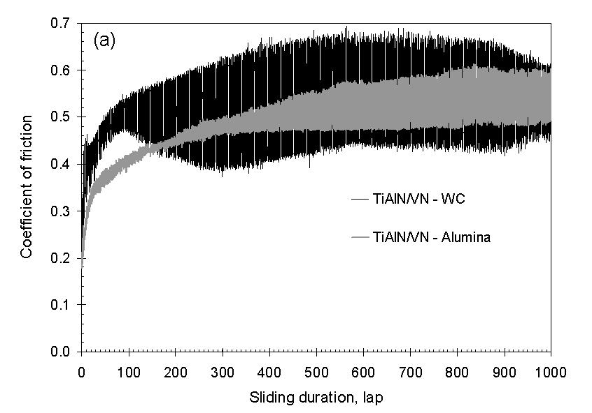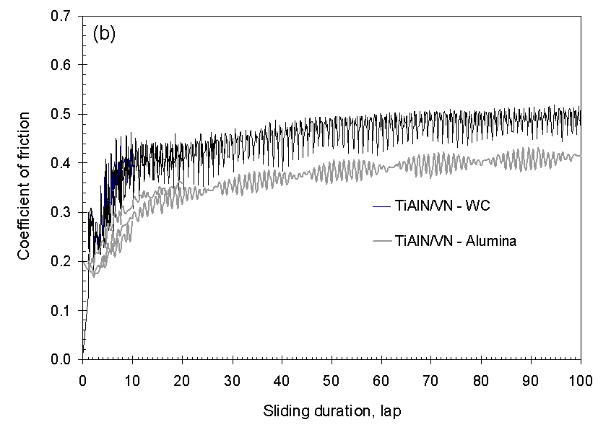
(a) (b)
Figure 2 Friction curves of the ball-on-disk sliding tests, acquired at frequency of 5 Hz for the alumina-TiAlN/VN contacting and 10 Hz for the WC/Co-TiAlN/VN contacting. (a) Friction curves for the test duration of 1,000 cycles; (b) friction curves for the test durations of 10, 20 and 100 cycles.

3. Results

3.1 The friction behaviour

Figure 2 shows the obtained friction coefficient curves in two charts: (a) the overall curves for the entire sliding duration of 1,000 cycles and (b) the starting period (the 0 – 100th cycles) for better resolution. In the statistic analysis, each friction curve was divided into small intervals and, in each interval, linear regression analysis was applied to obtain the slope reflecting the linear variation of friction coefficient as a function of increasing sliding cycles. The results, including the slope and average values of the friction coefficient, are listed in Table 2. The initial friction coefficients, i.e. those values acquired at the first cycle, were 0.20 ± 0.02 for the TiAlN/VN-alumina tests and 0.25 ± 0.05 for the TiAlN/VN – WC/Co tests. Then the values dropped by approximately 0.01 – 0.02 in the first 1 – 3 cycles and then increased continuously in the rest sliding period. The maximum increase of friction coefficient took place in the starting period, e.g. slope = 1.2 × 10⁻² in the first 10 cycles. Then with increasing sliding time the value of friction coefficient becomes higher and the linear slope becomes lower, i.e. less variable by approaching to a steady-state value. Eventually in the period 800 – 1,000 cycles, the mean value of friction coefficient was 0.56, only higher by 0.02 than the mean value in period of 500 – 800 cycles, and the slope of friction curve is only 1.4 × 10⁻⁷. This trend of variation exists in all the obtained friction curves regardless of the counterpart materials.

Table 2 Statistic analysis of friction coefficient curves in the ball-on-disk sliding tests
Partition period | Slope |  | Mean value
 | alumina | WC/Co | alumina | WC/Co
 | - | - | 0.20 | 0.25
< 10 cycles | 1.2×10⁻² | 2.0×10⁻² | 0.24 | 0.22
10 – 20 cycles | 4.3×10⁻³ | 1.6×10⁻³ | 0.31 | 0.39
20 – 100 cycles | 9.7×10⁻⁴ | 8.8×10⁻⁴ | 0.39 | 0.42
100 – 200 cycles | 3.2×10⁻⁴ | 4.0×10⁻⁵ | 0.43 | 0.50
200 – 300 cycles | 2.1×10⁻⁴ | 6.7×10⁻⁵ | 0.49 | 0.49
300 – 500 cycles | 1.1×10⁻⁴ | 1.0×10⁻⁴ | 0.53 | 0.48
500 – 800 cycles | 8.1×10⁻⁵ | 5.3×10⁻⁶ | 0.54 | 0.52
800 – 1,000 cycles | 1.4×10⁻⁷ | 3.7×10⁻⁵ | 0.56 | 0.50

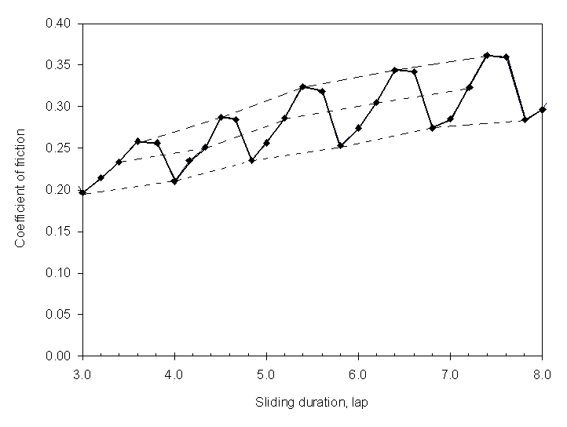
Figure 3 Demonstration of data fluctuation in the friction coefficient curves with respect to the different sliding contact area or conditions: TiAlN/VN-alumina contact, sliding speed 0.05 m⋅s⁻¹ and 60 rpm, the period between the 3rd and 8th cycle.

In addition to the increase of friction coefficient with increasing sliding duration, data fluctuation exists in each obtained curve in Figure 2. The fluctuation was mainly attributed to the variation of data-loging locations with respect to the circumference of wear track. The relationship between the data fluctuation and the data-logging locations is explained in Figure 3. In Figure 3, a portion of friction curve recorded in Test 2 (Table 2) exhibits periodical variation of the friction coefficient in each sliding cycle. In this test, the disk rotation speed was 59.58 rpm or approximately one cycle per second. Therefore, given the applied data logging frequency of 5 Hz, there were five equally distributed contact points in the wear track circle at which the coefficients of friction were recorded. Two types of data variation can be seen in Figure 3: (1) dramatic fluctuation of the friction coefficient with respect to the variation of contact regions in each rotation cycle; and (2) continuous increase of friction coefficient existing in each of the five contact regions. The latter is shown by the dashed lines linking the data points of the 1st, 3rd and 4th contacts respectively. Similar periodic variations of friction coefficient have been observed in other cases. These data suggest that, the variation of friction coefficient was related to the variation of sliding contact situations, firstly due to the variation of data logging locations and secondly as a result of worn surface evolution in each individual contact region. The variation of worn surface characteristics with respect to these two factors has been analysed in details by nano-SEM observations.

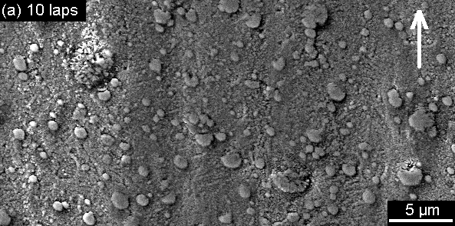
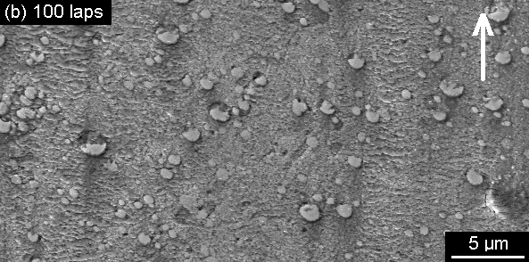
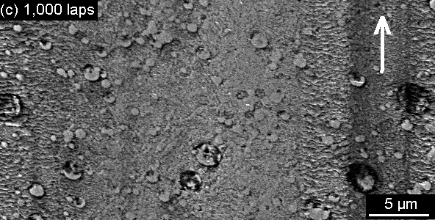
Figure 4 Low-magnification SEM images of the worn surfaces of the TiAlN/VN coating samples after various sliding durations, from 10 to 1,000 cycles, against an alumina ball. The arrow in each image indicates the counterpart sliding direction.

3.2 Worn surface observations

Figure 4 shows low magnification micrographs of the worn surfaces after 10, 100 and 1,000 cycles of sliding against an alumina ball. Progressive changes of worn surface morphology with increasing sliding duration include smoothening of the rough coating surface, breaking and spalling wear of large protruding grains (i.e. the growth defects induced by metal droplet generation during the arc ion-etching stage), and ‘fish-scale-like’ bands distributing along the sliding direction.

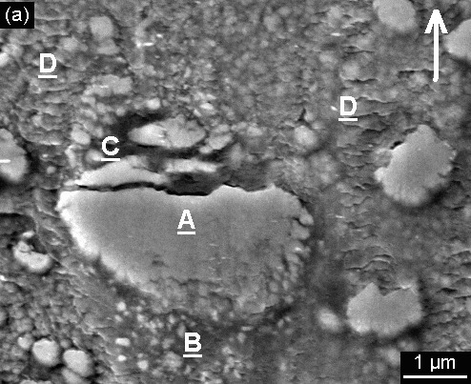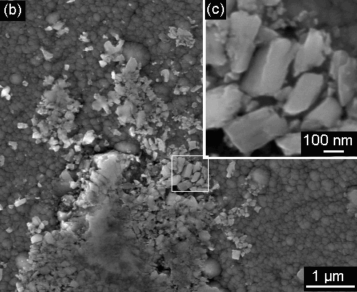

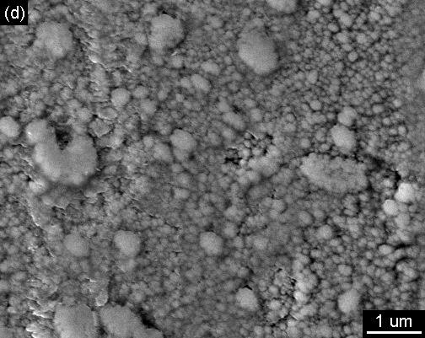

Figure 5 High-magnification SEM images of typical wear features on the TiAlN/VN surfaces after 10 or 20 cycles of sliding wear. (a) Breaking and spalling of a large defect grain, initial sliding/rolling traces, and agglomerates of fine wear debris; (b) wear debris accumulated at the wear track edge with an inserted enlarged micrograph in (c) showing the size of initial wear particles; and (d) attachment of a thin semi-electron-transparent film on the rough coating surface.

After 10 or 20 cycles of sliding, the main wear features observed include localised breaking and spalling wear, short scratches, and attachments of surface absorbent films, Figure 5. Spalling wear took place in the large-size droplet defect grains as a result of localized load concentration, i.e. the contribution of asperity contact. Details of one such defect grain undergoing spalling wear are shown in Figure 5a. The region labbeled ‘A’ is the top of the grain. The region ‘B’ shows the agglomeration of fine wear debris generated from both the coating and the alumina counterface as the protruding grain sliding against the counterface. Region ‘C’ shows breaking of the grain into small fragments. Obviously these fragments were the original generation of wear particles. Some of the generated wear particles were found to accumulate along the wear track edges, as shown in Figure 5b-5c. The size of the wear particles ranged from 20 to 400 nm approximately. EDX analysis showed that these agglomerates exhibited marginal presence of carbon and oxygen whereas the overall chemical composition was almost identical to the fresh TiAlN/VN coating. A few fish-scale-like traces were observed on the worn surfaces, seeing the ‘D’-labelled regions in Figure 5a and the left-hand side in Figure 5d. The features consist of irregular-shaped edges, being parallel to and separated from each other, and packed along the sliding direction. These traces should have been the attached fine fragments of wear particles following their rolling/sliding motion over the rough coating surface. In addition, some regions of the worn surfaces were covered with a film which was semi-transparency in the secondary electron imaging, Figure 5d. The film showed an EDX spectrum containing low intensities of Ka-C and Ka-O accompanying high intensity of Ka-N. These phenomena suggest that the film might be accumulation of hydro-oxygen-carbon based surface absorbents. The absorbent film appeared only on the 10-cycle and 20-cycle worn surfaces and disappeared completely in the rest having undergone longer sliding periods.

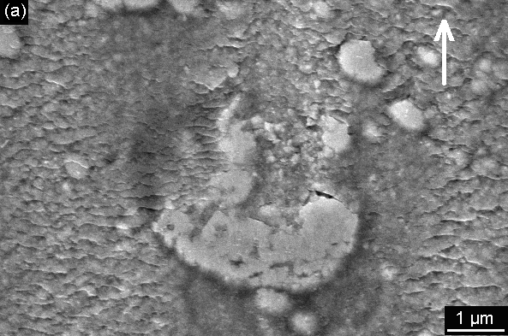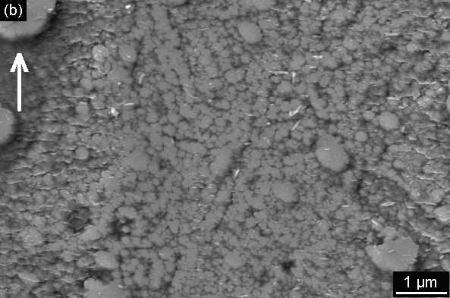
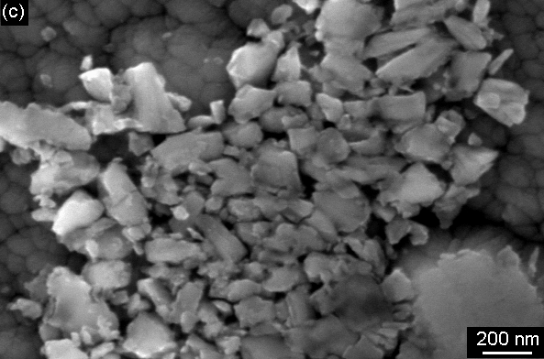

Figure 6 High-magnification SEM images of typical wear features on the TiAlN/VN surfaces after 100 cycles of sliding wear. (a) Spalling wear of a defect grain and fish-scale-like attachments in surrounding area; (b) worn surface smoothening, fish-scales and nanoscale rod-like fragments; and (c) wear debris agglomerates accumulated along the worn surface edge.

The worn surface after 100 cycles of sliding wear, as shown in Figure 6, contained wear features of increased severity, including localised breaking and spalling in droplet-defect grains (Figure 6a), smoothening of the normal coating surface (Figure 6b), and fish-scale-like wear attachments, as well as more quantity of wear debris attached along the wear track. Figure 6 (a) shows spalling wear of a growth defect grain. The fish-scale-like wear features surrounding the worn grain are similar to, but more significant than, those shown in Figure 5a. Fish-scales of wear debris attachments were observed even in smooth worn surface regions, Figure 6b. Interestingly, some of the fish-scales showed broken edges generating rod-like nano-particles dispersing over the worn surface. The wear particles agglomerated along the wear track edges, Figure 6c, were found to be smaller and in more uniform size, e.g. ranging from 10 to 200 nm as compared to those observed along the 10-cycle and 20-cycle wear tracks. This suggests progressive powdering of the wear particles as they were trapped in the sliding contact.

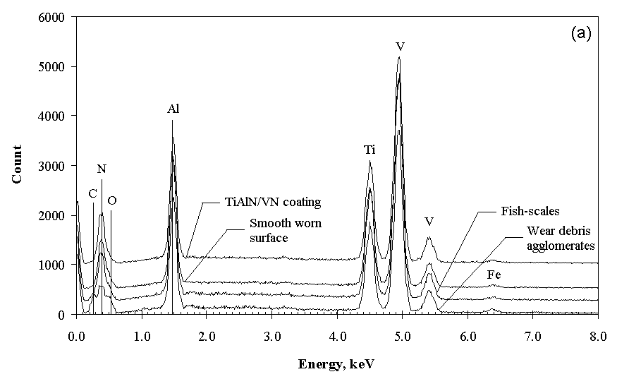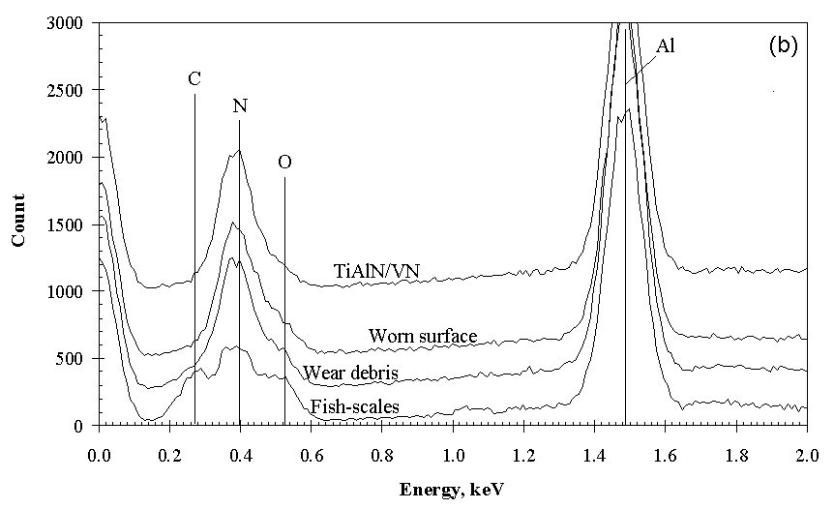

Figure 7 Examples of EDX spectra acquired in typical wear features of the wear tracks after 10-100 cycles of sliding wear against an alumina ball: (a) full energy-range spectra and (b) enlarged low-energy-range spectra.

Typical EDX spectra acquired in the wear debris, fish-scales, smooth worn surfaces as well as the fresh TiAlN/VN coating surface are shown in Figure 7. The EDX analysis showed that, both the fish-scale-like products and the wear debris contained remarkable oxygen in addition to nitrogen whereas the smooth worn surface exhibited identical compositions to the as-deposited coating, indicative of progressive tribo-oxidation of the entrapped wear debris accompanying the powdering. In addition, some of the wear debris attached on the wear track edges contained carbon and oxygen, which could be explained by the attached surface absorbents as described previously.
The worn surfaces after 500 or 1,000 cycles of sliding wear showed further flattening in the surface asperities and the wide bands of fish scales of the wear product attachments, Figure 4c. Detailed morphology of typical wear features are shown in the high-resolution SEM images in Figure 8. The attached wear debris scales are packed being parallel to each other and along the sliding direction. Fish scale patterns, being approximately 1 μm in length or less, were found in both the rough and smooth regions of the worn surfaces (Figure 8 a-c). The adhesion of the attachments to the parent surface was strong that they could not be removed either by acetone-ultrasonic cleaning or by wiping using soft cotton. Along with the fish-scale like features, extremely fine particles distributed over the worn surfaces. EDX spectrum showed that these scales contained substantial amount of oxygen in addition to nitrogen, indicating the occurrence of tribo-oxidation, Figure 9. These characteristics suggest that, the formation of these fish scales was attributed to several factors including powdering, strong adhesive bonding to the parent nitride surface, and tribo-oxidation.
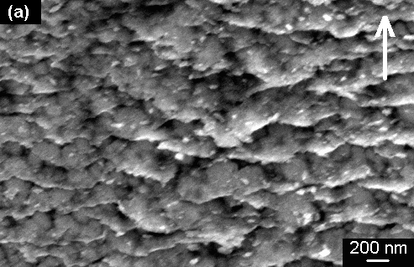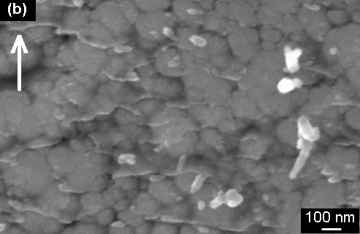
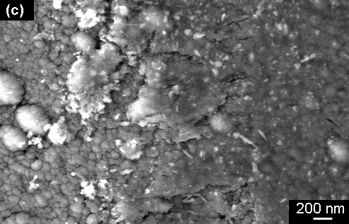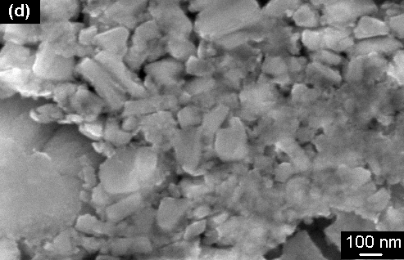

Figure 8 High-magnification SEM images of typical wear features on the TiAlN/VN surfaces after 500 – 1,000 cycles of sliding wear. (a-c) Fish scales on rough and smoothened regions; (d-f) wear particle agglomerates along the wear track edges.

In addition to the severe fish-scale-like features in the rough worn surface regions, the smooth regions of the worn surfaces showed continued flattening of the protruding tops of growth defect grains and the arch-like columnar grains, Figures 8 b-c. The wear debris agglomerating along the wear track edges was further broken into smaller sizes as compared to those shown in previous figures, Figures 8 d-f. In some regions, the size of the wear debris was beyond the resolution limit of the FEG-SEM, indicating continuous powdering with increasing sliding. EDX analysis showed that the wear debris also contained substantial amount of oxygen along with nitrogen, similar to the fish scales, Figure 9.

SEM observations were also undertaken on the counterpart balls to characterize the corresponding wear features accompanying the progression of the sliding wear. Typical worn surface images are shown in Figure 10. After 10 cycles of sliding contact, the worn surface of the ball showed only scratches and preferential wear of the cobalt binder, which are typically features of the mechanical or abrasive wear of the WC/Co composite, Figure 10 (a). Then on the worn surface of 20 cycles of sliding wear, the abrasive wear features became more severe, Figure 10 (b). Importantly, there was no attached wear debris attachment within the worn surfaces or in their nearby regions. This was generally consistent to the SEM observations of the wear tracks, Figure 4 (a). In Figure 10 (c – d), one can see that increasing amount of wear debris attachment was accumulated in front of the sliding worn surface, whereas the worn surfaces of the ball became more and more smoothened. These observations suggest that fine wear debris also attached on the worn surfaces of the counterpart.

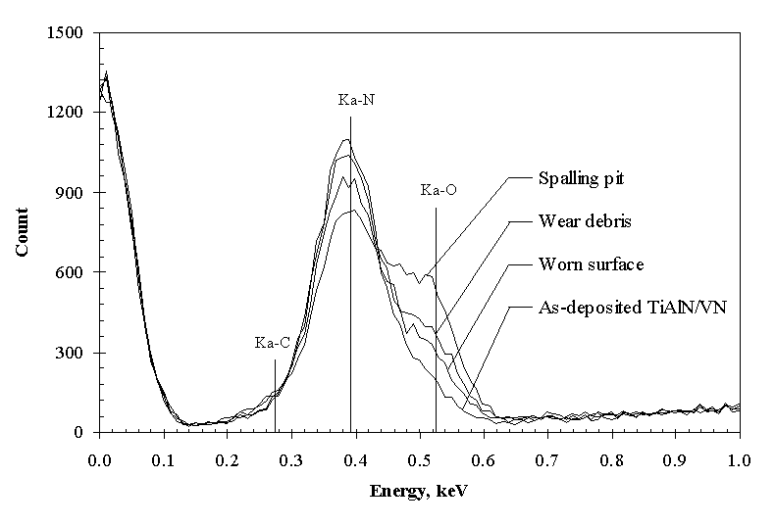
Figure 9 Low-energy range of the EDX spectra acquired in typical wear features of the wear tracks after 500-1,000 cycles of sliding wear against an alumina ball. Note that pronounced oxygen was found in the wear debris accumulated in different regions of the worn surfaces including (from upper to lower) the debris insider the spalling pits, agglomerates along the wear track edge, and fish-scales attached on the worn surface.

Figure 10 SEM observation of the worn surfaces of the counterpart WC/Co balls having experienced different lengths of sliding wear: (a) 10 cycles; (b) 20 cycles; (c) 100 cycles;
and (d) 1,000 cycles.

4. Discussion

4.1 Wear mechanisms taking place in the running-in period

Several wear mechanisms have been observed to take place in the running-in sliding wear:
- Wear particle generation by the fracture of large growth defect grains;
- Sliding/rolling motion and continuous fragmentation of the generated wear particles;
- Formation of fish-scale-like agglomerates of the wear particles adhesively attaching to the parent nitride surface;
- Continuous shearing deformation, powdering and amorphorization of the fish-scale-like attachments;
- Progressive tribo-oxidation of the fish-scale-like attachments.

The initial sliding contact took place in a limited number of irregularities on the as-deposited coating surface, i.e. those large growth defect grains protruding above the average surface level as shown in Figure 1. Such surface profile has been attributed to the columnar growth mode and growth defects of sputtered coatings [16, 18]. In very early stage of each test, i.e. fewer than 10 cycles of the ball-on-disk sliding, the generation of large wear particles had been observed as a sequence of the localised fracture of these defect grains, Figures 4a and 5a-c. This wear process continued until these large growth defects were completely worn away, Figure 4b-c and 6a. Such wear particle generation through brittle fracture was widely reported in the wear of many other ceramics [4-13].
The wear particles experienced sliding/rolling motion under the applied compressive and tangential loads when they were entrapped in the sliding contact. This motion had several sub-sequences, including abrasive wear of the counterface (Figure 10 a-b), scratches on the TiAlN/VN worn surface (Figures 5a and 5c), breaking of the particles into smaller fragments, and more importantly adhesive attaching of the fine fragments to the parent nitride surface. The adhesive attaching should have been attributed to the maximum compressive/shear stresses acting in the nano-scale contacting areas which caused cold-welding of the smashed fragments to the parent nitride surface according to the accepted theory of adhesive wear. This was the origin of the observed fish-scale-like attachments which took place in the very early stage of sliding contact (Figure 5a) and developed substantially with increasing sliding time (Figures 6a-b and 8a-b). These attached fish scales formed an interfacial layer between the sliding surfaces.
The attached fish-scale-like interlayer, often termed as tribo-layer or tribofilm, experienced extensive shearing flow or deformation. According to literature [19], the externally provided mechanical energy was anticipated in the interlayer to amorphorize the structure and, in the applied ambient atmosphere, to activate the tribo-oxidation. The tribo-oxidation in the fish-scale attachments and in the wear debris has been confirmed by the SEM-EDX analysis in Figures 7 and 9, being consistent to our previous TEM-EDX and EELS (electron energy loss spectroscopy) work reported in [2-3]. The amorphorization of the wear debris with increasing sliding period has been evidenced by the high resolution SEM images in Figures 5, 6 and 8. Then with increasing sliding period, the fish-scales would gradually promote conformal contact by increasing the real contact area and by re-distributing the contact load. For semi-conductive nitrides a direct response of varying contact area can be the change of electrical resistance or conductivity, which is not available to measure in the employed tribotest regime. However, in literature [5] it was reported that accompanying continuous increase of friction coefficient with increasing sliding distance, there was a simultaneous increase of electrical conductivity in the Si₃N₄ self-mating contact. The observed wear particle generation and fish-scale-like wear particle attachments agree well to the reports of other researchers in terms of wear debris origins and interactions [4-8, 13]. In particular, the FEG-SEM findings reported in this paper provide evidences to explain the origin of friction.

4.2 Origin of friction in running-in sliding wear

According to the results presented in this paper, several wear mechanisms had contributed to the origin of friction during the running-in sliding. The results provide further experimental evidences following our recent studies on the formation of tribofilms [2-3, 20] and are consistent to the work of other researchers [5-6, 10, 21-22]. The origin of friction has been found in three periods.
In the first, the initial friction coefficient before the wear particle formation represented the friction generated purely due to the asperity contact. In this period the values of friction coefficient were low, namely 0.20 ± 0.02 for the TiAlN/VN - alumina contacts and 0.25 ± 0.05 for the TiAlN/VN - WC/Co contacts (Table 2). These low values arose from mechanical inter-locking of droplet-induced growth defects (Figure 1) and the abrasive wear of the counterpart surface. Therefore, the slightly higher coefficients measured in the TiAlN/VN – WC/Co sliding pairs can be explained by the preferential abrasive wear of the cobalt binder. This kind of preferential wear is common for cemented carbide materials and the features of abrasive wear have been confirmed in this study by SEM observation, Figure 10. In addition, the carbon-oxygen-containing surface absorbent did show a little lubricious effect in the first few cycles when the absorbent film was swept away from the wear track and accumulated in front of the sliding contact. Such concentration of carbon-oxygen-containing surface absorbent has been observed on the worn surfaces after short sliding periods (10, 20 or 100 cycles) and confirmed by EDX analysis (Figure 7). This lubrication effect, however, was soon terminated after exhausting all the absorbent film and was masked by the quick increase of friction coefficient with increasing sliding cycles.
The second period, the first 10 to 100 cycles of sliding wear, was a transition from the mechanical wear dominated friction to the adhesion dominated friction. In this period, the measured coefficient of friction remained still in relatively low values, namely, 0.3 – 0.4, but showed a non-linear increase with the estimated slope of the friction curves decreased from the scales 10⁻² to 10⁻⁴ (Table 2, Figure 2). In particular, the fast increase of friction took place in the first 10 to 20 cycles of sliding corresponding to the fracture and spalling off of most large protruding defect grains on the worn surface. As increasing amount of wear particles were generated and entrapped in the sliding contact, these particles experienced several mechanical and chemical interactions with the parent worn surface, including sliding/rolling motion, fracturing, adhesive jointing to the worn surface and subsequent shearing/breaking, as well as tribo-oxidation. In this study it is impossible to distinguish and rank the contribution of these interactions to the origin of friction. However, SEM observations indicated that mechanical interactions were more pronounced in the beginning period whereas the chemical and adhesive interactions became more predominant in the later period, the latter being evidenced by the increase of fish-scale-like patterns (Figure 4 - 6). Thus, it is obvious that the adhesion and tribo-chemical interactions would have played a more pronounced role in the increase of friction.
Following the above periods, the third period was the remaining period of each test, which eventually led to a conformal ‘three-body’ sliding contact within the sliding surfaces and the interfacial wear debris agglomerates. This period mainly dealt with mechanical, structural and chemical evolutions taking place in the entrapped wear debris agglomerates, i.e. the attached fish-scale-like material. These evolutions have been reported in the tribofilm formation of metallic and ceramic materials [2-13, 19-24]. In brief, the external frictional energy provided to the sliding wear results in (1) powdering and eventually amorphorization of the entrapped wear debris agglomerates, (2) shearing deformation/flow within the agglomerates, and (3) tribo-oxidation. The factor which is directly reflected in the measured friction is the resistance arising from the shear deformation. Because of the extremely fine crystalline structure in which most of the constituent atoms are in a disordered state, the shear deformation should behave like viscous flow rather than the well-known dislocation-governed slip motion. Thus, the friction in this stage is determined by the viscous resistance. Nevertheless, transition metal nitride coatings exhibit increased coefficient of friction in running-in sliding wear due to the formation of tribofilms.

5. Conclusions

The running-in friction and wear mechanisms of a TiAlN/VN multilayer coating grown by combined cathodic arc ion etching and unbalanced magnetron sputter deposition have been investigated by ball-on-disk tribotests against alumina and WC/Co counterfaces followed by detailed high resolution SEM observations of worn surfaces obtained after a series of sliding durations up to 1,000 cycles. The experimental study led to the following conclusions.

- Localised fracture of large growth defect grains protruding on the coating surface resulted in wear particle generation immediately after the beginning of each test. The wear particles generated were entrapped into the sliding contact, leading to a series of processes including sliding/rolling motion, breaking/powdering, adhesive self-agglomeration, adhesive attaching to the parent worn surface, and tribo-oxidation. These processes eventually resulted in the formation of a nanocrystalline/amorphous multicomponent oxide tribofilm strongly attached to the worn surface.
- A transition of friction kinetics was found in the first 10 to 100 cycles of the running-in period, in which the coefficient of friction varies from a low initial value around 0.2 – 0.25 to increasingly higher values approaching the value of steady-state coefficient of friction in a range of 0.4 – 0.5. Such variation was non-linear by showing a decreasing slope of the friction curve with increasing sliding duration.
- The origin and evolution of friction in the tests was found to be related to the variation of wear mechanisms. The asperity contacting in the beginning was responsible for the low values of friction; accumulation of hydrocarbon absorbent in the sliding contact showed marginal lubrication for a short period of only 1 – 3 cycles; wear particle generation and the subsequent powdering and agglomeration contributed to the steep increase of friction coefficient in the early period of sliding; the formation and spreading of fish-scale-like wear debris attachments contributed significantly to the increasingly high friction coefficient; eventually the friction coefficient when approaching the steady-state sliding was governed by the viscous shearing flow taking place within the attached tribofilm.

References

- Luo, Q., Hovsepian, P. Eh., Lewis, D. B., Münz, W. D., Kok, Y. N., Cockrem, J., Bolton, M., Farinotti, A.: Tribological perperties of unbalanced magnetron sputtered nanoscale multilayer coatings TiAlN/VN and TiAlCrYN deposited on plasma nitrided steels. Surf. Coat. Technol. 193, 39-45 (2005)
- Luo, Q., Hovsepian, P. Eh.: Transmission electron microscopy and energy dispersive X-ray spectroscopy on the worn surface of nano-structured TiAlN/VN multilayer coating. Thin Solid Films 497, 203-209 (2006)
- Luo, Q., Zhou, Z., Rainforth, W. M., Hovsepian, P. Eh.: TEM-EELS study of low-friction superlattice TiAlN/VN coating: The wear mechanisms. Tribology Letters 24, 171-178 (2006)
- Ajayi, O. O., Ludema, K. C.: Mechanism of transfer film formation during repeat pass sliding of ceramic materials. Wear 140, 191-206 (1990)
- Xu, J.G., Kato K.: Formation of tribochemical layer of ceramics sliding in water and its role for low friction. Wear 245, 61-75 (2000)
- Fischer, T.E., Zhu, Z., Kim, H., Shin, D.S.: Genesis and role of wear debris in sliding wear of ceramics. Wear 245, 53-60 (2000)
- Jones, A. H., Dobedoe, R. S., Lewis, M. H., Lumby, R. J.: Sialon/TiB2 composites: synthesis, properties, and tribology. British Ceramic Transactions 98, 274-281 (1999).
- Biswas S. K.: Some mechanisms of tribofilm formation in metal/metal and ceramic/metal sliding interactions. Wear 245, 178-189 (2000)
- Xu, J., Kato, K.: The effect of water vapour on the agglomeration of wear particles of ceramics. Wear 202, 165-171 (1997)
- Xu, J., Kato, K., Hirayama, T.: The transition of wear mode during the running-in process of silicon nitride sliding in water. Wear 205, 55-63 (1997)
- Dienwiebel, M., Pohlmann, K.: Nanoscale Evolution of Sliding Metal Surfaces During Running-in. Tribo. Lett. 27, 255-260 (2007)
- Nogueira, I., Dias, A. M., Gras, R., Progri, R.: An experimental model for mixed friction during running-in. Wear 253, 541-549 (2002)
- Engqvist, H., Hogberg, H., Botton, G. A., Ederyd, S., Axen, N.: Tribofilm formation on cemented carbides in dry sliding conformal contact. Wear 239, 219-228 (2000)
- Münz, W. D., Donohue, L. A., Hovsepian, P. Eh.: Properties of various large-scale fabricated TiAlN- and CrN-based superlattice coatings grown by combined cathodic arc-unbalanced magnetron sputter deposition. Surf. Coat. Technol. 125, 269-277 (2000)
- Hovsepian, P. Eh., Lewis, D. B., Münz, W. D.: Recent progress in large scale manufacturing of multilayer/superlattice hard coatings. Surf. Coat. Technol. 133-134, 166-175 (2000)
- Luo, Q., Lewis, D. B., Hovsepian, P. Eh., Münz, W.D.: Transmission electron microscopy and x-ray diffraction investigation of the microstructure of nanoscale multilayer TiAlN/VN grown by unbalanced magnetron deposition. J. Mater. Res. 19, 1093-1104 (2004)
- Meidia, H., Cullis, A. G., Schonjahn, C., Münz, W. D., J.M. Rodenburg, J. M.: Investigation of intermixing in TiAlNyVN nanoscale multilayer coatings by energy-filtered TEM. Surf. Coat. Technol. 151-152, 209-213 (2002)
- Münz, W.D., Smith, I. J., Lewis, D. B., Creasey, S.: Droplet formation on steel substrates during cathodic steered arc meytal ion etching. Vacuum 48, 473-481 (1997)
- Rymuza, Z.: Energy concept of the coefficient of friction. Wear 199, 187-196 (1996)
- Luo, Q., Zhou, Z., Rainforth, W. M., Bolton, M.: Effect of tribofilm formation on the dry sliding friction and wear properties of magnetron sputtered TiAlCrYN coatings. Tribo. Lett. 34, 113-124 (2009)
- Blau, P. J.: On the nature of running-in. Tribo. Inter. 38, 1007-1012 (2005)
- Blau, P. J.: Embedding wear models into friction models. Tribo. Lett. 34, 75-79 (2009)
- Luo, Q., Rainforth, W. M., Münz, W.D.: TEM studies of the wear of TiAlN/CrN superlsttice coatings. Script. Mater. 45, 399-404 (2001)
- Inman, I. A., Datta, P. K., Du, H. L., Burnell-Gray, Pierzgalski, S., Luo, Q.: Studies of high temperature sliding wear of metallic dissimilar interfaces. Tribo. Inter. 38, 812-823 (2005)

