**Effect of tribofilm formation on the dry sliding friction and wear properties of magnetron sputtered TiAlCrYN coatings**

Q. Luoa, Z. Zhoub, W. M. Rainforthb, M. Boltonc

aMaterials and Engineering Research Institute, Sheffield Hallam University, Sheffield, S1 1WB, UK

bDepartment of Engineering Materials, University of Sheffield, Sheffield, S1 3JD, UK

cELTRO(GB) Limited, Unit B4 Armstong Mall, Farnborough, Hampshire, GU14 0NR, UK

**Abstract:**

Nano-structured TiAlCrYN coatings, grown by unbalanced magnetron sputtering on various steel substrates, exhibited friction coefficients 0.6 – 0.8 and wear coefficients 10-16 – 10-15 m3N-1m-1 in dry sliding wear tests. This paper reports comprehensive worn surface analyses using SEM, TEM, EDX, EELS and Raman spectroscopy. A ~80 nm thick tribofilm formed on the TiAlCrYN worn surface was found to have dense amorphous structure and homogeneous oxide composition of Cr0.39Al0.19Ti0.20Y0.01O0.21. Viscous flow of the amorphous tribofilm was dominant in causing the high friction coefficient observed. The coatings showed combined wear mechanisms of tribo-oxidation and nano-scale delamination.

**Keywords:** Hard coatings, friction, wear, PVD, tribofilms, TEM

**1. Introduction**

Hard coatings of transition metal nitrides fabricated by advanced physical vapour deposition (PVD) techniques can exhibit multicomponent compositions, nano-multilayer and nano-composite structures, and strong coating-substrate adhesion, providing combined properties of super-high hardness, enhanced oxidation resistance and excellent wear resistance [1-4]. Their tribological properties, especially the friction coefficient, depend strongly on the chemical composition. For example, TiN and TiAlN based coatings exhibit coefficients of dry sliding friction typically in a range of 0.7 – 0.9 or even higher [5-6], whereas the incorporation of vanadium, carbon and chromium can significantly decreased the value to 0.2 – 0.5 depending on the test environment [1, 7-9]. However, the friction coefficients reported refer mostly to steady-state friction, in which a relatively conformal sliding contact has been established, including the participation of wear debris clusters and tribofilms in the friction and wear. Unless being simultaneously removed from the sliding contact, wear particles are engaged between the sliding surfaces and form a three-body contact. The three-body contact results in progressive physical and chemical interactions of the wear particles, such as breaking, refining and agglomeration, tribofilm formation, and associated tribo-chemical reactions [10-12]. It has been widely observed that many transition metal nitride coatings, regardless of their chemical composition, show similarly low coefficients of friction in the range of 0.2 – 0.3 in the beginning of dry sliding tests prior to the generation of wear debris. Such low values of friction coefficient were also obtained in dry sliding tests of chemically different nitride coatings, where the wear debris generated was simultaneously removed from the wear track [13]. These phenomena suggest that the physical and chemical interactions of wear debris influence strongly frictional behaviour in sliding friction, although the mechanisms are not fully understood.

To improve understanding of the origins of friction and the mechanisms of wear, comprehensive physical and chemical characterization of worn surfaces and wear products is a powerful experimental tool. To date, many sophisticated surface analysis techniques have been applied in the study of wear products, such as analytical transmission electron microscopy (TEM) with energy dispersive X-ray spectroscopy (EDX) and/or electron energy loss spectroscopy (EELS), scanning electron microscopy (SEM) and Raman spectroscopy, as well as other spectroscopic techniques [11, 12, 14-16]. Recently, we have published TEM based structural and chemical characterization of wear debris and tribofilms generated during the unlubricated sliding wear of TiAlN/VN, a magnetron sputtered nano-structured multilayer nitride coating [15-17]. Results suggest that the low friction coefficient of the vanadium-containing super-hard coating can be attributed to the formation of a nano-scale lubricious tribofilm. Such tribofilms are nano-crystalline or amorphous and contain V-O chemical bonds in a multicomponent Ti-Al-V-O medium. Similar to the solid lubricity of vanadium oxide V2O5, the V-O containing tribofilm was responsible for the low friction coefficient.

In this paper, we attempt to extend the experimental study of friction and wear mechanisms to TiAlCrYN, an important TiAlN based multicomponent and multilayer hard coating for high-speed cutting tools and many other high-temperature applications. Since the late 1980’s, meta-stable nitride TiAlN coatings have been developed to show superior thermal stability, oxidation resistance and wear resistance in comparison to the binary nitride TiN [18-19]. A detailed review of the composition, structure and wear resistance of TiAlN hard coatings can be found in ref. [4]. In TiAlCrYN coatings, the incorporation of chromium and yttrium further enhances the oxidation resistance, hardness and wear resistance [20-21]. Following our previous research [22], this paper reports the friction and wear properties of the TiAlCrYN coatings deposited on different grades of steel substrate having various carbon and alloying element contents. In particular, excellent coating wear resistance has been achieved on relatively soft materials, through a duplex process of plasma nitriding pre-treatment and magnetron sputter coating deposition. This paper shows that a Ti-Al-Cr-O based tribofilm is formed on the worn surface of TiAlCrYN coatings subjected to ball-on-disc sliding wear against an alumina counterface. The tribofilm plays a decisive role both in the high friction coefficient observed, and in the combined tribo-oxidation and delamination wear mechanisms.

**2. Experimental**

Metallographically polished coupon specimens of hardened M2, H13, P20 and S106 steels were used as substrate materials. The chemical compositions of the substrate materials are given in Table 1. Nitriding pre-treatment of the polished coupons was conducted in an industrial pulse plasma nitriding unit. Parameters applied to the nitriding processes were: sputtering clean time 120 min and temperature 4900C, nitriding time 5 hours and temperature 5200C, N/H ratio 1:1 and total pressure 300 Pa, bias voltage -470 V, pulse duration 50 μs and pulse repetition 150 μs. The case depths for the H13 and P20 were approximately 300 µm as determined by cross-sectional optical microscopy. On the S106 steel, three case depths of 150, 270 and 400 µm were obtained by varying the process time. The M2 tool steel coupons were not nitrided. Following the nitriding pre-treatment, oxide contamination on the coupon surfaces were removed by polishing for a short time (30 seconds) using 1µm diamond paste.

**Table 1** Chemical compositions of substrate steels (wt%)

|  |  |
| --- | --- |
| Steel | Composition (wt%) |
| M2 | C 0.83, Si 0.4, Mn 0.4, W6.4, Mo 5.0, Cr 4.1, V 1.9 |
| H13 | C 0.4, Si 1.0, Mn 0.4, Cr 5.3, Mo 1.4, V 1.0 |
| P20 | C 0.4, Si 0.4, Mn 0.4, Cr 1.2, Mo 0.35 |
| S106 | C 0.2-0.28, Si 0.1-0.35, Mn 0.4-0.7, Cr 3.0-3.5, Mo 0.45-0.65 |

The multilayer and multicomponent TiAlCrYN coatings were grown by using a Hauzer ABS 1000-4 system under the modes of cathodic arc etching and unbalanced magnetron sputtering deposition. In the deposition chamber, the four cathodes were arranged as: a pair of TiAl (50:50 at.%) targets opposing each other, a TiAlY (48:48:4 at.%) target and a Cr (99.8 % pure) target opposing each other. Consequently a multilayer architecture was formed. After being heated to 4000C, highly energetic chromium ions were generated by cathodic arc evaporation from the pure Cr target, to clean and etch the pre-polished substrate surface, followed by sputter deposition of a 0.3 – 0.4 μm thick TiAlCrN base layer and a 2.0 μm thick TiAlYN/TiAlCrN multilayer (period λ = 1.6 nm) when the TiAl and TiAlYN targets were powered to 8 kW each and the pure Cr target to 0.5 kW only. At the final stage, a 0.5 – 0.8 μm thick topcoat of TiAlY(O)N/Cr(O)N multilayer was deposited by gradually increasing the Cr target power to 8 kW and introducing dried air to the deposition chamber. The total thickness of the layered TiAlCrYN coating was therefore approximately 3.5 μm.

Scratch test was performed on the coated surfaces to determine the adhesion property. In the test, a diamond stylus (tip radius 0.02 mm) slides on the coating surface at a linearly increasing load of 1 N increment per millimeter. The obtained scratching trace was observed using the attached optical microscope, in which the critical load Lc was defined as the load lesding to the first occurrence of coating spallation.

A computer-controlled pin-on-disc tribometer (CSM Instruments) was employed to evaluate coating friction and wear properties under the following conditions: a 6 mm diameter Al2O3 ball counterface, applied normal load 5 N, linear sliding speed 0.1 m·s-1, room temperature 20 – 30 0C, and unlubricated sliding at relative humidity 30 – 40 %. The sliding duration in each test was 60,000 laps which, for a wear track radius of 12 mm, meant a sliding distance of 4,523 meters. Following such a test duration, the wear depth created on the tested coatings was controlled between 0.5 and 3.0 μm. The friction force data was recorded at a frequency of 1 Hz to display changes in friction coefficients with time. After the test, a laser beam surface profilometer was used to scan the wear track cross-sections from which the wear volume loss occurred and wear coefficients were calculated.

After the tribo-tests, the obtained worn surfaces were subjected to comprehensive wear mechanism investigation by employing a series of analytical tools. SEM-EDX analysis was undertaken on a Philips XL-40 instrument. The attached EDX facility comprises an ultra-thin window X-ray detector and Oxford Link ISIS software. Raman micro-spectroscopy was undertaken on a Renishaw-2000 Raman System with an excitation wavelength of 632.8 nm from a HeNe laser. This system allowed a lower spectral limit of ~150 cm-1 and upper limit of 2,000 cm-1. In particular, the small amount of wear debris accumulating along the edge of the wear track was collected and dropped onto a clean glass plate to perform Raman analysis, avoiding contributions from the TiAlCrYN coating to measurement made.

TEM foil specimens containing longitudinal cross-sections of the obtained worn surface were prepared by argon ion beam milling on a two-cathode Gatan precision ion polishing system [15]. In addition, wear particles generated during the wear tests were collected on a carbon-filmed 200-mesh copper grid for direct access to TEM. Conventional TEM characterization and EDX analyses were performed on a 200 kV Philips STEM-CM20 instrument with a LaB6 filament and an attached EDX system. In the TEM-EDX analysis, spectra were only acquired in extremely thin areas to minimize the mass absorption of low-energy signals such as O-Kα and N-Kα. In each of the acquired spectrum, the Cliff-Lorimer ratio technique was employed to calculate the chemical composition [23]. The method of quantitative EDX evaluation has been described previously in [15]. In the quantification, assumptions were made according to previous research [20-21]: stoichiometric nitrogen content (50 at%) in the TiAlCrYN as well as the yttrium content (2.0 at.%) in the analysed areas. The average composition in each analysed area was determined from up to five measurements. Electron energy loss spectroscopy (EELS) was performed in a JEOL 2010F field emission TEM operating at 200 kV and equipped with GATAN Imaging Filter (GIF200). The instrument is capable of generating useful analytical probes of 1 – 2 nm diameter and provides a routine energy resolution for EELS studies of 1.2 eV. Spectrometer energy dispersions of 0.2 – 0.3 eV per channel were used, with convergence and collection semi-angles of 8.5 and 4.8 mrad respectively.

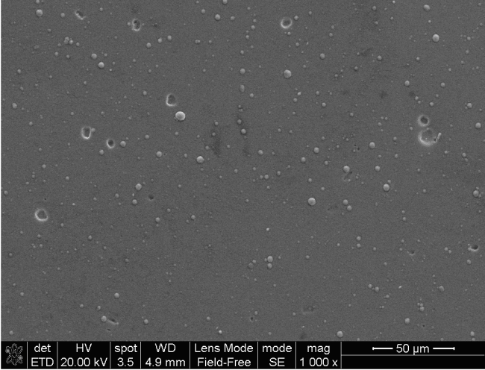 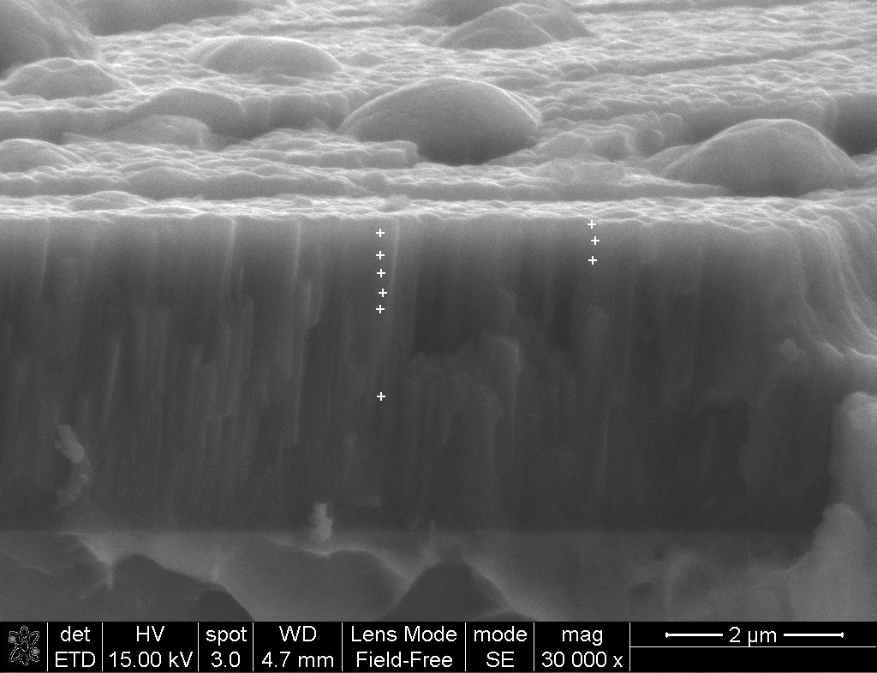

(a) (b)

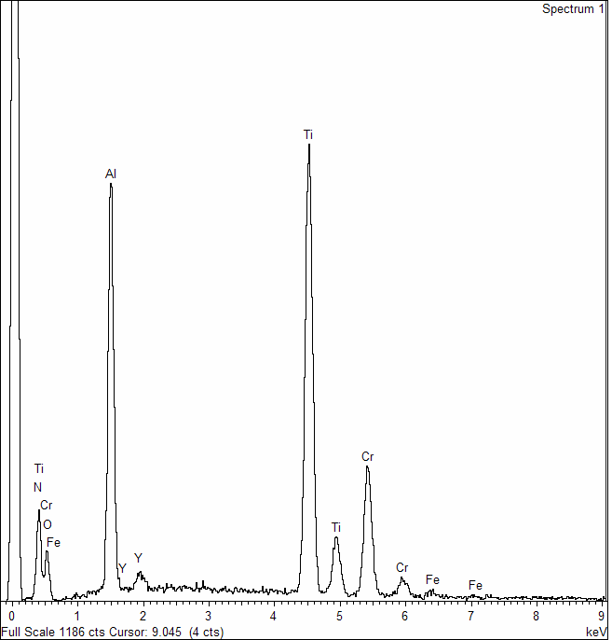 

(c) (d)

**Figure 1** High resolution SEM imaging and cross-sectional EDX profile of the TiAlCrYN coating.

(a) Secondary electron image of the coating surface;

(b) Secondary electron image of a fractured cross-section of the coating on which the labels ‘+’ indicate position of EDX analysis;

(c) A sample EDX spectrum acquired in the TiAlYN/CrN topcoat;

(d) normalised content of Al, Ti, Cr and Y plotted verses deposition position.

**3. Results**

Figure 1 shows SEM-EDX characterization of as-deposited TiAlCrYN coating. Figure 1a is a scanning secondary electron image of the coating surface on which the distribution of droplet-induced growth defects are visible. Figure 1b is a high resolution scanning secondary electron image of a fractured section showing, in an inclined angle, both the nano-scale waving features and extruding growth defects on the coating surface and the columnar dense cross-section of the entire coating thickness. Detailed EDX analysis was carried out on the coating surface (in Figure 1a) and at a series of depth positions on the cross-section (seeing the ‘+’ labels in Figure 1b). An example spectrum is provided in Figure 1c. The spectra showed presence of metallic components Al, Ti, Cr and Y, as well as light elements N and O. It is not possible to give valid evaluation of the N and O contents due to the instrumental limitation of SEM-EDX, i.e. the low intensity of low-energy signals K-N and K-O and their overlap with the L-Ti and L-Cr respectively. More comprehensive analysis of O and N has been performed by TEM-based EDX and EELS which are given in later section of this paper. Nevertheless, the cross-sectional EDX profiling analysis has shown the variation of Cr content versus the depth position in the topcoat, Figure 1d. The maximum Cr content exists only in a depth of approximately 100 nm, whereas it reduces dramatically with increasing depth. At depth larger than 300 nm, the Cr content is much lower than the Al and Ti content. The coatings grown on polished substrates showed surface roughness of Ra = 0.198 µm whereas those grown on pre-nitrided substrates showed Ra = 0.378 µm. The hardness of the coatings was measured to be HK0.025 26.6 GPa regardless of different substrate steels.

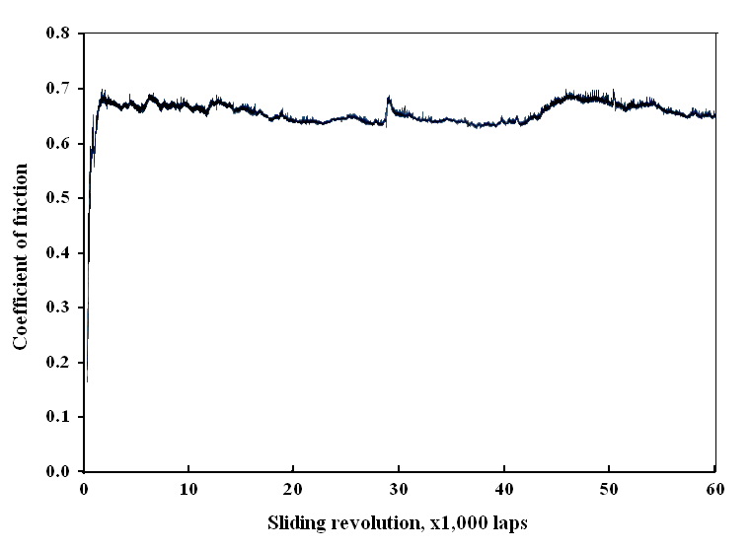

**Figure 2** A friction curve of TiAlCrYN coating deposited on P20 steel for a total sliding duration of 60,000 laps (i.e. a total sliding distance of 4,524 m). The test was conducted at 250C, humidity 33%, normal load 5N, sliding speed 0.1 ms-1, wear track radius 12 mm, against a 6 mm alumina ball.

**3.1 Friction and wear properties**

A typical friction curve of the TiAlCrYN coating obtained in the sliding wear tests is shown in Figure 2. At the beginning of sliding test, the friction coefficient was lower than 0.2; it then increased gradually to a high value of 0.6 – 0.7, after several thousands of sliding revolutions, i.e. the so-called running-in period. Meanwhile, wear debris was observed to appear along the edge of the wear track, with the amount increasing with sliding time. Following the running-in period was a period of steady state sliding, until the test was terminated. In the steady state sliding period, the friction coefficient was relatively stable, maintaining the high average values mentoned above, while irregular fluctuations of the friction coefficient can be found in the friction curve. A increasing amount of wear debris was observed to distribute along both sides of the wear track.

Table 2 shows the friction and wear properties of all the tested samples. The friction coefficients measured on the TiAlCrYN coated samples were between 0.61 and 0.68, which were slightly lower than the coefficients of the uncoated steels (µ = 0.70 – 0.76), but significantly higher than the friction coefficient of another transition metal nitride TiAlN/VN (µ = 0.4 – 0.5 [13, 22]).

**Table 2** Adhesion (Lc, N), friction coefficient (μ) and wear coefficient (kc, 10-16 m3N-1m-1) of TiAlCrYN coatings grown on various steel substrates

|  |  |  |  |  |  |
| --- | --- | --- | --- | --- | --- |
|  |  | **Adhesion** | **Friction and wear** | | |
| **Coating** | **Substrate** | **Lc** | **RH** | **μ** | **kc** |
| None | M2 | - | 25% | 0.73 | 1200 |
| TiAlCrYN | M2 | 46.0 ± 3.0 | 23% | 0.70 | 12.65 |
| None | H13 | - | 25% | 0.71 | 3130 |
| TiAlCrYN | H13 | 26.8 ± 2.3 | 33% | 0.65 | 51.5 |
| TiAlCrYN | Nitrided H13 | 48.4 ± 1.2 | 30% | 0.67 | 5.16 |
| TiAlCrYN | P20 | 20.7 ± 3.5 | 33% | 0.66 | 3.91 |
| TiAlCrYN | Nitrided P20 | 73.0 ± 3.6 | 32% | 0.61 | 3.57 |
| None | Nitrided S106 (150 µm) | - | 27% | 0.74 | 2660 |
| None | Nitrided S106 (270 µm) | - | 27% | 0.75 | 438 |
| None | Nitrided S106 (400 µm) | - | 27% | 0.76 | 582 |
| TiAlCrYN | Nitrided S106 (150 µm) | 47.9 ± 2.3 | 23% | 0.67 | 15.9 |
| TiAlCrYN | Nitrided S106 (270 µm) | 46.2 ± 2.6 | 23% | 0.68 | 19.5 |
| TiAlCrYN | Nitrided S106 (400 µm) | 27.4 ± 0.9 | 23% | 0.68 | 11.3 |

The uncoated steels M2 and H13 exhibited high coefficients of wear in the scale of 10-13 m3N-1m-1. In the nitrided S106 steel, increasing the nitrided case depth from 150 to 400 μm led to a decrease in wear coefficient, with an exceptionally higher wear coefficient at the nitrided depth of 270 μm. Nevertheless, the wear coefficients of the TiAlCrYN coatings ranged from 5.16 to 51.5 × 10-16 m3N-1m-1, being lower by 2 – 3 orders than the values of the uncoated steels. The TiAlCrYN deposited on the hardened M2 steel exhibited an adhesion strength of Lc = 46 N and a wear coefficient of 12.65 × 10-16 m3N-1m-1. On the substrates of the H13 and P20 steels which are substantially softer than the steel M2, low adhesion strength of Lc = 20.7 – 26.8 N implies poor load bearing capability of the coating-substrate systems. Consequently the wear coefficient of the TiAlCrYN coatings was dependent on the occurrence of spalling failure. In the TiAlCrYN-P20 sample, where the wear track kept a smooth worn surface without cracking and spalling, the resulting wear coefficient was of the same order as that of the TiAlCrYN-M2. However, spalling wear was found in the wear track of the TiAlCrYN-H13 leading to a wear depth of 3.8 µm and wear coefficient of kc = 51.5 × 10-16 m3N-1m-1. The duplex treatment of pre-nitriding and PVD coating has achieved adhesion at least equivalent to the TiAlCrYN-M2, e.g. Lc = 48.4 N in the TiAlCrYN-H13 and Lc = 73.0 N in the TiAlCrYN-P20. Consequently the wear coefficients obtained were kc = 3.57 – 19.5 × 10-16 m3N-1m-1, being of a similar order to that of the TiAlCrYN-M2.

Moreover, it is apparent that the wear coefficient obtained was affected by the test environment, i.e. the relative humidity. The TiAlCrYN coatings exhibited wear coefficients in ~ 10-16 m3N-1m-1 scale at relative humidity of 30 – 33% whereas a small decrease of the humidity to 23 – 25% led to considerably higher wear coefficients in the scale of ~ 10-15 m3N-1m-1. It was reported in literature that water molecules can be absorbed on the wear debris and tribofilm to result in lower severity of adhesive interaction within the sliding contact zone [24-25].

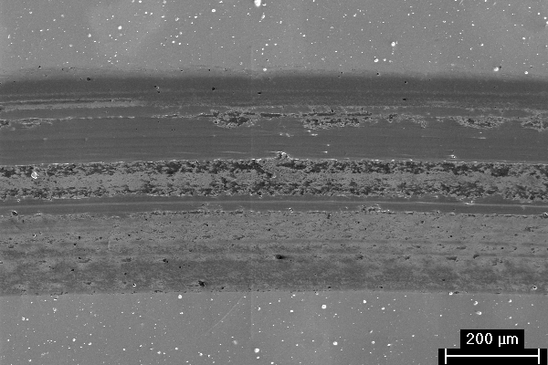 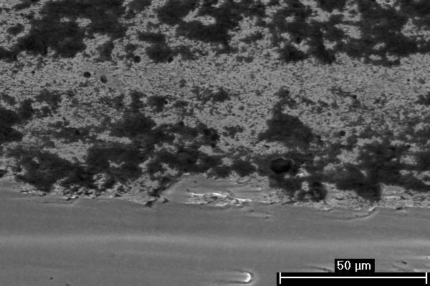

(a) (b)

**Figure 3** The worn surface of TiAlCrYN coating observed by SEM.

(a) a low magnification scanning secondary electron image;

(b) a high magnification secondary electron image taken in the middle of the wear track, showing attached wear debris clusters in the upper part and smooth worn surface in the lower part.

**3.2 SEM observation of worn surfaces**

Worn surface of each tested TiAlCrYN coating was observed and analysed by SEM and EDX. As an typical example, Figure 3a is a secondary electron micrograph showing that, after 60,000 laps (4,523 m) of sliding, the wear track was approximately 480 μm wide, containing a 260-μm-width area of severe sliding contact in the middle. A depth of 0.5 - 1.5 μm was measured in the severe contact area, not exceeding the coating's thickness (approximately 3.0 - 3.5 μm). At high magnification of the SEM observation, the severe contact area exhibited bands of smooth worn surface and wear debris build-up along the sliding direction, Figure 3b. In Figure 3b, the smooth worn surface (the lower part) shows no visible cracking or spallation, indicating the absence of severe wear. The upper part of the area shown in Figure 3b was covered with agglomerated wear debris and or a tribofilm. SEM-EDX spectroscopy showed pronounced intensity of Kα-O both in the attached tribofilm and in the loose wear debris. Note that the attached tribofilm and wear debris was not removable using soft tissue in acetone, showing its strong adhesive binding to the nitride coating.

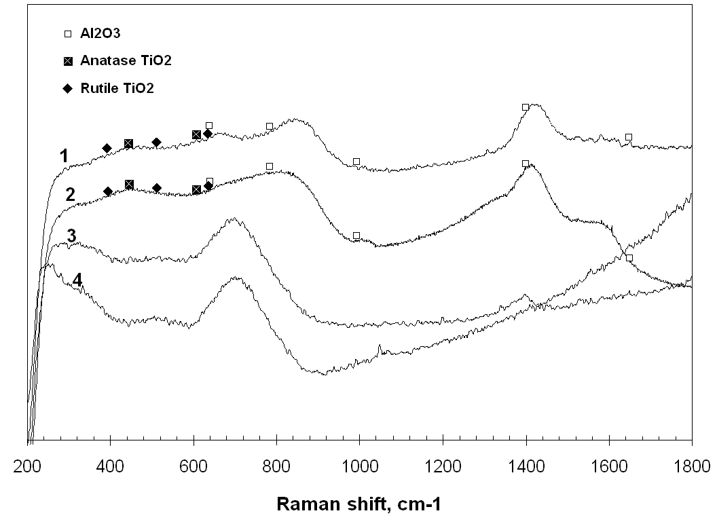

**Figure 4** Raman spectra acquired in (1) free-standing wear debris, (2) thick agglomerates of wear debris attached on the worn surface, (3) thin tribofilm on the worn surface, and (4) the as-deposited TiAlCrYN coating.

**3.3 Raman spectroscopy**

Raman spectroscopic analysis was undertaken in the regions of wear debris, thick and thin tribofilms attached to the worn surface, and the as-deposited TiAlCrYN coating. Typical Raman spectra acquired in these regions are shown in Figure 4. The Raman spectra of the wear debris and the thick tribofilm, i.e. Spectra 1 and 2, are similar, showing a series of broad Raman shifts at 1587, 1422, 843, 686 and 462 cm-1. Some of the shifts, such as the strong bands at 1400, 873 and 639 cm-1 are close to, although not exactly fitting to, the spectrum of α-Al2O3. Such alumina-type bonding was even detected in thin tribofilm. These Raman shifts do not fit to other related oxides, such as rutile and anatase TiO2 oxides. The misfit was attributed to the fact that the wear debris and tribofilm were multi-component and in amorphous or nano-crystalline state although they showed partly alumina-type bonds. In our previous study [16], wear debris and tribofilms generated in dry sliding of metal nitride coatings were found to exhibit short-range ordered structure, being amorphous or nano-crystalline. Such structure in wear debris and in tribofilms can also be observed in current experiment by TEM imaging (as we show later in this paper). Obviously such short-range ordered structures emit different Raman vibrations as compared to standard (crystalline) oxides, i.e. substantially broadened vibration bands are expected. Spectrum 3 in Figure 4, being acquired in a thin agglomerate of wear debris, contains a small but distinct vibration band at 1406 cm-1 which matches to α-Al2O3. In addition, the high-intensity broad peaks at 264 and 718 cm-1 are contributed to by acoustic and optical bands, respectively, of the underlying TiAlCrYN coating. These nitride bands were confirmed in the Raman spectrum of the as-deposited coating, Spectrum 4. More details of the formation of such acoustic and optical bands can be found in the literature [26-27]. It has been found, by comparing these Raman spectra, that the wear debris emits completely different Raman vibration bands to the TiAlCrYN coating, indicating different chemical bonds between the wear products and the nitride coating as a result of tribo-chemical reactions. Moreover, the Raman spectra acquired in smooth worn surface areas showed only the acoustic and optical bands of the TiAlCrYN.

**3.4 Cross-sectional TEM observation and TEM-EDX-EELS analysis**

Figure 5 shows TEM bright field images of a longitudinal cross-section of the TiAlCrYN worn surface. The main part of the micrograph consists of three regions, namely the TiAlCrYN coating, a tribofilm developed on top of the TiAlCrYN, and a re-deposited copper layer. The copper layer was generated by re-deposition of the sputtered atoms during the ion beam milling stage of the sample preparation, containing mainly copper as well as iron. Detailed TEM-EELS-EDX characterizations of the regions are given below.

***3.4.1 The TiAlCrYN coating beneath the tribofilm***

The TiAlCrYN coating exhibit a dense columnar microstructure; more detailed microstructural characterization of such coatings can be found in previous publications [1, 20, 28]. Multilayer fringes were imaged in the coating from the top worn surface edge to a depth of ~150 nm, but were not found in the rest of the coating. According to the deposition procedure described in the previous section, the multilayer region was the TiAlYN/CrN topcoat because during its growth the pure chromium target was powered at 8 kW. The different Cr contents between the topcoat and the main TiAlCrYN region have been confirmed by the TEM-EDX spectroscopy in Figure 6.

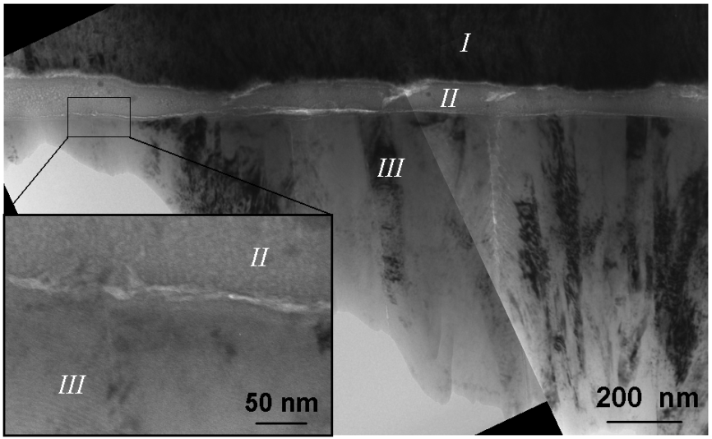

**Figure 5** TEM bright field images showing a longitudinal cross-section of the worn surface of TiAlCrYN coating. From upper to lower part of the main micrograph three regions are labelled as the copper re-deposit (I), the tribofilm (II) and the remaining TiAlCrYN coating (III) including a TiAlYN/CrN multilayer topcoat. The insert in the left-lower corner highlights the coating-tribofilm interface region.

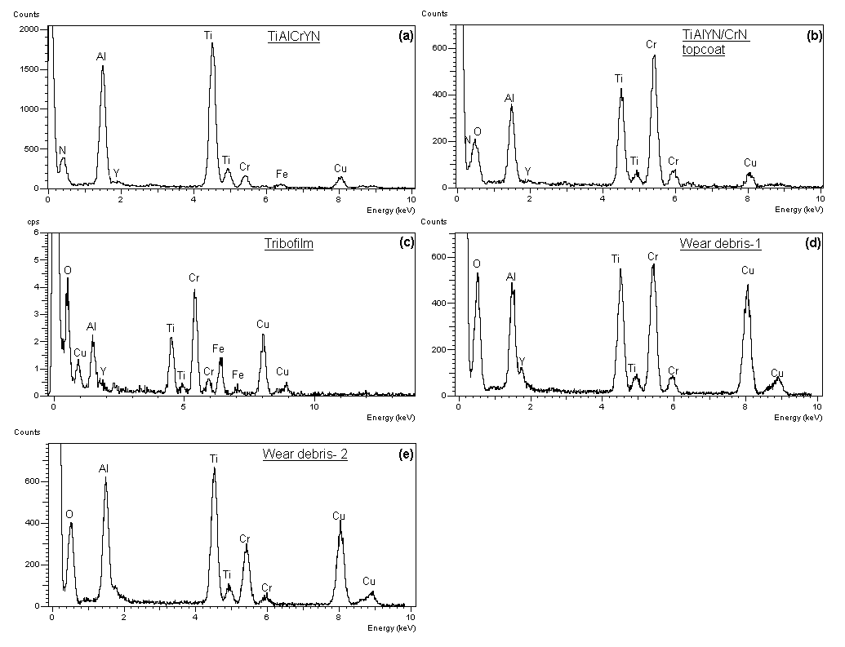

**Figure 6** Typical TEM-EDX spectra acquired in different regions. (a) in the middle thickness of the TiAlCrYN coating; (b) in the TiAlYN/CrN nano-layered topcoat beneath the tribofilm; (c) in the tribofilm, and (d-e) in the loose wear debris.

The TiAlCrYN coating in the main thickness was typically a TiAlN type nitride containing low contents of Cr and Y, showing high intensity peaks of Ti-Kα and Al-Kα, as well as low intensity peaks of Cr-Kα, and Y-Lα in the EDX spectrum, Figure 6(a). The topcoat shows a higher intensity of Cr-Kα in the EDX spectroscopy, Figure 6 (b). Quantification of the EDX data suggested Cr contents of 25.5 ± 1.2 at% in the topcoat and 2.1 ± 0.3 at% in the main TiAlCrYN respectively, Table 3.

**Table 3** Chemical compositions (at%) of the TiAlCrYN coating, tribofilm and wear debris determined by quantitative TEM-EDX.

|  |  |  |  |  |  |
| --- | --- | --- | --- | --- | --- |
|  | **O** | **Al** | **Ti** | **Cr** | **Y\*\*** |
| **TiAlCrYN** | N: 50 * | 23.9 ± 0.4 | 23.9 ± 0.3 | 2.1 ± 0.3 | 2 |
| **TiAlYN/CrN (topcoat)** | N: 50 * | 10.4 ± 0.6 | 13.0 ± 1.2 | 25.5 ± 1.2 | 1 |
| **Tribofilm** | 19.3 ± 7.5 | 19.9 ± 1.6 | 20.5 ± 3.0 | 40.4 ± 4.4 | 1 |
| **Debris** | 35.3 ± 7.4 | 25.3 ± 5.5 | 22.2 ± 5.2 | 15.2 ± 7.7 | 2 |

* Assuming stoichiometric nitrogen content (50 at%).

** Assuming 2 at% of yttrium in the TiAlCrYN [20, 21] and 1 at% of yttrium in the TiAlYN/CrN topcoat.

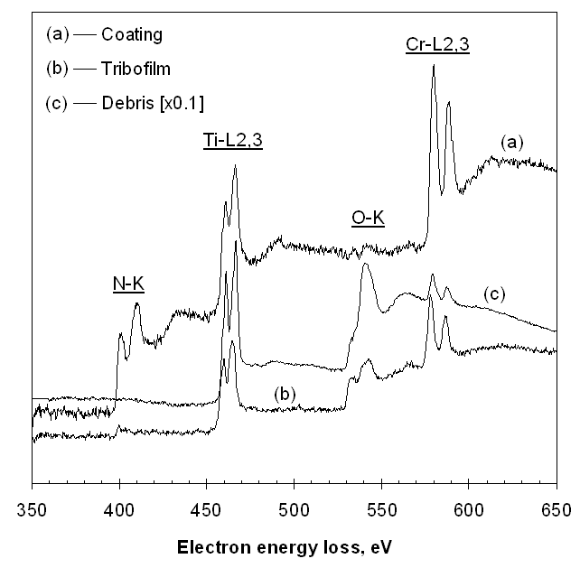

**Figure 7** Normalised transmission electron energy loss spectra acquired in various regions.

(a) the TiAlYN/CrN topcoat beneath the tribofilm;

(b) the tribofilm;

and (c) the wear debris.

Figure 7 shows EELS data for the coating, tribofilm and wear debris. Figure 7 (a) was acquired in the thinnest area of the TiAlYN/CrN topcoat adjacent to the tribofilm (Figure 5). The spectrum shows well defined energy loss edges of N-K, Ti-L2,3 and Cr-L2,3. Compared to the N-K edge, the intensity of O-K edge is barely detectable. In particular, the N-K edge exhibits a well defined double-peak pattern which, as discussed for other nitride coatings in a previous publication [16], demonstrates that the coating is a stoichiometric nitride. This result was then applied in the quantification of TEM-EDX data. In the EDX spectra of the TiAlYN/CrN, the intensity of O-Kα (0.53 KeV) was neglected and the low energy peak between 0.428 and 0.688 keV was assumed to be from the Cr-Lα only. Therefore an intensity ratio ICr-L:ICr-K = 0.14 was deduced and used in the EDX data quantification of the tribofilm and wear debris (to be shown later).

In Figure 5, the TiAlYN/CrN topcoat shows a clear boundary to the attached tribofilm without any evidence of intermixing. The TiAlYN/CrN columns exhibit no visible bending deformation. The only evidence of mechanical wear was nano-scale delamination sheets observed in some areas of the worn surface edge by cross-section TEM bright field imaging, as shown in Figure 8. In Figure 8, the main area of the TEM image (region III) shows the TiAlYN/CrN multilayer. On the topmost of the region is the worn surface, where the multilayer fringes become discontinuous by showing a bright line at a depth of less than 10 nm, which evidences a delamination sheet. The TEM observations of delamination wear are similar to our previous work [15, 28].

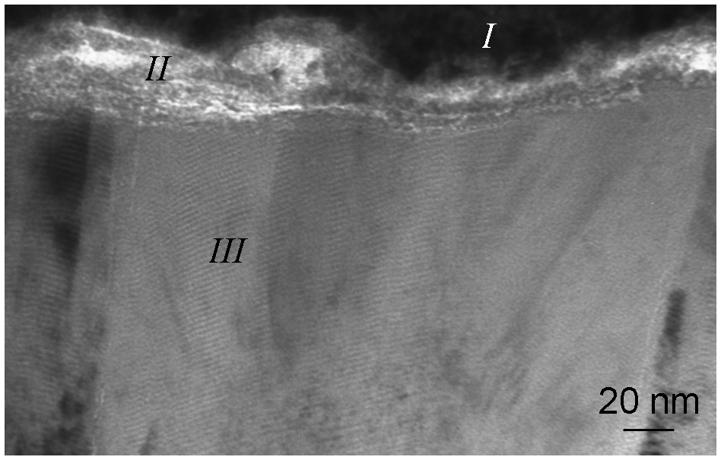

**Figure 8** Delamination wear observed on the worn surface of the TiAlCrYN multilayer coating. The marks ‘I’, ‘II’, and ‘III’ indicate the regions of copper re-deposit, tribofilm and TiAlYN/CrN multilayer topcoat, respectively.

***3.4.2 The tribofilm***

Beneath the copper layer was the outmost edge of the worn surface, where an approximately 80 nm thick tribofilm is attached to the TiAlCrYN worn surface. The tribofilm was amorphous as being recognized by tilting the sample during bright field imaging. In TEM bright field imaging or dark field imaging of crystalline materials, sample tilting results in simultaneously changing image contrast due to the varying electron diffraction angle, whereas for an amorphous sample, its image contrast remains almost constant because of the lack of ordered structure. This was also confirmed by selected-area electron diffraction patterns, which showed no distinct diffraction ring or spot but only a broad spot of the central transmission beam.

In Figure 6 (c), the EDX spectrum acquired in the tribofilm shows high intensity peaks of O-Kα, Al-Kα, Ti-Kα and Cr-Kα. In Figure 7 (c), the electron energy loss spectrum of the tribofilm shows a pronounced O-K edge in addition to the expected Ti-L2,3 and Cr-L2,3 edges. The intensity of N-K edge in the spectrum is low and close to the level of background noise. Also unlike the N-K edge in the stoichiometric TiAlCrYN in Figure 7 (a), the N-K edge of the tribofilm no longer has the double-peak shape, indicating depletion of nitrogen. These results suggest that the tribofilm contained a mixture of multicomponent oxides, with the overall chemical composition Cr0.39Al0.19Ti0.20Y0.01O0.21.

***3.4.3 The loose wear debris***

TEM-EDX spectroscopy of wear debris suggested a multicomponent Ti-Al-Cr-O mixture. However, the wear debris particles showed varying Cr-Kα intensity as compared to the relative constant Al-Kα and Ti-Kα. Typical spectra of high and low Cr contents are shown in Figures 6 (d) and 6 (e) respectively. The measurement with the minimum Cr content showed a composition: O 42.8 %, Al 28.2 %, Ti 23.8 %, Cr 5.8 % and Y 2.0 %, and that with the maximum Cr content showed a composition: 38.2 O %, Al 18.5 %, Ti 16.3%, Cr 25.1 %, and Y 2.0 %. In Table 3, the average values were determined from nine measurements, to be 35.3 O %, Al 25.3 %, Ti 22.2%, Cr 15.2 %, and Y 2.0 %. TEM-EELS of the wear debris showed energy loss edges of Ti-L2,3, O-K and Cr-L2,3. The O-K edge was even more pronounced and the Cr-L2,3 edge was substantially lower than in the spectra of the tribofilm, Figure 7 (b). The results of EDX and EELS were self-consistent in showing the high oxygen content and low Cr content. In particular, the N-K edge has completely disappeared suggestive of complete tribo-oxidation having exhausted most of the nitride debris generated due to mechanical wear.

**4. Discussion**

**4.1 Dry sliding friction and wear of TiAlCrYN coatings deposited on various substrates**

In this paper, the dry sliding friction and wear properties of TiAlCrYN coatings deposited on various steel substrates have been reported and compared to the properties of the uncoated substrates. The obtained experimental results reveal that, TiAlCrYN coatings exhibit friction coefficients in the range of 0.6 – 0.8 against an alumina counterface (Table 2), which is slightly lower than that observed for uncoated steels, comparable to those of TiN [5, 7] and TiAlN [1, 8] and higher than those of TiAlN/VN [13, 22] and CrN [1, 29].

Good repeatability has also been obtained in the wear coefficients of the TiAlCrYN coatings which fell between 10-16 and 10-15 m3N-1m-1, except the coating deposited on the non-nitrided H13 steel which failed by spalling wear, Table 2. These wear coefficient values were 3 – 4 orders lower than those of the uncoated steels. In particular, the duplex process of plasma pre-nitriding followed by magnetron sputter TiAlCrYN deposition, is effective in improving the wear resistance of relatively soft surfaces. Without the nitriding pre-treatment, on the other hand, the TiAlCrYN coating could maintain its low wear coefficient only when the load bearing capability was sufficiently high to resist substrate yielding, e.g. in the case of the TiAlCrYN-P20 combination. Otherwise, plastic deformation in the substrate would lead to spalling wear and catastrophic failure of the coating, which was found in the wear track of the TiAlCrYN-H13 combination. These results were consistent to our previous experiments [22] and agreed in general to the results of other researchers [30-31].

**4.2 The effect of two-body and three-body sliding on friction kinetics**

As shown in Figure 2, each friction curve obtained in the present study has recorded the kinetics of friction, i.e. the dynamic changes of the friction coefficient with increasing sliding duration. Firstly, the initial coefficients of friction were as low as between 0.15 and 0.3, which represented the sliding behaviour of the TiAlCrYN-alumina two-body sliding contact. In such circumstances, the severity of friction should have been determined by the asperity contacts between the two surfaces such as mechanical inter-locking, scratching and adhesion, according to accepted theory [32].

Secondly, in the running-in period of up to a few hundred laps, the friction coefficient experienced a steady linear increase until reaching its maximum value. This short period generated wear particles and subsequent mechanical and chemical interactions of them within the contact zone. Thus, running-in was an important period both for the build-up of a high friction coefficient and for the transformation of wear products from clusters of debris to a well established adhesive tribofilm. For this important period, detailed high resolution electron microscopy and chemical analysis have revealed the generation, breaking, refining, and oxidation of the wear particles, which will be published elsewhere. Nevertheless, it was the interactions between the wear debris and the sliding surfaces which determined the severity of frictional resistance.

Finally, in the long-term steady state sliding process after the running-in period, the high scale of friction coefficient was governed by the sliding and shearing behaviour of the tribofilm due to the TiAlCrYN-tribofilm-alumina three-body contact. Noting the existence of a distinct boundary between the tribofilm and the TiAlCrYN nitride and the regular columnar structure of the latter, it is unlikely that shearing deformation took place in the nitride layer. Instead, sliding induced shear deformation should have been at the tribofilm-counterpart interface and within the tribofilm. Thus the steady state friction was governed by the resistance arising from the shear straining of the amorphous tribofilm as well as its adhesive interaction with the alumina counterpart.

**4.3 Influence of tribofilm formation on friction and wear mechanisms**

It has been demonstrated from the current study and our previous work [13, 15 – 17, 22] that the friction coefficients of nitride coatings in un-lubricated sliding are determined by their chemical composition, through the generation of a multicomponent oxide tribofilm. Cross-sectional TEM observation (Figure 5) and the associated TEM-EDX and TEM-EELS analyses (Figures 7 and 8 and Table 3) have shown that the tribofilm was 80-nm thick, dense, amorphous, homogeneous, and exhibited a multicomponent chemical composition of Cr0.35Al0.17Ti0.18Y0.01O0.29.

The refining and structural amorphorization of wear debris and tribofilm was in fact caused by high rate shearing of the wear products. It is known that plastic deformation in nano-crystalline and amorphous structures is dominated by viscous flow of grain boundaries and the glassy medium respectively. Resistance arising from the viscous flow is predominantly determined by the strength of the inter-molecular bonds. In the Cr-Ti-Al-O tribofilm, the chemical bonds were mainly bonds between the metal and oxygen atoms, despite minor existence of nitrogen. Therefore, a proper explanation can be given to the different friction coefficients between the TiAlCrYN coatings and other low-friction coatings such as the vanadium-containing TiAlN/VN. In TiAlN/VN, sliding wear results in the formation of a multicomponent Ti-Al-V-O tribofilm. The V-O chemical bond in the tribofilm favours shear, similar to the solid lubricant behaviour of the V2O5 oxide; therefore, a low coefficient of friction was obtained. In TiAlCrYN, however, the tribofilm is populated with Cr-O, Al-O and Ti-O bonds, as evidenced by the Raman spectroscopy data in Figure 4. These metal-to-oxygen bonds are lilely to exhibit higher shear strength than the V-O bond; consequently, the resultant friction coefficients were higher.

In addition, it has been reported that oxide wear debris generated in a humid environment contains some level of hydration and the hydroxide component of the wear debris exhibits lower friction than the pure oxide alone [24-25]. In the sliding wear of TiAlCrYN, coatings being tested at RH = 33% showed lower wear coefficients than those tested at RH = 23% (Table 2). To confirm the influence of varying humidity on the friction coefficient, two pin-on-disc sliding tests of the TiAlCrYN coating against a 6-mm diameter alumina ball were performed under different levels of humidity (33% and 70%, respectively) while maintaining a constant normal load of 5N and a sliding speed of 0.1 ms-1. The test conducted at lower humidity showed slightly higher friction coefficient (µ = 0.70) that that at higher humidity (µ = 0.67).

The wear mechanisms of the TiAlCrYN coatings included tribo-oxidation and nano-scale delamination wear. Tribo-oxidation is supported by the fact that both the loose wear debris and the tribofilm contained mixtures of multi-component Cr-Ti-Al-O oxides, Figures 4-5 and 7-8 and Table 3. In particular, TEM-EELS analysis revealed the depletion of nitrogen in the tribofilm, suggesting the occurrence of progressive tribo-oxidation. Delamination wear was evidenced by the observed nanometer-scale delamination sheets on top of the worn TiAlCrYN surface (Figure 6), although such fine scale of mechanical wear was not detected in SEM observations for reasons of insufficient spatial resolution. The combined tribo-chemical and mechanical wear mechanisms in the TiAlCrYN coatings show a clear contrast to the solely tribo-chemical wear of TiAlN/VN, in which the worn surface shows no evidence of mechanical wear. The different wear mechanisms between the two coatings can be correlated to the different wear coefficients measured, namely 10-16 to 10-15 m3N-1m-1 in TiAlCrYN and 10-17 to 10-16 m3N-1m-1 in TiAlN/VN, not only because of additional mechanical wear in the former, but also because of the influence of a high friction coefficient in promoting tribo-oxidation wear [33-34].

**5. Conclusions**

1. Nano-structured TiAlCrYN multilayer coatings grown by combined cathodic arc and unbalanced magnetron sputtering on several steels, having a range of carbon and alloying contents, were evaluated on a ball-on-disc tribometer under ambient conditions against an alumina ball counterface. The coatings exhibited friction coefficients between 0.6 and 0.8, and wear coefficients ranging from 10-16 to 10-15 m3N-1m-1.
2. Low wear rates of TiAlCrYN coatings deposited on relatively soft substrates of S106, P20 and H13 steels was ensured by performing a duplex treatment of plasma pre-nitriding, followed by magnetron sputter coating deposition, to enhance the load-bearing capability of the substrate, and hence improve adhesion.
3. Coating wear was a result of combined mechanisms of tribo-oxidation and nano-scale delamination wear. The debris generated in sliding wear was found to be agglomerated mixtures of amorphous oxides with multicomponent chemical constituents of of overall composition Cr0.15Al0.25Ti0.22Y0.02O0.35. A dense amorphous tribofilm has been observed on the worn surface of TiAlCrYN, which was ~80 nm thick and chemically homogeneous, showing an overall composition of Cr0.39Al0.19Ti0.20Y0.01O0.21 as well as small amount of residual nitrogen. Extremely fine delamination sheets having a thickness of ~5 nm were observed by TEM on the TiAlCrYN worn surface.
4. High friction coefficients were obtained in the TiAlCrYN-tribofilm-alumina three-body contact, in which the friction arose from tribofilm viscous flow as well as from engaged wear debris. It appears from this work that the friction coefficient of transition meta nitride coatings is influenced strongly by the chemical composition of the oxide tribofilm formed during running-in. In the present study, the high friction coefficient of TiAlCrYN resulted from the lack of a low-shear strength lubricious component in the oxide tribofilm.

**References**

|  |  |
| --- | --- |
| [1] | Münz, W. D., Donohue, L. A., Hovsepian, P. Eh.: Properties of various large-scale fabricated TiAlN- and CrN-based superlattice coatings grown by combined cathodic arc-unbalanced magnetron sputter deposition. Surf. Coat. Technol. 125, 269-277 (2000) |
| [2] | Helmersson, U., Todorova, U., Barnett, S. A., Sundgren, J. E., Market, L. C., Greene, J. E.: Growth of single-crystal TiN/VN strained-layer superlattices with extremely high mechanical hardness. J. Appl. Phys. 62, 481-484 (1987) |
| [3] | Veprek, S., Reiprich, S.: A concept for the design of novel superhard coatings. Thin Solid Films 268, 64-71(1995) |
| [4] | PalDey, S., Deevi, S. C.: Single layer and multilayer wear resistant coatings of (Ti,Al)N: a review. Mater. Sci. Eng. A342, 58-79 (2003) |
| [5] | Huq, M. Z., Celis, J. P.: Reproducibility of friction and wear results in ball-on-disc unidirectional sliding tests of TiN-alumina pairings. Wear 212, 151-159 (1997) |
| [6] | Vancoille, E., Celis, J. P., Roos, J. R.: Dry sliding wear of TiN based ternary PVD coatings. Wear 165, 41-49 (1993) |
| [7] | Takadoum, J., Bennani, H. H., Allouard, M.: Friction and wear characteristics of TiN, TiCN and diamond-like carbon films. Surf. Coat. Technol. 88, 232-238 (1997) |
| [8] | Mo, J. L., Zhu, M. H., Lei, B., Leng, Y. X., Huang, N.: Comparison of tribological behaviours of AlCrN and TiAlN coatings - Deposited by physical vapor deposition. Wear 263, 1423-1429 (2007) |
| [9] | Kutschej, K., Mayrhofer, P. H., Kathrein, M., Polcik, P., Mitterer, C.: A new low-friction concept for Ti1-xAlxN based coatings in high-temperature applications. Surf. Coat. Technol. 188, 358-363 (2004) |
| [10] | Fischer, T. E., Mullins, W. M.: Chemical aspects of ceramic tribology. J. phys. Chem. 96, 5690-5701 (1992) |
| [11] | Biswas S. K.: Some mechanisms of tribofilm formation in metal/metal and  ceramic/metal sliding interactions. Wear 245, 178-189 (2000) |
| [12] | Engqvist, H., Hogberg, H., Botton, G. A., Ederyd, S., Axen, N.: Tribofilm formation on cemented carbides in dry sliding conformal contact. Wear 239, 219-228 (2000) |
| [13] | Hovsepian, P. Eh., Lewis, D. B., Münz, W. D.: Recent progress in large scale manufacturing of multilayer/superlattice hard coatings. Surf. Coat. Technol. 133-134, 166-175 (2000) |
| [14] | Minfray, C., Martin, J. M., Esnouf, C., Le Mogne, T., Kersting, R., Hagenhoff, B.: A multi-technique approach of tribofilm characterisation. Thin Solid Films 447-448, 272-277 (2004) |
| [15] | Luo, Q., Hovsepian, P. Eh.: Transmission electron microscopy and energy dispersive X-ray spectroscopy on the worn surface of nano-structured TiAlN/VN multilayer coating. Thin Solid Films 497, 203-209 (2006) |
| [16] | Luo, Q., Zhou, Z., Rainforth, W. M., Hovsepian, P. Eh.: TEM-EELS study of low-friction superlattice TiAlN/VN coating: The wear mechanisms. Tribology Letters 24, 171-178 (2006) |
| [17] | Zhou, Z., Mckay, S., Luo, Q., Rainforth, W. M., Chen, L, Hovsepian, P. Eh.: Investigating Worn Surface of Nanoscale TiAlN/VN Coating Using FIB and TEM. Journal of Physics Series 26, 95-98 (2006) |
| [18] | Münz, W. D.: Titanium aluminium nitride films – a new alternative to TiN coatings. J. Vac. Sci. Technol. 4, 2717-2725 (1986) |
| [19] | Mcintyre, D., Greene, J. E., Hakansson, G., Sundgren, J. E., Münz, W. D.: Oxidation of metastable single-phase polycrystalline Ti0.5Al0.5N films – kinetics and mechanisms. J. Appl. Phys. 67, 1542-1553 (1990) |
| [20] | Donohue, L. A., Smith, I. J., Munz, W. D., Petrov, I., Greene, J.E.: Microstructure and oxidation-resistance of Til-x-y-zAlxCryYzN layers grown by combined steered-arc/unbalanced-magnetron-sputter deposition. Surf. Coat. Technol. 94-95, 226-231 (1997) |
| [21] | Lembke, M. I., Lewis, D. B., Münz, W. D., Titchmarch, J. M.: Significance of Y and Cr in TiAlN hard coatings for dry rich speed cutting. Surf. Eng. 17, 153-158 (2001) |
| [22] | Luo, Q., Hovsepian, P. Eh., Lewis, D. B., Münz, W. D., Kok, Y. N., Cockrem, J., Bolton, M., Farinotti, A.: Tribological perperties of unbalanced magnetron sputtered nanoscale multilayer coatings TiAlN/VN and TiAlCrYN deposited on plasma nitrided steels. Surf. Coat. Technol. 193, 39-45 (2005) |
| [23] | Williams, D. B., Carter,C. B.: Transmission electron microscopy IV: Spectrosmetry, Plenum Press, New York (1996) |
| [24] | Ajayi, O. O., Ludema, K. C.: Mechanism of transfer film formation during repeat pass  sliding of ceramic materials. Wear 140, 191-206 (1990) |
| [25] | Zhou, Z., Rainforth, W. M., Tan, C. C., Zeng, P., Ojeda, J. J., Romero-Gonzalez, M. E., Hovsepian, P. Eh.: The role of the tribofilm and roll-like debris in the wear of nanoscale nitride PVD coatings. Wear 263, 1328-1334 (2007) |
| [26] | Barshilia, H. C., Rajam, K. S.: Raman spectroscopy studies on the thermal stability of TiN, CrN, TiAlN coatings and nanolayered TiN/CrN, TiAlN/CrN multilayer coatings. J. Mater. Res. 19, , 3196-3205 (2004) |
| [27] | Constable, C. P., Yarwood, J., Hovsepian, P. Eh., Donohue, L. A., Lewis, D. B., Münz, W. D.: Structural determination of wear debris generated from sliding wear tests on ceramic coatings using Raman microscopy. J. Vac. Sci. Technol. A18, 1681-1689 (2000) |
| [28] | Luo, Q., Rainforth, W.M., Münz, W.D.: TEM observations of wear mechanisms of TiAlCrN and TiAlN/CrN coatings grown by combined steered-arc/unbalanced magnetron deposition. Wear 225-229, 74-82 (1999) |
| [29] | van Essen, P., Hoy, R., Kamminga, J. -D., Ehiasarian, A. P., Janssen, G. C. A. M.: Scratch resistance and wear of CrNx coatings. Surf. Coat. Technol. 200, 3496-3502 (2006) |
| [30] | Sun, Y., Bell, T.: Plasma surface engineering of low-alloy steel. Mater. Sci. Eng. A140, 419-434 (1991) |
| [31] | Vanstappen, M., Malliet, B., Stals, L., Deschepper, L., Roos, J.R., Celis, J.P.: Characterization of TiN coatings deposited on plasma nitrided tool steel surfaces. Mater. Sci. Eng. A140, 554-562 (1991) |
| [32] | Erdemir, A. Donnet, C.: Tribology of diamond-like carbon films: recent progress and future prospects. J. Phys D: Appl. Phys. 39, R311-R327 (2006) |
| [33] | Lim S. C., Ashby M. F.: Wear mechanism maps. Acta. Metall. 35, 1-24 (1987) |
| [34] | Kalin M.: Influence of flash temperatures on the tribological behaviour in low-speed sliding: a review. Mater. Sci. Eng. A374, 390-397 (2004) |