Evaluation of the Global Citizenship Portfolio

Executive Summary
This impact evaluation measured the effectiveness of the Global Citizenship Portfolio (GCP), which aims to help students at Sheffield Hallam become global citizens by helping them to develop skills and evidence that they: 1) are able to engage with different values systems wherever they encounter them; 2) can communicate effectively across cultures, and in different cultural contexts; 3) have understanding of how their actions and those of others can have global implications. The GCP is a non-credit bearing module that engages students in self-directed learning by combining academic-run sessions, lectures, experiential learning and reflection. A total of 78 students completed the module in 2019/20.
The evaluation was focused on the cohort of students who started the module in October 2019 and January 2020 and finished in May 2020, with the evaluation taking place throughout the delivery of the module. A mixed-methods programme of data gathering and analysis was employed to provide quantitative and qualitative evidence from pre and post-module surveys, which captured baseline data and enabled changes in knowledge, skills and attitude to be determined for 19 students, and a sample of 15 reflective journals. The data sources were triangulated and analysed using the markers that appear in the Global Citizens identikit (Lilley, Barker & Harris, 2015) as a framework.
It is evident that the GCP has had a positive impact on students’ development in becoming ‘global citizens’. Analysis of the data, particularly the reflective journals, indicated that the majority of students have demonstrated evidence of acquiring intercultural competencies, regardless of whether they undertook an experience at home or abroad. This will help them to engage with different value systems, communicate effectively across cultures and understand how their actions and those of others have global consequences. For many students, there were indications that they have gone beyond this by developing a global ‘mindset’ that involves having a capacity for criticality, respect and responsibility towards self, others and the world.
The magnitude of change in students was evident but less profound in the surveys than the reflective journals, with high proportions of students responding confidently to sections of the pre-module survey. There are several possibilities for this finding, such as the limitations of the self-report survey instrument, overconfident estimates from students about their knowledge and understanding in the surveys and the possibility that those on the module do not represent the students who would benefit most from it. It is important that these points, alongside other potential limitations, are explored and addressed in future evaluations. Recommendations are provided on the steps that can be taken to enhance the provision of the GCP and to increase the robustness of the evaluation.
This evaluation report was completed on 29th June 2020 by Alan Donnelly (Researcher in Student Engagement and Evaluation), Emily Houfe and Temi Labinjo (Student Researchers).
Context
The Global Citizenship Portfolio (GCP) was initiated in response to the University's ambition to provide global experiences to all students and create world-ready graduates who can work successfully in an increasingly globalised world. UK global student mobility trends (Newman, 2014) show that only a small proportion of students seek to develop these skills through actual experience abroad, therefore equal, if not greater, efforts should be made to develop global opportunities on campus as an accessible option for all. The GCP is complementary with the Hallam Model, which is a series of principles which underpin the applied learning experienced by Hallam students, for example, that learning: engages with the world beyond the University; occurs with, from and alongside others; enables students to thrive personally, culturally and professionally.
The GCP provides a flexible model for the development and recognition of intercultural competence and global skills; in or outside the curriculum. It is based on the model of intercultural competence proposed by Deardorff (2011) who defines intercultural competence as the "ability to develop targeted knowledge, skills and attitudes that lead to visible behaviour and communication that are both effective and appropriate in intercultural interactions". The GCP is a non-credit bearing module that engages students in self-directed learning by combining academic-run sessions, lectures, experiential learning and reflection. There are four clearly defined steps in the module:
- an introductory workshop on developing intercultural competence.
- engagement with at least two global topics out of six, and attending additional workshops/lectures.
- undertaking an intercultural experience - period abroad, or intercultural volunteering locally or on campus.
- reflection on any changes in the skills, knowledge, attitudes and values through a reflective journal or peer-observed moderated discussion.
A total of 286 students expressed an interest in Global Citizenship Portfolio at the beginning of the academic year, while 78 completed the module. There is limited data collected on the numbers of students who drop out at each stage.
Evaluation approach
This impact evaluation measured the effectiveness of the Global Citizenship Portfolio, which is a module that aims to help students at Sheffield Hallam become global citizens by helping them develop skills and evidence that they:
- are able to engage with different values systems wherever they encounter them
- can communicate effectively across cultures, and in different cultural contexts
- have understanding of how their actions and those of others can have global implications
Applying Kirkpatrick and Kirkpatrick’s (2006) model, it was apparent that the aims of this module related to the levels of ‘Reaction’ (for example, how participants felt about the experience), ‘Learning’ (for example how there have been increases in knowledge and skills) and ‘Behaviour’ (for example, how learning has been applied and results in personal change). The focus of the evaluation was not to examine the impact of GCP on the institution, for example, in terms of student engagement, academic achievement and graduate outcomes.
The evaluation was focused on the cohort of students who started the module in October 2019 and January 2020 and finished in May 2020, with the evaluation taking place throughout the delivery of the module. The specific aims of the module could have been utilised as a framework to analyse the impact of the programme. However, the pre-defined themes that appear in the Global Citizens identikit (Lilley, Barker & Harris, 2015) were selected as the framework for a number of reasons: 1) the themes are compatible and correspond with the aims of the module; 2) the themes capture the process of learning and the markers for a global citizen disposition; 3) the themes of the identikit were used to design some of the questions used in the survey instrument. The Global Citizens identikit defines a global citizen as someone who:
- leaves their comfort zone.
- thinks differently, such as using moral and ethical reasoning in problem solving and recognising common humanity.
- engages beyond the immediate circle of family and friends.
- shows a mature attitude and initiative and considers self, life and others beyond narrow expectations.
The identikit was used as a framework for the analysis but the specific aims of the module were revisited in the discussion section. A mixed-methods programme of gathering and analysis was employed to provide quantitative and qualitative evidence from more than one source of data:
- Pre-module (Appendix D) and post-module (Appendix E) test surveys completed by students, which captured baseline data and enabled changes in knowledge, understanding and confidence to be determined. Some items in the survey were taken from an existing survey on cultural intelligence (Earley & Mosakowski, 2004) while other items were developed specifically for this evaluation. Response options consisted of: ‘Strongly agree’, ‘Agree’, ‘Neither agree nor disagree’, ‘Disagree’, ‘Strongly disagree’ and ‘Not sure’.
- A sample of reflective journals to explore students' understanding of the concept of global citizenship and the process of becoming one, as well as their assessment of impact on self as a result of taking part. These journals were completed towards the end of the module and had a minimum word limit of 1,500.
In relation to the Office for Students’ standards of evidence, this evaluation was an empirical (type 2) standard as data was collected on outcomes and impact, including before and after the GCP has taken place (Centre for Social Mobility, 2019). Using two sources of data offsets the limitations of solely using one approach, for example, the reflective journals might provide insight into how and why changes have occurred on the pre-post module survey. Another form of triangulation was adopted by using multiple researchers to work on this evaluation, with two student researchers being employed to work alongside a member of STEER to strengthen the internal validity of the evaluation (Parsons, 2017).
The analytical process was designed to be deductive, with theoretical insight from the markers of the Global Citizens identikit being used to identify and analyse patterns in the data. Specific analysis undertaken consisted of:
- Deductive thematic analysis was undertaken on the reflective journals and Braun and Clarke’s (2012) six-step guide was followed, which is comprised of: 1) Becoming familiar with the data; 2) Generating initial codes; 3) Search for themes; 4) Review themes; 5) Define themes; 6) Write up.
- Responses to the surveys were analysed using descriptive statistics to examine whether changes happened before and after the module in terms of numbers and percentages.
- Inferential testing, using McNemar’s Test, was used to determine whether there were significant changes in the number of participants who changed from an ‘Agreement’ response to ‘Non-agreement’ and vice versa in the pre-post survey comparison. This provides an indication of the impact of GCP, however, the complex environment in which it operates means causality can not be established.
There were 56 responses to the pre-module survey and 21 responses to the post-module survey. A total of 19 students completed both surveys, of which 14 had an intercultural experience on campus, such as Culture Connect mentoring, while the remaining 5 undertook a project, experience or study abroad (see Appendix A). The low number of survey respondents on experiences abroad means that it will not be possible to explore whether there are statistically significant differences compared with those on an experience on campus. In terms of the reflective journals, a sample of 15 were examined, of which 10 were from students on campus experiences and 5 were from students on an experience abroad. The analysis does not seek to directly compare these experiences but it will draw on examples of both. For each quotation used in the findings, the type of experience that the student went on will be disclosed – ‘home’ will represent students who took part in a project/experience in the UK while ‘abroad’ will signify students who took part in an international project/experience.
Ethical approval for this evaluation was granted at Sheffield Hallam. All data collection during the evaluation was conducted within defined parameters of confidentiality, with no data being reported that could identify a participant. Consent was sought from all respondents at each data collection point.
Analysis and Findings
A full summary of the pre and post-module survey comparison is provided in Appendix B, while the results of a small number of questions only asked in the post-module survey are shown in Appendix C.
- Leaves comfort zone
The activities and scenarios encountered on the module led several students to express the view that they had been pushed ‘out of their comfort zone’. Words such as “anxiety” (student 13, home) and “nervous” (student 6, home) were used to convey their sense of unfamiliarity prior to engaging in these experiences that they were not accustomed to. In the case of students learning on campus, the most common examples were of students communicating with peers from different backgrounds and in designing and delivering activities. For those students on an experience abroad, examples consisted of the challenges of adapting to the day-to-day lifestyle of a different culture, homesickness and experiencing language difficulties (see Theme 3):
“‘This was demonstrated when I used a taxi to get from the airport to the hostel. The taxi driver had difficulty understanding where I was heading toward, and I had difficulty responding. This language barrier was present throughout the duration, particularly when trying to communicate with my landlady” (Student 12, abroad).
However, there was recognition that exposure to the ‘new’ and ‘different’ were necessary to provide them with opportunities to learn (also see Theme 4.2). After encountering an experience that was ‘out of their comfort zone’, many students recognised the benefits that they had accrued: “Even though it was nerve wracking having to speak in a new language in front of new faces, I did it, and for that I feel proud” (student 11, abroad). In most of these cases, students emphasised that they relished opportunities that presented challenges and, even when they felt less enthusiastic, they felt that a willingness to try new activities was a demonstration of respect. A small number of participants stated that the process of acquiring and developing knowledge to adapt to a new environment was initially challenging as they were “not able to understand or accept why people from other cultures do certain things in a specific way” (student 7, abroad).
The statistical test on the pre-post survey shows that, in terms of changes in the numbers of students who responded in agreement with the statement ‘I have the confidence to engage with learning out of my comfort zone’, an improvement was recorded in one student. However, it is important to note that the majority of students responded confidently in the pre-module survey (16 out of 17, or 94%, strongly agreed/agreed compared with 17, or 100%, in the post). The magnitude of change in students was more profound in the reflective journals than the surveys, which was a finding that was evident across several other statements. There are a range of possibilities for this occurrence, some of which relate to the survey instrument. Approaches to investigate this occurrence further are outlined and addressed in the Discussion and Conclusion sections.
- Thinks differently
This theme captures the participants’ process of change in relation to criticality, openness, respect and responsibility towards self, others and the world.
2.1 Uses moral and ethical reasoning in problem solving
Whilst engaging with the module, many students demonstrated criticality by questioning their assumptions about situations and recognising the need to subject information they receive to greater scrutiny: “Before doing this portfolio, I did not question why things are like they are” (student 11, abroad). The lectures and encounters with other individuals prompted students to question the ‘truth’ and universality of knowledge, such as recognition that information presented by media outlets and other sources might be distorted:
“one thing important thing I learnt through this challenge was how sometimes perspectives are only represented from the people in position of power, rather than the entire population; and therefore not to trust everything presented in the news” (student 1, home).
A few students identified the steps that they need to take to be more critical of information, for example, by reading beyond headlines, considering the credibility of the source and author and exploring a wider range of sources.
The experience made a number of students challenge their own assumptions that they had a deep understanding about different cultures before starting the module. The phrase “a tunnel vision approach” (student 8, home) was used by one student who questioned their previously held belief that they had strong awareness of cultural differences simply by living in a multicultural society.
By engaging with people and stories from various cultures, many students reported a greater willingness to listen to the viewpoint of others, which subsequently led to more tolerance and respect for cultural differences: “this experience made me more understandable about their beliefs and help me thinking comparatively and without prejudice about cultural differences” (student 6, home). These experiences helped students see beyond their own environment which had previously restricted their perspective.
Students described how they learnt about cultural specific knowledge, such as communication styles and beliefs, and they began to value the diversity that exists between and within cultures. with Hofstede’s six dimensions of culture cited as being particularly informative. One student used the analogy of an iceberg to describe how there are many aspects of culture which are “invisible” (student 11, abroad), while others wrote about how discussions enable differences to be made visible and explored in an appreciative manner. The notion of ‘educating whilst being educated’ was implied within a few accounts to exemplify the importance of respectful and reciprocal learning in cross-cultural contexts: “The role of a teacher was also a mentor role which not only helped the international students but for us also as we got to learn cultural things about their country which we might never have been aware of”.
After appreciating how cultures shape identities and perspectives, a few students expressed confidence that they would be more open-minded and less judgemental if they encountered differences of opinion. In a few cases, students demonstrated relationality by being able to think about others in comparison with themselves. These students reflected on their own lives, their lack of awareness and the aspects of life which they had taken for granted. Another student wrote:
“I can imagine myself in someone else's shoes being completely new to a foreign country and culture, needing guidance as I may not particularly be completely efficient in the language nor understand my surroundings very well due to cultural differences” (student 4, home)
A number of students reflected on the role of knowledge and learning in avoiding negative intercultural experiences, such as misunderstandings and inappropriate reactions. By being more confident about ‘reading’ situations, some students felt reassured that they would be able to respond and communicate more appropriately (also see Theme 3).
The statistical test shows that an improvement was recorded in 2 students for the statement ‘I am able to question my own assumptions about people and situations’ but this was non-significant (18 out of 18, or 100%, strongly agreed/agreed in the post-module survey compared with 16, or 89%, in the pre). The descriptive statistics show that some improvement was found in terms of the number of students who strongly agreed with this statement and another about openness to other perspectives (see Figure 1).

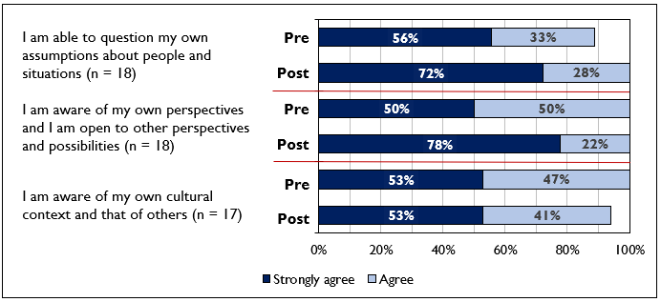
Figure 1 – Percentage of respondents who strongly agreed and agreed with statements in the pre and post-module surveys
2.2 Recognises common humanity and environmental sustainability
A significant area of development for participants concerned their understanding of global issues and awareness of the consequences. In the reflective journals, the majority of students reported that they had deepened their knowledge about how global issues are affecting the world. While some students had a basic grasp before the module, they admitted to underestimating the severity and magnitude of the challenges. A couple of students demonstrated an understanding of how global issues are interconnected, for example, how ‘fake news’ has been used to contradict scientific consensus on climate change.
Several students provided an insight into how they were planning to translate their understanding of global issues into altering the behaviours of themselves and others. In some cases, students focused on the individual changes that they had made in the present, such as limiting use of public transport and recycling more, and in the future: “I would make sure my business was built on foundations of sustainability and environmentally-friendliness” (student 10, abroad). Others identified the role of communication in influencing the actions of others: “I can educate others about the aspects I have learned about in order to make my contribution to resolve this global issue whilst being mindful of the most effective way to communicate this” (student 2, home).
There was some evidence that students recognised their shared humanity with others and the world. Following the lecture series, one student reflected on the shared cross-cultural endeavour of gaining human rights:
‘I also viewed how different cultures throughout time have the common goal of gaining basic humans rights for themselves, like Gandhi’s speech or Martin Luther King’s speech and civil rights movement, trying to gain basic human rights for African Americans. This highlights that this mutual goal unites many cultures in today’s modern world event though there are many cultural differences between countries/cultures’ (student 13, home).
The responses to the survey correspond with the thematic analysis in identifying some improvements. The statistical test shows that an improvement was recorded in 3 students for two statements, for example, 17 out of 17 (100%) respondents strongly agreed/agreed with the statement ‘I understand the interconnectedness of local/global issues’ post-module compared with 14 (82%) pre-module. These changes were non-significant. Figure 2 shows that a slightly higher percentage of students responded with strongly agree to the statements in the post-module survey than the pre. Four other survey questions relating to global issues were asked only in the post-module survey (see Appendix C), with percentage agree scores ranging from 100% to 95%.
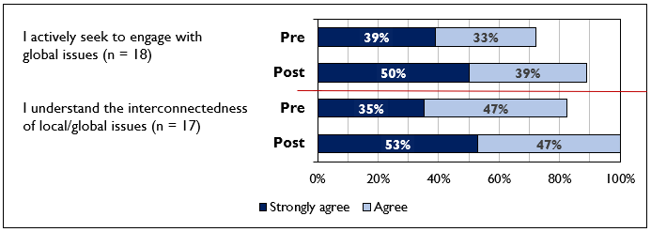
Figure 2 – Percentage of respondents who strongly agreed and agreed with statements in the pre and post-module surveys
- Engages beyond immediate circle of peers, family and friends
This theme focuses on the experiences of participants when communicating with others who were socially and culturally different, their accounts of these changes in behaviour and their willingness to support others.
  - Engages with social and cultural others
Participating in the module provided many students with opportunities to interact with various groups of individuals. In the case of those on the Culture Connect scheme, students engaged with both home and international students from different courses across the university: ‘I was surprised on how the whole project came together and allowed me to come across so many different cultures under one roof. This was an exciting time where I had networked with more people around the globe than I thought I would have, which resulted in lasting friendships’ (student 12, home). For those who were abroad, students described their experiences of being exposed to ‘a range of dialects’. The experiences of these students made them feel more confident (also see Theme 4.2) as they were able to adapt their communication skills to establish good rapport and ensure that language differences were not a barrier.
The statistical test shows that an improvement was recorded in 1 student for two statements relating to confidence in engaging with people from a different culture, which was a non-significant change (19 out of 19, or 100%, agreed/strongly agreed in the post-module survey compared with 18, or 95%, in the pre). Figure 3 shows that the number of students who responded with strongly agree in the post-module survey compared to the pre-module survey rose slightly.
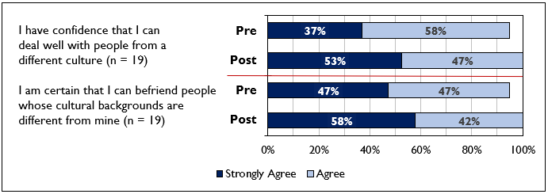
Figure 3 – Percentage of respondents who strongly agreed and agreed with statements in the pre and post-module surveys
  - Adapting communication skills for others
In the reflective journals, many students demonstrated sociolinguistic awareness and competence by adapting their communication skills for others. Several accounts highlighted that listening attentively (also see Theme 2.1) and providing others with opportunities to be heard and understood were the most useful skills for communication, for example, one student reflected that:
“the process taught me that talking less and listening more would allow you to learn about a person and their views a lot easier. Allowing others to guiding a conversation and keeping up with what was said meant that the other person feels attended to and understood, which I believe is a good skill to have as others feel appropriated and respected” (student 14, home).
Observation of non-verbal cues, such as body language, were also deemed to be important for gauging understanding by a couple of students, especially in the case of people who did not speak English as their first language. One student on the mentoring scheme initially met their mentees on an individual basis to understand their needs. There was some evidence that participants went beyond adapting their communication skills by tailoring activities to facilitate positive interaction, for example, for teaching: ‘I learnt the importance of planning and creating lessons which will suit the learners needs, interests, ability, their preferred learning styles which will ultimately make the lessons more interesting’ (student 1, home).
There were many individual examples of how students consciously modified their behaviour and approach to communication to ensure it was appropriate for their new context. Students made efforts to ensure that their messages were refined and clearly articulated, for example, those who were wary of their own accents: ‘Exposing myself to this situation made me adapt my usual language, which is very fast and includes slang, so that the audience can understand the presentation and be able to learn from me (student 3, home)’. The value in receiving and acting on feedback was identified as an important way of checking the appropriateness and effectiveness of communication, for example, one student learnt to slow down the pace of their speech by using pauses to give learners more time to think about the content. A student on an experience abroad demonstrated adaptability by learning the basics of a new language and they emphasised how meaningful exchange is possible if all parties are willing to show understanding and invest in efforts to communicate.
The survey responses are consistent with the content of the reflective journals in identifying enhancements in some students’ confidence to adapt their communication skills. The statistical test shows that, in terms of changes in the numbers of students who responded in agreement with the statement ‘I modify my speech style (for example, accent or tone) to suit people from a different culture’, improvement was found in 5 students and a decline was evident in 1 student (16 out of 18, or 89%, agreed/strongly agreed in the post-module survey compared with 12, or 67%, in the pre). This change was non-significant. Similar findings, albeit to a lesser extent, for found for other statements (see Figure 4).
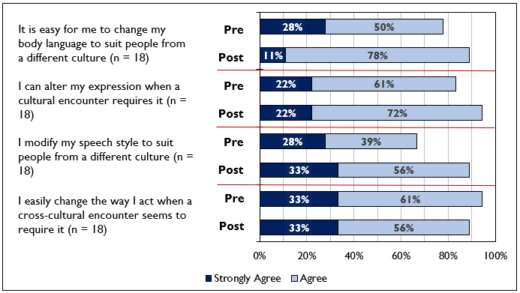
Figure 4 – Percentage of respondents who strongly agreed and agreed with statements in the pre and post-module surveys
  - Assists others
There was some evidence that students demonstrated greater awareness, responsibility and concern for others. Many of the examples from this sub-theme were from students undertaking an experience on campus who signposted mentees to appropriate resources, such as services that are available within the university. In one case, a student supported their mentee by proactively creating a study group by contacting people on their course and acting as a mediator. A number of students referred to feeling ‘proud’ for helping others and rewarded after observing improvements both in themselves and their peers: ‘Getting engaged in the activities prepared truly improved their speaking skills, they became strong at debating and started constructing interesting arguments. Seeing a general boost in their confidence was quite unexpected in such a short period’ (student 5, home).
In a small number of cases, students’ desire to help others extended to plans to participate in volunteering roles and community activities: ‘I plan on improving my intercultural skills by volunteering in ESOL centres on the weekends to practice actively listening and observing’ (student 1, home). Many students expressed a greater understanding of the reasons why individuals migrate and the issues facing refugees, which led one student to state that ‘learning about their challenges will make me more motivated to get involved with helping refugees’ (student 3, home).
- Shows a mature attitude and initiative and considers self, life and others beyond narrow expectations
This theme is concerned with the personal growth, confidence and maturity that participants have developed as a result of taking part in the module.
4.1 Examples of demonstrating leadership or responsibility
By participating in the module, some students assumed a level of responsibility which they were not previously used to: ‘being a mentor is a skill in itself - I have not had much experience in actually being accountable for or mentoring anyone professionally’ (student 4, home). Other examples focused on: planning and delivering classes to students who have English as a second language; the independence gained from travelling to various locations and finding accommodation abroad; and dealing with the accounts and pay roll of a company whilst on work placement.
Time management, organisational skills and flexibility were commonly identified as aspects which had been strengthened as a result of the module. On some occasions, students were faced with barriers that prevented them from seeing their mentees in-person, such as Covid-19 and the challenges of balancing study on-campus with off-campus commitments, but they demonstrated initiative to minimise the impact:
‘In order to support my mentees through the culture connect scheme I had to organise my time effectively as I also had my part time job and my course to contend with. As part of my course I am sometimes on placement which meant I was not at the University campus. Despite this inconvenience I put provisions in place to maintain contact and support for my mentees as appropriate’ (student 2, home).
4.2 Changes in confidence or personal growth
In the reflective journals, many students were able to recognise and articulate how their confidence had improved as a result of the module and adapting to the challenges it presented (also see Theme 1). Students indicated that they were more willing to take risks after embracing new experiences:
‘I was more inclined to step out of my comfort zone, which provided me with experiences to expand on my abilities and learn more about my own capabilities…This experience taught me that I am capable of more than what I could ever imagine. I learned that I could educate whilst being educated, and that I am capable of international employability. I learned that by pushing my limits, I can achieve anything’ (student 9, abroad).
Some students indicated that the module has changed them as a person and given them a greater understanding of their self, with increased motivation to learn from experiences (also see Theme 4.3). A significant number of students indicated that the skills that they have acquired has boosted their self-efficacy and confidence about fulfilling their personal and professional goals in the future (also see Theme 4.4): ‘I believe that this will help me immensely in the future during my travelling ambitions, as I will be able to use the knowledge I have gained to inform my behaviour and attitudes within other countries’ (student 6, home).
Other examples consist of students who recognised the benefits of particular skills in relation to their employability and their industry of interest: ‘Working in the food industry often involves travelling to different countries, so communication is a vital skill to have’ (student 3, home). In contrast, one student felt that the module did not have a direct impact on their learning and development, rather it provided them with an opportunity to critically reflect on their experience and its impact.
The pre-post survey comparison shows that enhancement was recorded in 3 students for the statement ‘I am confident that I can deal with a cultural situation that is unfamiliar’ (19 out of 19, or 100%, agreed/strongly agreed in the post-module survey compared with 16, or 84%, in the pre). This change was non-significant. Figure 5 shows that improvements were less evident across other areas but it is important to note that participants responded very confidently to some statements in the pre-module survey, which meant that there was not much, or any, room for improvement to be recorded in the post-module survey.
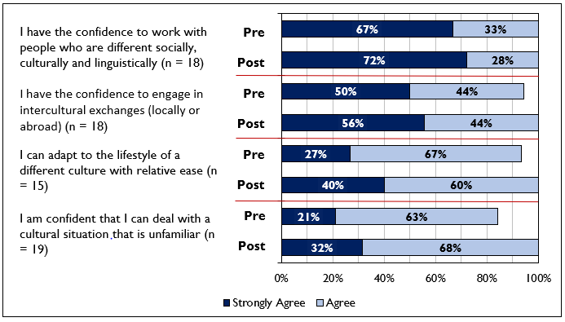
Figure 5 – Percentage of respondents who strongly agreed and agreed with statements in the pre and post-module surveys
4.3 Reflection and planning
While students conveyed the benefits that had occurred from taking part, many expressed the viewpoint that their development towards being ‘globally minded’ was not, and will never be, complete as it is a lifelong journey:
‘intercultural competence cannot be acquired in a short space of time. People continue improving their intercultural competence and knowledge throughout their life by being open to new cultures, experiences and critical reflection.’ (student 6, home).
In order to continue developing their skills and self-awareness, many students expressed an eagerness to find similar opportunities in the future. Other students reflected on how they would approach future situations differently based on their experiences, such as the steps they would make to be more prepared for encountering new individuals or situations: ‘[do] my research and try and find out as much as I can about these countries to make my settling in period easy for myself as I would be prepared’ (student 1, home). In one case, a student compiled an action plan to identify key areas for development by using Gibbs’ (1988) reflective cycle, while another set an aim of learning the names of students to encourage participation during activities and interactions.
Enhancements were found in several students’ ‘cognitive’ skills in the pre-post survey comparison. In relation to the statement ‘Before I interact with people from a new culture, I ask myself what I hope to achieve’, improvement was evident in 5 students and a decline in 1 student (10 out of 19, or 53%, strongly agreed/agreed in the post-module survey compared with 6, or 32%, in the pre). Figure 6 shows that some improvements were also found for two other statements, in particular ‘I plan how I am going to relate to people from a different culture before I meet them’.
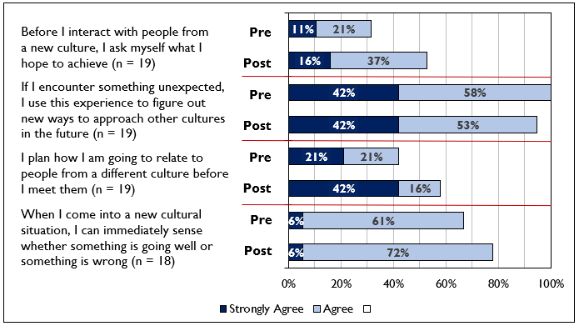
Figure 6 – Percentage of respondents who strongly agreed and agreed with statements in the pre and post-module surveys
4.4 Considers self, life and others beyond narrow expectations
It was clear from the reflective journals that the GCP has had a positive effect on the personal and professional plans of several students. Many students who went abroad stated that they were eager to work or study abroad in different countries, with the experience enhancing their desire even further. Those at home also sought to travel and work abroad, with a few stating that they are now more willing to discover new cultures. Both groups indicated that the experience had made them more confident that they could adapt without any major difficulties (also see Theme 4.2). For a small number of other students, the module has changed their perspective about life:
‘Having the opportunity to meet new people and learn from incredibly motivated individuals has allowed me to realise that there is more to university life than gaining a degree and I am very pleased that I have had the chance to explore that’ (student 6, home).
In contrast, the responses to the pre-post surveys indicate that there were no differences in students’ levels of excitement about their future personal and professional plans, with the majority of students strongly agreeing with both statements on both surveys (see Figure 7). However, the majority of students on the post-module responded that the GCP will be useful ‘In my future career and professional life’ (19 out of 19, 100%; see Appendix C), ‘In my personal life’ (18 out of 19, 95%) and ‘In my academic course’ (11 out of 19, 58%).
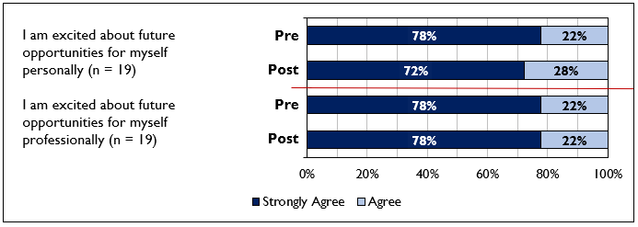
Figure 7 – Percentage of respondents who strongly agreed and agreed with statements in the pre and post-module surveys
- General experience of the module
The reflective journals and the responses to the post-module surveys show that students responded very positively about their general experience of the module. A few comments in the reflective journals stated that each component of the module provided them with knowledge that would not have possible through their course curriculum:
‘Without the lectures, workshops and activities that I have been able to engage with throughout this challenge, I would have less knowledge because I would not have had the opportunity to interact with a wide range of people’ (student 6, home).
In the post-module survey, the majority of participants responded favourably about the clarity of information that was provided, for example, 17 out of 19 (89%) strongly agreed/agreed with the statement ‘I found it easy to follow the steps required and received enough information to guide me’. There were high percentage agree figures for the lectures (for example, 18 out of 19, or 95%, agreed with the statement ‘The themes of the global lectures were relevant to me’) and for the duration and quality of the intercultural experiences (18 out of 19, or 95%, agreed). A couple of comments in the survey highlighted that the only aspect that could be improved was the advertisement of the module.
Discussion
The purpose of the GCP is to help develop students at Sheffield Hallam to become global citizens. There were three aims of the module, which were to support students in developing skills and evidence that they:
- are able to engage with different values systems wherever they encounter them.
- can communicate effectively across cultures, and in different cultural contexts.
- have an understanding of how their actions and those of others can have global implications.
Each of these aims will be addressed individually using the evidence that has been gathered in the previous section. The first aim of the module was to ensure that students ‘are able to engage with different values systems wherever they encounter them’. While a small number of students provided descriptive accounts of their learning, the findings of the thematic analysis provided insight into the process of change that occurred in many students’ thinking during the module. These accounts exemplify how students reflected and applied the knowledge that they had gained to become more critical of assumptions and more respectful, mindful and curious about cultural differences. This change in mindset was deemed to be crucial for avoiding misunderstandings and helping cross-cultural communication and increasing their confidence about integrating into new cultures in the future.
The survey responses corresponded with the reflective journals by showing that there were developments in the students’ confidence in relation to ‘thinking differently’. Improvement was also noted in terms of students’ cognitive skills relating to cultural intelligence, for example, asking what they hoped to achieve from encounters. Nevertheless, the magnitude of change in students was more profound in the reflective journals than the surveys. In some areas, high proportions of students responded confidently to the pre-module survey which meant that it was not possible for much, or any, improvement to be recorded in the post-module survey. There are several possibilities for this finding, of which a number relate to the design of the survey instrument. Single self-report measures of cognitive processes can produce inaccurate responses, while broad interpretations of concepts used in the survey, such as cultural intelligence, might also affect responses (Thomas et al., 2008). A finding from the journals indicated that some students overestimated their level of confidence before the module. Response biases are another factor to consider, such as the potential reluctance of respondents to honestly report low levels of confidence and knowledge (Paulhus, 1991). There is the possibility that those enrolled on the module are not the students who would benefit most from it, as indicated by the high percentage agree figures in the pre-module survey, but the majority articulated in the journals how the module has enhanced their understanding and skills. It is imperative that these points are explored and addressed in future evaluations.
The second aim of the module was to ensure that students ‘can communicate effectively across cultures, and in different cultural contexts’. In the reflective journals, the experiences of students made them feel more confident as they were able to demonstrate sociolinguistic awareness by adapting their communication skills to ensure language differences were not a longstanding barrier and to establish rapport with others. Students emphasised the importance of listening attentively, applying self-awareness skills and fostering trust between all parties. Students were aware of how they needed to adapt their communication to ensure it is refined and articulated clearly for others, with examples providing some evidence of how their knowledge had been applied. This resonated with the pre-post survey comparison where enhancement was evident in some students, most notably in relation to modifying speech style to suit people from different cultures.
The third aim of the module was to ensure that students ‘have an understanding of how their actions and those of others can have global implications’. The analysis undertaken on the reflective journals and survey responses were corresponding in showing that many students have developed an understanding of global issues and an awareness of the consequences. The lectures on fake news, global warming and cultural differences challenged the prior views of some and they were deemed to be informative. In a number of reflective journals, students outlined how they could apply their understanding to tackle global issues at a local level and influence the behaviour of others.
It was not a specific aim of this evaluation to examine differences between those who went on an experience at home and those who went on an international experience. However, analysis of the data that was available indicates that there was an overlap in terms of the benefits reported by both groups of students, particularly in relation to ‘thinking differently’ and communication skills. There were a few differences that were noted in terms of the types of challenges that they faced, for example, students on experiences abroad faced difficulties adapting to a new culture, such as adjusting to different lifestyles, beliefs and customs, whereas students on ‘home’ experiences tended to have challenges in relation to creating positive learning environments for others, such as for mentees.
Limitations
There are a number of limitations to the evaluation which need to be highlighted. The evaluation has collected data on impact and reported evidence that those on the module have demonstrated improvements in outcomes. However, this does not establish any direct causal effect. The complex environment in which the module operates means causality would be very difficult to determine due to the difficulty of isolating other factors which might have an effect on students, for example, other extra-curricular activities beyond the GCP and course curriculum. Furthermore, differences in the experiences of sub-groups of students have not been explored, such as level of study, motivation and other background characteristics. Use of a control or comparison group, comprised of individuals who are similar to participants, could strengthen the causal inference of findings (Centre for Social Mobility, 2019).
It is important to note that there was a drop in the number of respondents in the pre-module survey (56) compared with the post-module survey (21). Of these, only 19 completed both the pre and post-module survey. It is not known whether the decline in survey participants was due to students dropping out of the module, them deciding against completing the survey or for other reasons. If it is the former, this might introduce a bias to the results of the evaluation as it does not capture their viewpoints. There are no notable differences in responses to the pre-survey module between those who only completed the pre-survey and those who completed both.
The survey instruments were comprised of a mix of items which have been previously used within the sector (Earley & Mosakowski, 2004) and items developed for the purposes of this evaluation. It would be useful for the survey in its entirety to be cognitively tested in the future to examine whether students’ interpretations are in alignment with the expectations of the evaluation team and to review other aspects of the survey design, thereby ensuring the results have greater internal validity. It is also important to note that an issue with tests, particularly those developed in Western countries, is the lack of equivalence of definitions of cultural intelligence across the world (Thomas et al., 2008). The survey design might be one reason for limited development being shown by students in some areas. Additional sources of data should be utilised to provide a ‘matrix’ of approaches to tap into constructs, particularly at pre-module phase.
Conclusion and Recommendations
It is evident that the GCP has had a positive impact on students’ development in becoming ‘global citizens’. The reflective journals show that the majority of students have demonstrated evidence of acquiring intercultural competencies which will help them to engage and adapt with different value systems and contexts. For many students, there were indications that they have gone beyond this by developing a global ‘mindset’ that involves having a capacity for criticality, respect and responsibility towards self, others and the world.
The module was deemed by many students to be insightful that allowed them to see beyond their own confined boundaries to become more curious and willing to discover ‘new’ and ‘different’ cultures. The findings indicate that many students are able to develop global citizenship attributes regardless of whether they are on an experience at home or abroad. However, any future evaluations seeking to specifically compare ‘home’ versus ‘international’ experiences will require more data to be gathered from students who went abroad to ensure that any dissimilarities or similarities found are robust.
There are several recommendations that can be taken to enhance the provision of the GCP and to increase the robustness of the evaluation to provide greater understanding about the impact of the module:
- Consider evaluation needs at the point of design and not during delivery.
- Capture data on which individuals only partially engaged with, and thereby did not complete, the module and explore the underpinning reasons for ‘dropping out’.
- Consider the ‘counterfactual’ argument by exploring what might have happened if the module had not taken place (Parsons, 2017), for example, by looking at the outcomes of those who complete the module against those who did not engage at all and those who partially engaged (e.g. attended the initial workshop and lectures but nothing else).
- Conduct follow-up evaluations to explore the impact of the module on participants after it has taken place, for example, longer-term student outcomes and whether students’ future personal and professional plans were fulfilled.
- Collect data from sources beyond the student enrolled on the module, such as other beneficiaries, to avoid a reliance on self-report measures of cognitive processes which might be inadequate to make accurate assessments (Thomas et al., 2008).
- Utilise additional sources of data to provide a greater ‘matrix’ of approaches to tap into constructs, such as interviews or focus groups at pre-module stage, and include the moderated discussion, which students are able to complete as an alternative to the journals, in the analysis to provide further triangulation of data.
- In order for the International Experience Team to conduct this evaluation in future years, it is recommended that staff engage with STEER to build capacity and confidence, for example, by using relevant resources and CPD.
References
Braun, V. & Clarke, V. (2012) Thematic analysis. In Cooper, H. (Ed.), The Handbook of Research Methods in Psychology. Washington, DC: American Psychological Association.
Centre for Social Mobility (2019). Using standards of evidence to evaluate impact of outreach. Retrieved from https://www.officeforstudents.org.uk/media/f2424bc6-38d5-446c-881e-f4f54b73c2bc/using-standards-of-evidence-to-evaluate-impact-of-outreach.pdf (last accessed 26th June 2020)
Deardorff, D. K. (2011). Assessing intercultural competence. New directions for institutional research, 2011(149), 65.
Earley, P. C., & Mosakowski, E. (2004). Cultural intelligence. Harvard business review, 82(10), 139-146.
Gibbs, G. (1988). Learning by doing: A guide to teaching and learning methods. Further Education Unit.
Kirkpatrick, D., & Kirkpatrick, J. (2006). Evaluating training programs: The four levels. Berrett-Koehler Publishers.
Lilley, K., Barker, M., & Harris, N. (2015). Exploring the Process of Global Citizen Learning and the Student Mind-Set. Journal of Studies in International Education, 19(3), 225–245.
McNemar, Q. (1947). Note on the sampling error of the difference between correlated proportions or percentages. Psychometrika, 12(2), 153-157.
Parsons, D. (2017). Demystifying evaluation: Practical approaches for researchers and users. Policy Press.
Paulhus, D. L. (1991). Measurement and control of response bias. In J. P. Robinson, & P. R. Shaver (Eds.), Measures of personality and social psychological attitudes (Vol. 1; pp. 17–59). San Diego, CA: Academic Press.
Thomas, D. C., Elron, E., Stahl, G., Ekelund, B. Z., Ravlin, E. C., Cerdin, J. L., Poelmans, S., Brislin, R., Pekerti, S., Aycan, Z., Maznevski, M., Au., K. & Lazarova, M. B. (2008). Cultural intelligence: Domain and assessment. International Journal of Cross Cultural Management, 8(2), 123-143.

‘Considers self, life and others beyond narrow expectations’ is a separate theme in the Global Citizens identkit but it was merged with ‘Shows a mature attitude and initiative’ for this analysis due to an overlap in content.
McNemar’s Test (1947) is a matched pair test used to determine whether there is a significant change in nominal data before and after an event. A 2x2 contingency table was used (Pre/Post survey and Agreement/Non-agreement), It would have been preferable to use a test that examines pre-post survey changes in all five response categories but there was an insufficient sample size and variation in responses.
‘Agreement’ was classified as those students who responded with ‘Strongly agree’ or ‘Agree’.
‘Non-agreement’ was classified as those students who responded with ‘Neither agree nor disagree’, ‘Disagree’ or ‘Strongly disagree’.
Although 19 students responded to both the pre and post-module surveys, this figure will vary across questions as responses of ‘Not sure’ were excluded from the analysis.

